Recognising Graphs
Exercise 1
- Identify the coordinates of the indicated points.
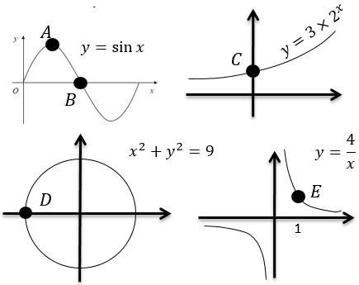
- Which of these graphs could have the equation $y=x^{3}-2x^{2}+3$?
Explain why.
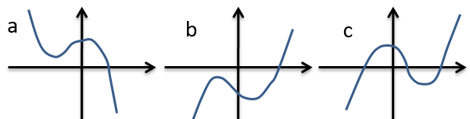
- Match the graphs with their equations.
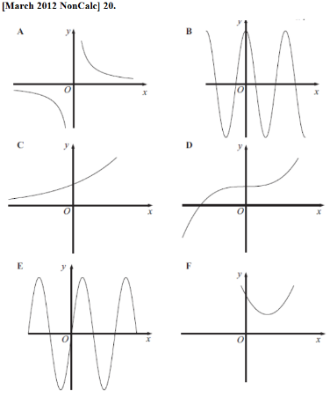
i. $y=4\sin{x}$
ii. $y=4\cos{x}$
iii. $y=x^{2}-4x+5$
iv. $y=4×2^{x}$
v. $y=x^{3}+4$
vi. $y=\frac{4}{x}$

Exercise 2
- Given that the points $(1,6)$ and $\left(4,48\right)$ lie on the exponential curve with equation $y=b×a^{x}$, determine $a$ and $b$.
- Given that the points $(2,48)$ and $\left(5,3072\right)$ lie on the exponential curve with equation $y=b×a^{x}$, determine $a$ and $b$.
- Given that the points $(1,3)$ and $\left(3,108\right)$ lie on the exponential curve with equation $y=b×a^{x}$, determine $a$ and $b$.
- Given that the points $(3,\frac{1}{72})$ and $\left(7,\frac{1}{1152}\right)$ lie on the exponential curve with equation $y=b^{2}a^{x}$, determine $a$ and $b$.

