GCSE – Graph Transformations

Mini-Exercise
$$y=f\left(x\right)$$ | $$(4,3)$$ | $$(1,0)$$ | $$\left(6,-4\right)$$

$$y=f(x+1)$$

$$y=f\left(x\right)-1$$

$$y=f(-x)$$

$$y=-f(x)$$

$$y=f(2x)$$

$$y=3f(x)$$

$$y=f\left(\frac{x}{4}\right)$$

Test Your Understanding

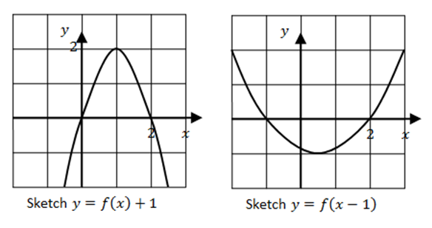

Question 1
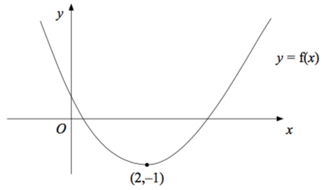
The diagram shows part of the curve with equation
$y=f\left(x\right)$.The minimum point of the curve is at (2,–1)
Write down the coordinates of the minimum point of the curve with equation $y=f\left(x+2\right)$
..........................

Question 2
The diagram shows part of the curve with equation
$y=f\left(x\right)$. The minimum point of the curve is at (2,–1)
Write down the coordinates of the minimum point of the curve with equation $y=3f\left(x\right)$
..........................

Question 3
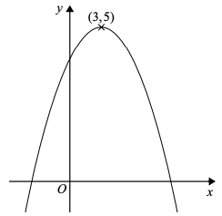
The diagram shows part of the curve with equation
$y=f\left(x\right)$ The coordinates of the maximum point of the curve are $\left(3,5\right)$.
Write down the coordinates of the maximum point of the curve with equation $y=f\left(3x\right)$
..........................

Question 4
The curve with equation $y=f\left(x\right)$ has a maximum point at $\left(2,-7\right)$.
Find the coordinates of the minimum point of the curve with equation $y=-f\left(x\right)$
..........................

Question 5
Here is the graph of $y= sin x^{°}$ for $0≤x≤360$
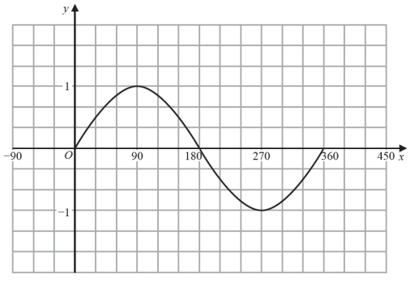
In $0≤x≤360$, the graph of
$y= sin {\left(\frac{x}{2}\right)}^{°}+3$ has a maximum at the point $A$.
Write down the coordinates of $A$.
..........................

Question 6
The graph of $y=f\left(x\right)$ is shown on the grid.
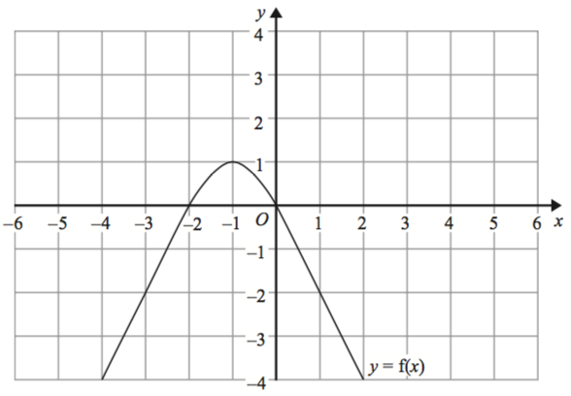
The graph of $y=f\left(x\right)$ has a turning point at the point $\left(-1,1\right)$. Write down the coordinates of the turning point of the graph of $y=f\left(-x\right)+2$
..........................

Question 7
The diagram shows part of the curve with equation $y=f\left(x\right)$ The coordinates of the maximum point of the curve are $\left(3,5\right)$. The curve with equation $y=f\left(x\right)$ is transformed to give the curve with equation
$$y=f\left(x\right)-4$$
Describe the transformation.

..........................

Question 8
The graph of $y=g\left(x\right)$ is shown on the grid.
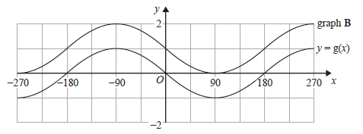
Graph $B$ is a translation of the graph of $y=g\left(x\right)$.
Write down the equation of graph $B$.

$y=$ ..........................

Question 9
The graph of $y=f\left(x\right)$ is shown on the grid.
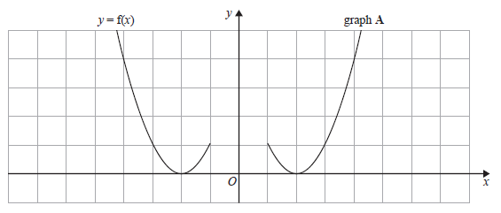
Graph $A$ is a reflection of the graph of $y=f\left(x\right)$.
Write down the equation of graph $A$.

$y=$ ..........................

Question 10
This is a sketch of the curve with equation $y=f\left(x\right)$ .
It passes through the origin $O$.
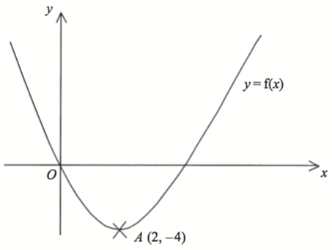
The only vertex of the curve is at $A\left(2,-4\right)$.
The curve with equation $y=x^{2}$ has been translated to give the curve $y=f\left(x\right)$.
Find $f\left(x\right)$ in terms of $x$.
$f\left(x\right)=$ ..........................

Question 11
Here is the graph of $y=f\left(x\right)$
On the grid, draw the graph of $y=2f\left(x\right)$
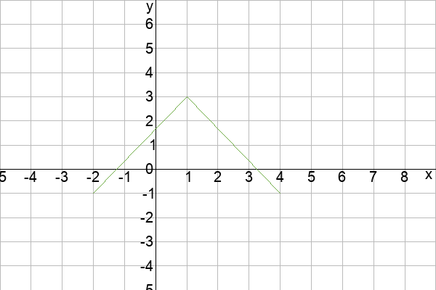

Question 12
Here is the graph of $y=f\left(x\right)$
On the grid, draw the graph of $y=f\left(-x\right)$

Question 13
The coordinates of the turning point of the graph of $y=x^{2}-8x+25$ is $\left(4,9\right)$.
Hence describe the single transformation which maps the graph of $y=x^{2}$ onto the graph of
$y=x^{2}-8x+25$.

..........................

Question 14
Here is the graph of $y= sin x$, where $0^{°}≤x≤{360}^{°}$
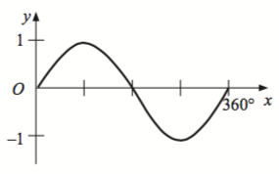
Match the following graphs to the equations.
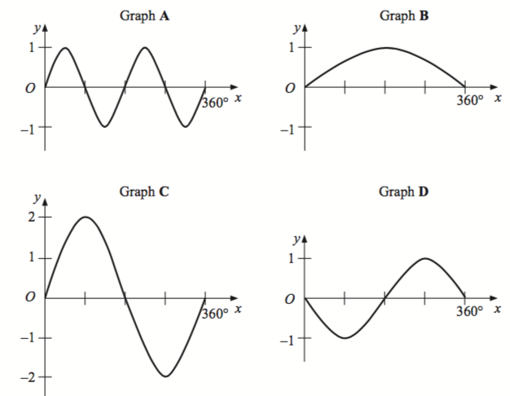
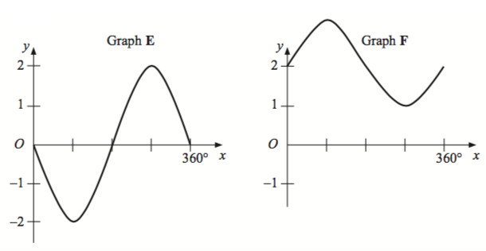
Equation | Graph
$$y=2 sin x$$ | ..................
$$y=- sin x$$ | ..................
$$y= sin 2x$$ | ..................
$$y= sin x+2$$ | ..................
$$y= sin \frac{1}{2}x$$ | ..................
$$y=-2 sin x$$ | ..................

Question 15
Here is a sketch of the curve y = a cos bx° + c,
0 ≤ x ≤ 360
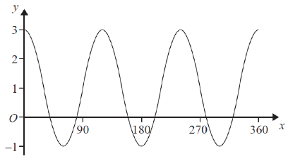
Find the values of a, b and c.
..........................

