Exercise 2 – Tangents/Normals
Question 1
[IGCSEFM June 2012 Paper 1 Q8] A curve has equation $y=x^{3}+5x^{2}+1$
(a) When $x=-1$, show that the value of $\frac{dy}{dx}$ is -7.
(b) Work out the equation of the tangent to the curve $y=x^{3}+5x^{2}+1$ at the point where $x=-1$.
Question 2
[IGCSEFM June 2013 Paper Q8] A curve has equation $y=x^{4}-5x^{2}+9$
(a) Work out $\frac{dy}{dx}$.
(b) Work out the equation of the tangent to the curve at the point where $x=2$
Give your answer in the form $y=mx+c$
Question 3
[IGCSEFM Set Paper 1 Q11] Show that the tangents to the curve $y=x^{3}+3x^{2}+3x+1$ at $x=1$ and $x=-3$ are parallel.
Question 4
[IGCSEFM Set 1 Paper 2 Q17] Work out the equation of the normal to the curve $y=2x^{3}-x^{2}+1$ at the point (1, 2). Give your answer in the form $y=mx+c$.
Question 5
[IGCSEFM Set 2 Paper 1 Q15] The graph shows a sketch of $y=(x-2)(x-3)$. The curve intersects the $x$-axis at $P$ and $Q$.
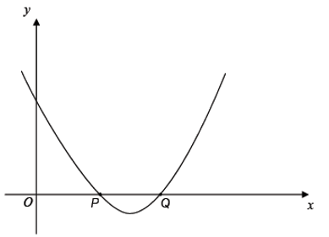
Show that the tangents at $P$ and $Q$ are perpendicular.

Question 6
[IGCSEFM Set 4 Paper 2 Q20] A sketch of the curve $y=(x+1)(2-x)$ is shown.
$A\left(0,2\right), P(2,0)$ and $Q$ are points on the curve.
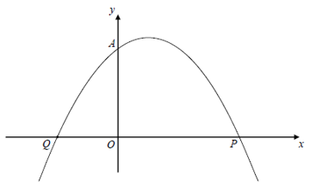
(a) Write down the coordinates of point $Q$.
(b) Show that the normal to the curve at $A$ intersects the curve again at $P$.
Question 7
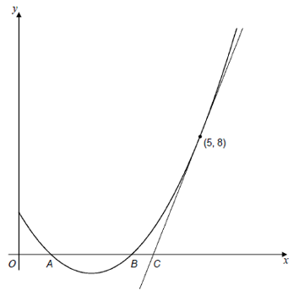
[IGCSEFM Specimen Paper 2 Q22] The diagram shows the graph of $y=x^{2}-4x+3$
The curve cuts the $x$-axis at the points $A$ and $B$.
The tangent to the curve at the point (5,8) cuts the $x$-axis at the point $C$.
Show that $AB=3BC$.

Exercise 4 – Stationary Points
Question 1: [Set 4 Paper 2 Q22] A sketch of $y=f\left(x\right)$, where $f(x)$ is a cubic function, is shown.
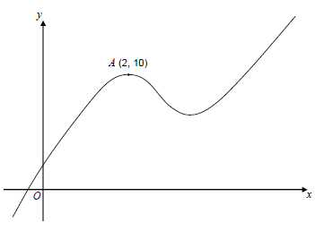
There is a maximum point at $A\left(2,10\right)$.
(a) Write down the equation of the tangent to the curve at $A$.
(b) Write down the equation of the normal to the curve at $A$.
(c) Circle the word that describes the cubic function when $x<2$.
positive negative increasing decreasing
Question 2: [June 2013 Paper 2 Q8] A sketch of $y=f\left(x\right)$ is shown. There are stationary points at $A$ and $B$.
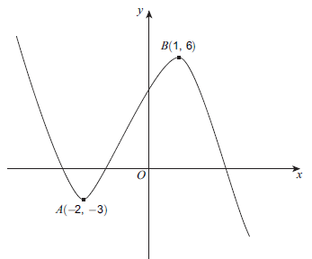
(a) Write down the equation of the tangent to the curve at $A$.
(b) Write down the equation of the normal to the curve at $B$.
(c) Circle the range of values of $x$ for which $f\left(x\right)$ is an increasing function.
$$x<-2 -2<x<1 -3<x<6 \\ x>1$$

Question 3: [Set 2 Paper 2 Q12] A curve has equation $y=x^{3}-9x^{2}+24x-16$
(a) Work out $\frac{dy}{dx}$
(b) Work out the coordinates of the two stationary points on the curve.
Question 4: [Set 1 Paper 2 Q14] (a) Work out the stationary points on the curve $y=x^{3}-12x$.
(b) Sketch the curve $y=x^{3}-12x$
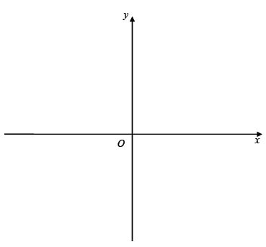
Question 5: [Set 3 Paper 1] A curve has equation $y=4x^{3}+6x^{2}+3x+5$
Work out the coordinates of any stationary points on this curve and determine their nature.

Question 6: [Specimen Paper 1 Q13] (a) Work out the coordinates of the stationary point for the curve $y=x^{2}+3x+4$.
(b) Explain why $x^{2}+3x+4=0$ has no real solutions.

Question 7: [Jan 2013 Paper 1 Q13] $y=2x^{3}-12x^{2}+24x-11$
(a) Work out $\frac{dy}{dx}$, giving your answer in the form $\frac{dy}{dx}=a{\left(x-b\right)}^{2}$, where $a$ and $b$ are integers.
(b) Hence, or otherwise, work out the coordinates of the stationary point of
$$y=2x^{3}-12x^{2}+24x-11$$
(c) Explain how you know that this stationary point is a point of inflection.

Question 8: [June 2012 Paper 2 Q23] The curve $y=f(x)$ is such that $\frac{dy}{dx}=-x{\left(x-2\right)}^{2}$
The stationary points of the curve are at $\left(0,\frac{4}{3}\right)$ and $\left(2,0\right)$.
Determine the nature of each stationary point. You must show your working.

