It is hoped that the punishment will deter the person from repeating the crime. It is also hoped that the fear of the punishment will stop other individuals from committing crimes.

**DETERRENCE.**

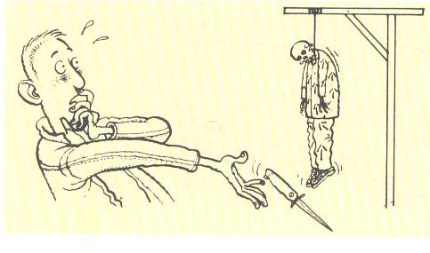

**REPARATION.**

If someone breaks the law they must be prepared to make amends, in other words, pay back something to the victim or to society.



Based on the idea of an eye for an eye. If someone has done something wrong they should be given a punishment that fits the crime.

**RETRIBUTION.**

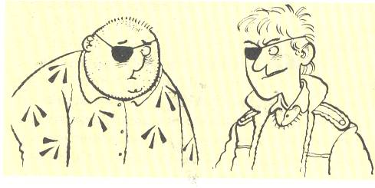

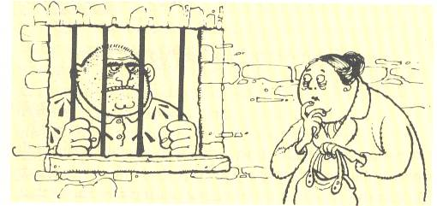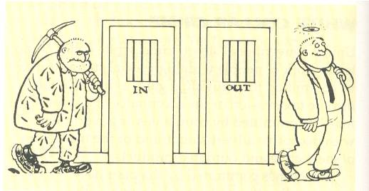

Punishing someone by locking them up is a way of protecting society from the anti – social behaviour of some people. Sometimes the punishment is also to protect the offender.

**PROTECTION**

For people to live together and to feel safe the law must be respected and seen to be upheld.

Punishment should not only stop people from continuing to commit crimes, but should help them become responsible members of society.

**REFORM**

**VINDICATION**