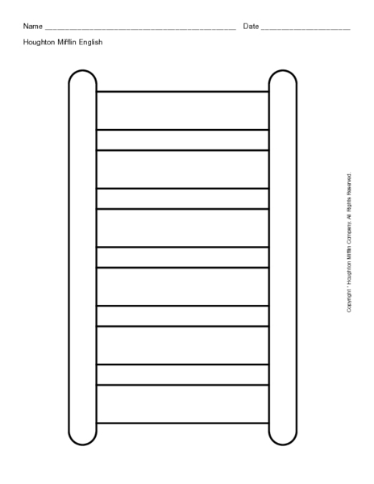4

The Three Poisons are …?

The Three Poisons are …?

**7**

**7**

**6**

**6**

**5**

**5**

**4**

**4**

**2**

**3**

**3**

**2**

**1**

**1**

Give the name for the crime of stealing from a shop.

Give the name for the crime of stealing from a shop.

Where are the laws made, that apply to all people in the UK?

Where are the laws made, that apply to all people in the UK?

What is the title of the person who leads a trail in court?

What is the title of the person who leads a trail in court?

Burglary is a crime against _________?

Burglary is a crime against _________?

Murder is a crime against a ________ ?

Murder is a crime against a ________ ?

Give the name of a type of punishment designed to keep people safe.

Give the name of a type of punishment designed to keep people safe.

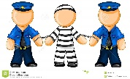



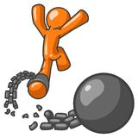4

What does the term ‘redeemable’, mean?

What does the term ‘redeemable’, mean?

**14**

**14**

**9**

**9**

**8**

**8**

**13**

**13**

What is perjury?

What is perjury?



Who creates bye-laws?

Give the name of a charity that helps victims struggling with the effects of crime.

Give the name of a charity that helps victims struggling with the effects of crime.

**10**

What is the name of the group of 12 people that decide whether or not an accused person is guilty or not.

**11**

What is the name of the group of 12 people that decide whether or not an accused person is guilty or not.

**12**

Who creates bye-laws?

**12**

**11**

What do most Christians believe tries to make us do evil things?

What do most Christians believe tries to make us do evil things?

What is arson?

**10**

What is arson?