

Committing crime is, of course, mostly wrong. However, how wrong it is may depend on why the crime was committed. Sometimes it is down to pure selfishness and greed, whereas at other times there may be circumstances that make the crime somewhat

understandable. Christians and Buddhists both believe in compassion and

show understanding when people have committed crimes due to very

difficult circumstances. However both also believe followers should obey the

law. In the Bible it says, *‘let everyone be subject to the governing authorities,*

*for there is no authority except that which God has established’.* (Romans 13:1)

Poverty…

Some people in the UK, live in poverty which means they cannot afford the basics in life. Benefit payments help but sometimes these do not cover all living expenses. This can lead some people to steal food and essentials that they cannot afford to buy. However, even though it may be for a good reason but it is still against the law and perpetrators found, will still be arrested. Christians try to prevent this kind of crime by encouraging people to help the poor by giving to charities and food banks.

Upbringing…

Growing up in a household where crime is a way of life is likely to encourage a

young person to follow that example and drift into crime themselves,

sometimes they are even encouraged to commit crime by their parents. Once

this happens it is difficult for them to stop.

Mental Illness.

Some types of mental illnesses may cause sufferers to commit crimes. Kleptomania is a compulsive disorder that makes some people steal. Anger management issues may lead to violent crimes and schizophrenia and other personality disorders have led some people to commit murder. An infamous example of this is the ‘Yorkshire Ripper’, Peter Sutcliff. He murdered thirteen women. He was found to be suffering from schizophrenia and is currently serving indefinite time in Broadmoor secure hospital.

Addiction.

Addiction to drugs, alcohol and gambling can all lead to crime, very often to fund a habit. It is obviously a crime to possess or deal in illegal drugs, but some people are so addicted that they will steal to get money to buy their drugs. Alcohol, however is responsible for more crimes than any other drug. As well as stealing to fund alcoholism, getting drunk can lead

people to lose control of their thoughts and actions, fights may break out

and those that drink drive are far more likely to cause an accident. Most

Christian denominations do not forbid the drinking of alcohol, but do

discourage excessive drinking. The Buddhist 5th Precept says, *‘Avoid*

*intoxicants which cloud the mind’*. This means that most Buddhists do not

drink alcohol.

**Reasons for crime.**

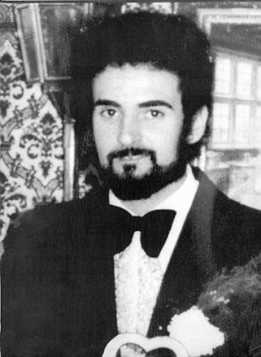

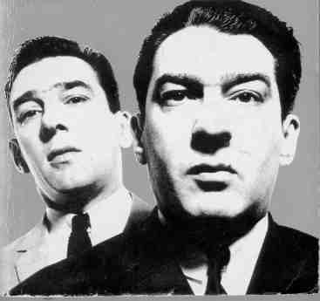





Greed…

The UK is a materialistic society. The want of possessions the adverts tell us we

must have can lead to greed and that can lead to theft and fraud. The Ten

Commandments tell Christians*, ‘Do not covet’*. This means they should not be jealous and want what other people have.

Hate…

Hate can lead to violence, murder or aggression. It can cause racism and other forms of negative discrimination.

Opposition of unjust laws…

There are occasions when people have deliberately broken laws because they

thought the laws were unjust. In the USA in 1955, Rosa Parks was arrested

because she refused to give up her seat on a bus to a white man. Martin

Luther King broke laws during the fight for Civil Rights and equality for black

people in America. He was arrested several times in his fight to get unjust,

racist laws changed. He was inspired by his Christian beliefs that everyone is

equal and he never resorted to violence. He was also aware of the Bible verse in the book of Daniel, *‘King [Nebuchanezzar]… we will not worship the gold idol you have set up’*. This shows that when laws are not right it is acceptable to break them.



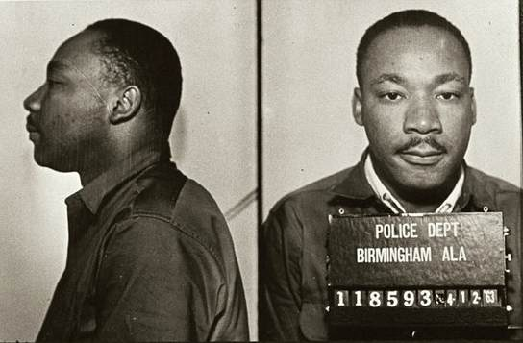



And now…

1. In the hexagon outline, explain, briefly the six causes of crime mentioned on this sheet.
2. In your exercise books, give an example of a crime that might be committed for each cause of crime.
3. Write down each of the quotations mentioned on this sheet. For each one, explain the context in which you would refer to the quotation.
4. ‘It is never right to break the law’. How far do you agree with this quotation? Explain your opinion. Explain a different point of view and include examples and religious teachings in your response.



Being without money, food or other basic needs of life.

Medical conditions that affects a person’s feelings, emotions or moods and perhaps their ability to relate to others and make rational choices.

Physical or mental dependency on a substance or activity which is very difficult to overcome.

Wanting to possess wealth or items of value which are not needed.

Key terms…

Poverty

Mental illness

Addiction

Greed