Different kinds of Law.

In the UK there are different types of law.

* **Civil Law** – this is different from criminal law as it concerns matter between private individuals or groups. These may include divorce settlements, disputes between landlords and tenants and failure to pay what is owed. These cases are often dealt with in the small claims courts.
* **Bye-laws** – these are made by elected councillors and apply to a local area.

Bye-laws include such things as parking restrictions,

fines for dog fouling and littering and alcohol free zones.

* **Parliamentary Laws** – these are laws made by the government and apply to everyone in the country. There are two categories of these laws; *Non-indictable offences* such as minor crimes and minor driving offences which are dealt with in the magistrate’s court; and indictable offences which are more serious crimes dealt with in the Crown Courts and carry more serious penalties such as imprisonment.

Different Types of Crime.

* **Crimes against the person** – offences that cause direct harm

to a person, e.g. murder, rape, GBH and hate crimes.

* **Crimes against property** – offences that damage or deprive people of their property, e.g. arson, burglary, theft.
* **Crimes against the state** – offences that potentially endanger

everyone or affect the smooth running of society, e.g. terrorism,

selling state secrets and perjury.

**Crime & Punishment – Why do some people commit crime?**



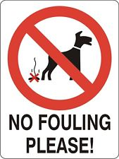

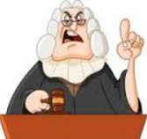

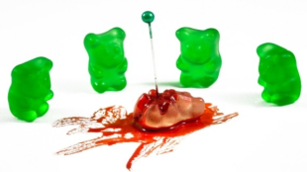

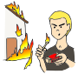



Things to do.

1. Using the headlines identify (a) what types Laws the headlines refer to and (b) what types of crimes the headlines refer to. Give reasons for your responses.
2. Explain why you think some laws are national and local laws, rather than one set of laws for everyone.
3. Explain the difference between criminal and civil law.
4. Crimes against the state are the worst kind of crime. Do you agree? Explain reasons for your response and explain, with reasons, a different point of view.



The rules that govern a country to keep us safe.

Laws that govern private disputes, e.g. business laws, divorce laws.

Laws made by parliament for everyone for which you can be arrested.

Laws set by councillors that apply to a local area.

Definitions...

Law –

Civil Law –

Criminal Law –

Bye-laws -

**1**

Was Johnny Depp’s family’s ‘hatred’ of Amber Heard behind their divorce? Tension occurs as the battle over his $400 million fortune begins.

**3**

Kim Philby and Anthony Blunt turned on their fellow 'Cambridge' agents

Secret documents reveal for the first time how the defectors attempted to deflect suspicion from themselves as the Soviet spy ring first began to be exposed.

**2**

**Man murders boss over unfavourable employment conditions.**

## 



**5**

**4**

**Arsonists target Salford primary school for second time in two weeks.**



Racist hate crimes increase five-fold in week after Brexit vote. Police chiefs hint the current figures may be the tip of the iceberg as hate crime is 'significantly under reported'.

**6**

Council launches louts' gallery of dog foulers, and litter droppers in bid to clean up their area.

**7**

**8**

**Six men arrested in Bridgwater on suspicion of burglary, money laundering and drugs supply.**

Taunton Times

**Three arrested on suspicion of aggravated burglary in Taunton leaving victim with severe injuries**

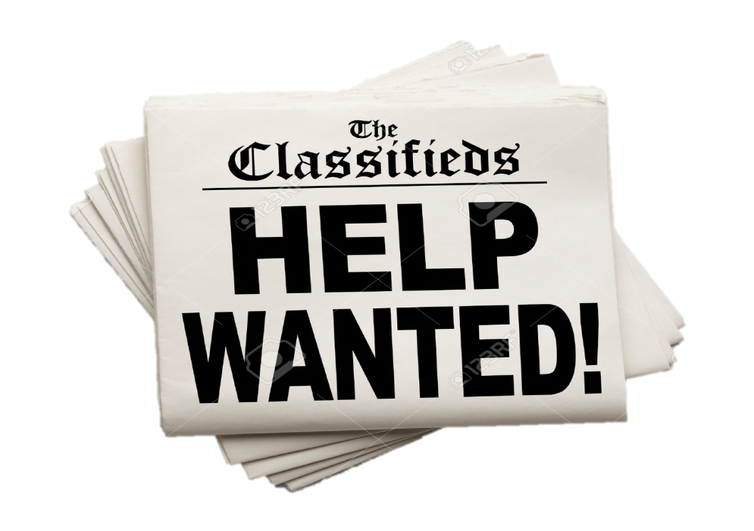

**9**



**Inheritance dispute sees bailiffs seize more than 100 cars towed away from Amlwch garage.**



**10**

Man with weapons was headed to L.A. gay pride parade.

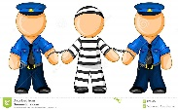

Where does evil come from?

Some people suggest that people that commit some of the worst, most violent crimes are evil. But, what is evil? Where does it come from?

Definitions…

***Evil*** – something that is immoral and wicked, malicious and depraved, sometimes linked to the ideas of a malevolent force, e.g. the devil.

***Good*** – morally right, good, virtuous.

**Good & Evil Intentions & Actions**

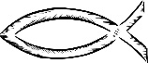

Christianity.

Evil is seen as the abuse of God’s gift of free will – the ability to make our own choices and to choose right or wrong actions. In order to appreciate good, evil must exist. Most Christians believe in a devil who continually tries to make people choose bad actions (e.g. Adam and Eve). Evil is therefore a combination of internal (self) and external (the devil) factors.

Buddhism.

Good and evil are two inseparable aspects of life, you cannot have one without the other. Evil is caused by the Three Poisons – greed, hatred and ignorance. Everyone is subject to these and it is the Buddhist’s aim to combat the Three Poisons. We are responsible for our own actions and there consequences.

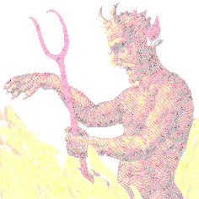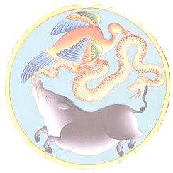

Other ideas about where evil comes from…

Non-religious people may also believe in evil. They may believe that everyone has the capacity to do evil and suggest it comes from our own human nature or how we were brought up. We do not all show evil but certain things could trigger or sow the seeds for evil actions such as being abused as a child or a psychotic illness.

Evil person or evil action…

The Christian phrase, ‘hate the sin, not the sinner’, makes the point that it is the actions that are wrong but they should love the people in spite of their actions. However, the fact remains that we cannot punish the action without punishing the person who committed the sin. Most religious people believe that people who do wrong are redeemable (can change and be forgiven), that they can be brought back to good ways (be reformed).

How do we deal with evil…

We obviously deal with criminals through the court system and with appropriate punishments. However crimes can affect people well beyond the actual event. Evil events disturb a person’s well-being and feeling of safety. The victims of evil have to be helped and reassured. Religious people may do this by volunteering for the Victim's Support Service or charities like the Samaritans.

