 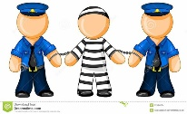

**Crime & Punishment**

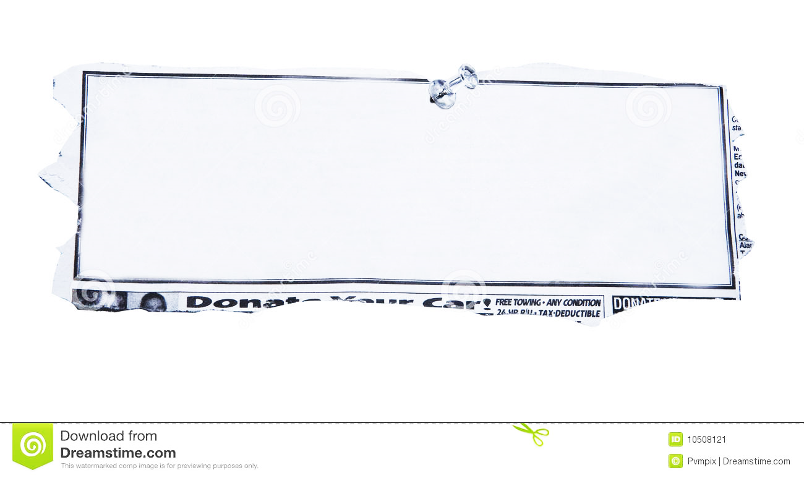

Robber gets caught when he deposits _______________he ____________ from a bank into his bank account at the

same bank! Judge gives him _______________________________



Burglar caught thanks to finger _______________ left on a pen

used to write, ‘____________me if you can! _______________

has no sympathy for the bungling burger as he orders him to

complete 100 hours of ______________________ service.



## _________ dealer caught

## red-handed after posting

## ________ holding huge

## wad of _________

## Sent to ___________ for

## ______ years.

A [______ driver](http://www.mirror.co.uk/all-about/drink-driving) was caught

after trying to inflate his

car's tyres using a __________

station's vacuum cleaner.

Loses his _____________and

gets a £ ________ fine.

Crime & Punishment.

Fill in the blanks with the most appropriate words considering the crimes committed and the consequences and most appropriate punishments.