|  |  |
| --- | --- |
| Helping the poor | **Helping the poor**  Explanation |
| http://www.xmarksthespot.co.uk/various/charity-collection-tin1.jpg | Give examples of Christian charities and how charity can help the poor… include examples of long term and emergency aid… |
| http://www.nhs.uk/Conditions/social-care-and-support-guide/PublishingImages/MONEY%20RIGHTS%20LEGAL/BENEFITS%20AND%20TAX%20CREDITS/employment-allowance_364x200_E729CH.jpg | bd06662_Give examples of benefits people in the UK can claim. Explain how one of these benefits helps… |
| https://thoughtsofaleicestersocialist.files.wordpress.com/2015/08/rmt-min-wage-placard.jpg | Explain the difference between the ‘minimum’ and ‘living wage’ and how such wages may help people… |
| https://www.evanandsus.com/wp-content/uploads/2016/02/Oxfam-Logo-2-1.png | What kind of aid is the Oxfam unwrapped campaign? Explain how it works… |
| https://upload.wikimedia.org/wikipedia/en/1/1b/Fairtrade.png | Explain how fair trade works and helps people… |

|  |  |  |  |
| --- | --- | --- | --- |
| Issue | **Exploiting and Helping the Poor**  Explanation | Examples | Problems this issue |
| https://sparaszczukster.files.wordpress.com/2013/07/shocking_copy_fuck_me_wonga.jpghttps://sparaszczukster.files.wordpress.com/2013/07/shocking_copy_fuck_me_wonga.jpghttps://sparaszczukster.files.wordpress.com/2013/07/shocking_copy_fuck_me_wonga.jpg  https://sparaszczukster.files.wordpress.com/2013/07/shocking_copy_fuck_me_wonga.jpg |  |  |  |
| http://i.huffpost.com/gen/1706634/images/o-HUMAN-TRAFFICKING-facebook.jpg |  |  |  |
| https://www.thestage.co.uk/wp-content/uploads/2015/03/shutterstock_generic-low-pay-no-pay-peanuts-money-700x455.jpg |  |  |  |
| http://i2.istockimg.com/file_thumbview_approve/809061/5/stock-illustration-809061-couch-potato.jpg |  |  |  |

bd06662_

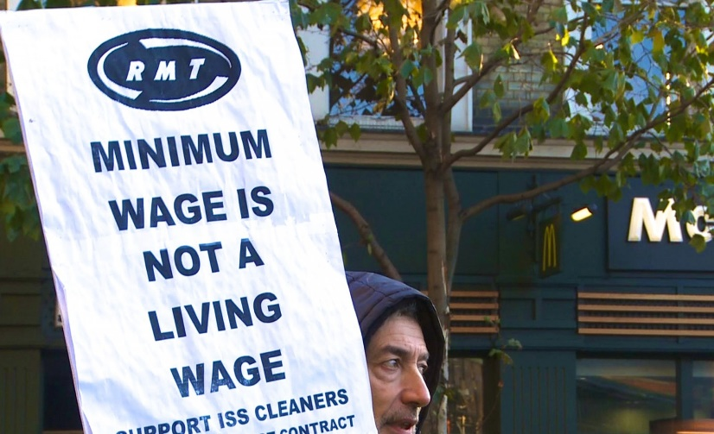









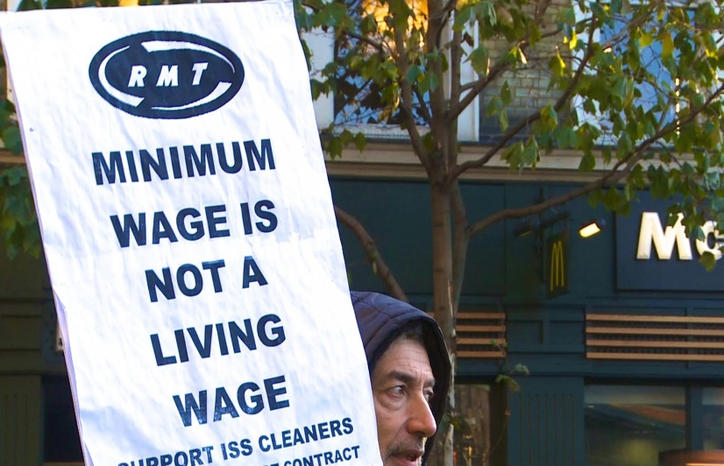



1. Which of the following is a charity of the main religious tradition in Britain? *(1 mark)*
2. Give two ways in which the poor can be helped. *(2 marks)*

*The poor can be helped by the government by… …………………………………………………………*

*…………………………………………………………………………………………………………………………………………………*

*They can also be helped by… …………………………………………………………………………………………….*

*…………………………………………………………………………………………………………………………………………………*

1. Explain two religious beliefs about helping the poor. Refer to scripture or sacred writings in your answer. *(5 marks)*

Christians will help the poor because … …………………………………………………………………………

…………………………………………………………………………………………………………………………………………………

And this means that… ………………………………………………………………………………………………………….

…………………………………………………………………………………………………………………………………………………..

………………………………………………………………………………………………………………………………………………….

They may help the poor by … ……………………………………………………………………………………………

…………………………………………………………………………………………………………………………………………………

………………………………………………………………………………………………………………………………………………….

Buddhists will also help the poor because … …………………………………………………………………..

……………………………………………………………………………………………………………………………………………………

……………………………………………………………………………………………………………………………………………………

…………………………………………………………………………………………………………………………………………………

…………………………………………………………………………………………………………………………………………………

Religion, Wealth & Poverty – Exam Questions

(a) Red Crescent (b) Karuna (c) Red Cross (d) Islamic Relief