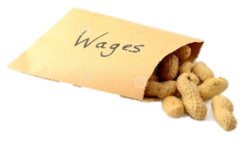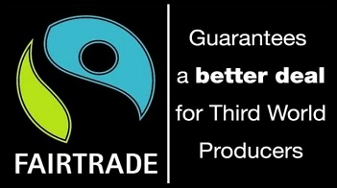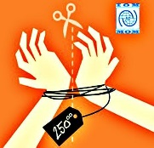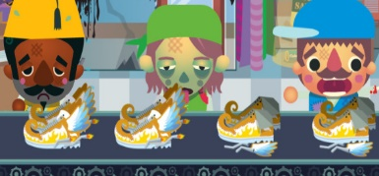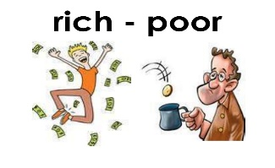

*Exploiting and Helping the poor…*

**Low wages** are a problem all over the world. In LEDCs big multinational companies often pay very low wages so they can make huge profits. This is particularly a problem in countries like Bangladesh, India and China. Workers on tea plantations in Bengal, India typically earn £1 a day. Working conditions are often very poor and hours very long. In 2013 a factory in Bangladesh that produced clothes for

companies like H&M and Primark collapsed killing over 1100 workers. Due to

such low wages and poor conditions some workers migrate to look for better

paid work which can leave them vulnerable to people traffickers and forced

labour.

**People Trafficking** is the illegal control and exploitation of people usually for forced labour and the sex industry. People wanting to escape poverty and dreadful lives may pay people smugglers to get them to developed countries in the hope of finding work and a better life. As economic migrants, rather than refugees they are illegals and easy to exploit. They often have their passports taken away from them and forced to work as domestic slaves and prostitutes. Some criminal gangs even kidnap victims to force them to work.

**Fairtrade** products are one way of trying to make pay and working conditions better for people,

particularly in LEDCs. When buying a product with the Fairtrade logo, consumers

know that the producer of that product is paid a fair price for that product and

they will being paying his workers a fair wage and will be supporting his workers’

rights. Key Fairtrade products are tea, coffee, cotton and cocoa.

**The minimum or ‘living’ wage** was introduced to set the lowest wage an employer can legally pay workers in the UK. It was designed to protect the lowest paid from exploitation. Christians supported this as they believe in a fair day’s pay for a fair day’s work. The problems employees have found now

that the ‘living wage’ has been introduced (2016) are loss of bonuses and reduced

overtime pay. Some have seen working benefits cut, leaving them worse off than

before. The new law also only applies to the over 25s.

**‘Pay day’ loans and Loan Sharks** charge people huge interest for borrowing money. Poorer people often have difficulty getting credit so if they get into difficulties they may borrow from a company (such as Wonga) that will take the risk in lending to them, but charge percentage rates in the thousands. If the loan is only for a few days and will be paid back in full very quickly this is not a problem and may even be cheaper than going overdrawn on your bank account, however if such a loan is not paid back quickly a loan of a few hundred pounds can easily turn into a loan of several thousand pounds. If the loan cannot be paid back bailiffs may be sent in to repossess property. Loan ‘sharks’ are illegal and may prey on desperate people charging excessive interest and threatening violence if the loan cannot be paid back.

Exploiting & Helping the Poor.

Things to do…

1. Use the information above to complete the table you will be given explaining ways in which the poor are exploited, with examples and the problems these types of exploitation cause for people.
2. Also explain (also on the table) how some people could do more to help themselves out of poverty. Explain what the issues might be for such people.

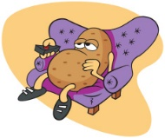

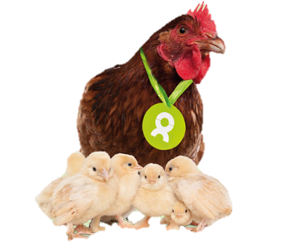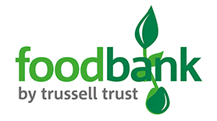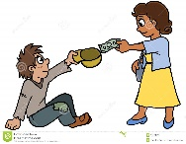

*Helping the poor…Charity and Benefits*

**Emergency Aid** – Sometimes people require immediate help with the basic needs, this might be after a

natural disaster such as a flood or earthquake. Charities such as Christian Aid and the

Red Cross help by providing temporary shelter, food, clean water and health care.

**Long-term Aid** aims to provide education, tools and training to help people get themselves out of

poverty and have a long lasting effect. Projects like ‘Oxfam Unwrapped’ are gifts bought

to help people in LEDCs. For example for £10 chickens can be bought and sent with some

training to a family in an LEDC, these chickens will produce eggs which give good

nutrition, some of the eggs will be used to breed other chickens, the fertiliser from the

chickens will help crops grow better. The extra eggs, chickens and crops can be sold to

help make the family some money which could be used to send their children to school,

giving them a more hopeful future.

**Food Banks** – Sometimes things get so desperate for people that they have to use a food bank to feed

their family. These are often run by religious organisations such as the Christian

Trussell Trust. Some of these are now providing gas and electric tokens for people

who cannot afford to pay their energy bills.

**Government Benefits** help people on very low wages, unemployed or people who cannot work. The benefits depend on your circumstances for example how much money you have saved, how many hours you work etc. Income support is around £60 per week, if you are on this benefit you may also be able to get housing benefit for help with paying council tax and rent. Unemployed people are eligible for Job Seekers allowance which is also around £60 per week but you must prove you are actively looking for work. Working Tax Credits help people who work more than 16 hours a week but are also on a very low wage. These benefits are paid for through the taxes and national insurance payments of working people.

Helping the Poor.

Things to do…

1. Use the information above and on the previous page to explain different ways in which the poor are helped.
2. Add definitions for the key terms (below) on your key terms sheet.



Key Terms …

Exploitation:

Human Trafficking:

Emergency Aid:

Long term aid:



*Misuse of power or money to get others to do things for little or unfair reward.*

*The illegal movement of people typically for the purpose of forced labour or commercial sexual exploitation*

*Also known as short term aid; help given to communities in a time of crisis, for example food during a famine or shelter after an earthquake.*

*Assistance given to communities in poor countries over a long period of time that has a long lasting effect.*