bd06662_

**Religion and Sexism**

*Society and Sexism*

*Examples of different treatment of men and women.*

* Men have normally held power. Most people live in societies controlled by male attitudes and values. Today, women do 66% of the world’s work, produce 50% of the food but get 10% of world income and own 1% of world property (source – World Bank).
* 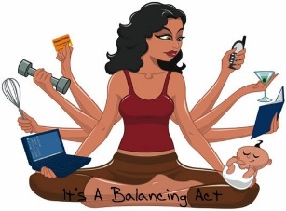Male terms are used - chairman, masterpiece, statesman, forefathers, God the Father.
* Women have been stereotyped as mothers and child-rearers. Education is still limited for girls in some parts of the world.

*The Sex Discrimination Act 1975.*

Illegal for employers to discriminate against job applicants on the basis of gender. Men and women should have equal opportunities for training and promotion.

Exceptions:

* Church did not have to have women priests.

Despite the Sex Discrimination Act 1975, all is not fair…..

* If women take time out to have children, it can mean falling behind in promotion.
* Some firms are reluctant to train women for responsible posts in case they want more time off than men, e.g. have children, or look after sick children.
* Women hold far fewer positions of power and influence.
* A small percentage of MPs are women.
* Women are the majority of churchgoers, but some Churches will not allow women leaders.

*Christianity and Sexism*

**Sexism and the Church**

* 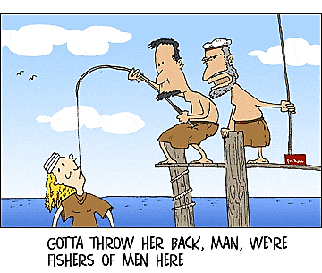Genesis 1-3: Eve is made from Adam’s rib to be his helper. Eve gave into temptation first. As a punishment God says, “Your husband will rule over you.”
* Bible Times - male-dominated.
* Men could divorce women, but not vice versa
* women - “unclean” for much of adult life (menstruation);
* God is called “Father”, “He”, “Him”, etc..
* Jesus had no female disciples;
* St. Paul - “Women should be silent in the churches”. (1 Corinthians 14:34).
* The Catholic Church does not allow women to become priests.

**Churches in favour of women priests**

* The Salvation Army have always allowed women to be ministers.
* The Church of England allowed women to become vicars in 1992, and Bishops in 2015. It caused widespread division with some male leaders, and other men and women, leaving the Church.

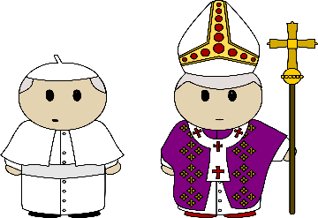**Arguments for the ordination of women**

* Jesus came to break down barriers of sex, nationality, race, etc.
* Men and women are made in the image of God.
* In the past, women weren’t allowed a leading role, but times have changed.
* Jesus chose men because women were not listened to publicly in his society. If Jesus came today, he would choose men and women without question.

**Churches against women priests**

The Roman Catholic Church and The Orthodox Church will not allow women priests. They do not see this as sexist. They say that because Jesus only had male disciples and that he handed the leadership of the Church to Peter, not a woman, men should take the leadership roles.

**Arguments against the ordination of women**

* Jesus chose men to be his Apostles and the foundation of the Church, not women.
* Jesus’ authority has been passed on through men – tradition should not be ignored.
* When celebrating Eucharist, the priest represents Christ who was a man. Women cannot play this role.

**Christians' attitudes to the role of women -** Christians disagree about the role of women.

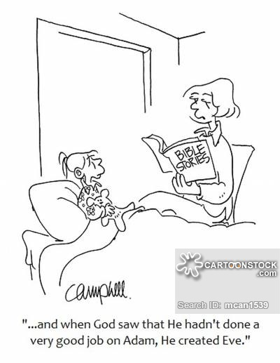Some believe men and women should be treated the same in every way, e.g. be leaders, preachers and priests, too. Christians should recognise that everyone is made in the image of God. Women should have important roles in the Church, not just arranging the flowers, organising the crèche or making tea! If a woman feels God is calling her to be a priest, who can argue?

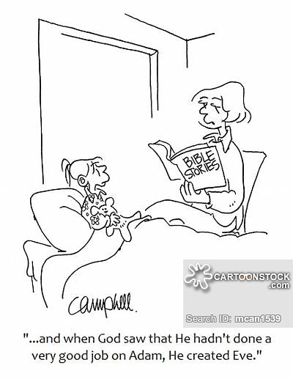Others believe that men and women are equally valuable to God, but have different roles and important differences, physical, psychological and emotional. They have different gifts which should be put to different uses. It is no good pretending that men and women are the same – they are not. Jesus did not choose men to be his Apostles by accident. Some roles in the church are more suitable for men. Who says raising a family is not important? It is the most important job in the world. We are equal, but different. Women should stop trying to be men.

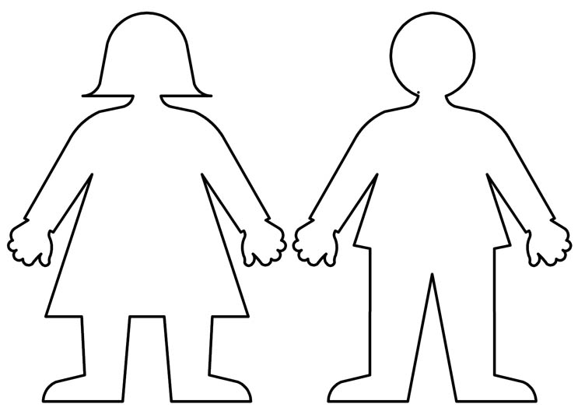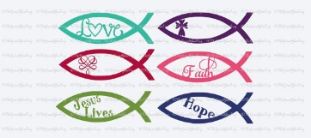

**Negative attitudes to women in the Church**

**Positive attitudes to women in the Church**