bd06662_

**Prejudice and the Law**

The Equality Act 2010 is an [Act](https://en.wikipedia.org/wiki/Act_of_Parliament) of [Parliament of the United Kingdom](https://en.wikipedia.org/wiki/Parliament_of_the_United_Kingdom). It requires equal treatment in access to employment as well as private and public services, regardless of the of age, [disability](https://en.wikipedia.org/wiki/Disability), [gender reassignment](https://en.wikipedia.org/wiki/Sex_reassignment_therapy), marriage and civil partnership, race, religion or belief, sex, and [sexual orientation](https://en.wikipedia.org/wiki/Sexual_orientation). In the case of gender, there are special protections for pregnant women. In the case of disability, employers and service providers are under a duty to make [reasonable adjustments](https://en.wikipedia.org/wiki/Reasonable_accommodation) to their workplaces to overcome barriers experienced by disabled people.

*Certain employment is exempted from the act, including:*

* Priests, monks, nuns, rabbis and ministers of religion.
* Actors and models in the film, television and fashion industries (they may need a [British Chinese](https://en.wikipedia.org/wiki/British_Chinese) actress for a specific role, for instance).
* Special employment training programmes aimed at ethnic minorities, ex-offenders, young adults, the long term unemployed, or people with physical or learning disabilities.
* Employment where there are cultural sensitivities (such as a documentary where male victims of domestic violence need to be interviewed by a male researcher, or a gay men's domestic violence helpline).
* 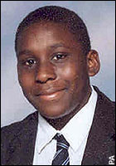Where national security could be jeopardised.

Justice.

Justice is bringing about what is right and fair. When someone breaks the law they are punished. Therefore if a person applies for a job and is not given it solely because they are disabled, then the disabled person can take the company to court. For most cases that break the Equality Act companies are usually punished with a fine and ordered to pay compensation. Some cases are much more serious.

Anthony Walker…

…was a sixth form student who was murdered with an ice axe in 2005. He was murdered by two young men, simply because he was black. Anthony’s killers were given life sentences. His mother, Gee Walker is a Christian she brought her children up to stand for peace, love and forgiveness therefore she forgives her son’s killers, she says she only feels pity for their families.

Things to do.

1. Explain how the Equality Act aims to ensure people are treated equally. In your answer include some of the groups of people the Act covers.
2. Explain why you think some religious groups are exempt from this law.
3. Explain how the Equality Act enables justice to be done when discrimination happens.
4. Briefly explain what happened to Anthony Walker. Why did his mother forgive his killers?



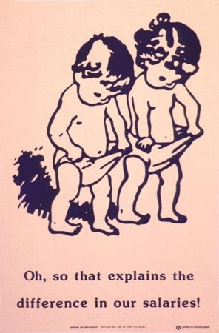

Race Relations Act 1976

Sex Discrimination Act 1975

Disability Discrimination Act 1995

Equality Act 2010

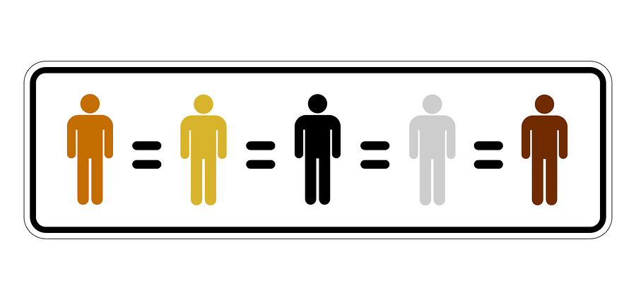



Race Relations Act 1976

Sex Discrimination Act 1975

Equality Act 2010

Disability Discrimination Act 1995