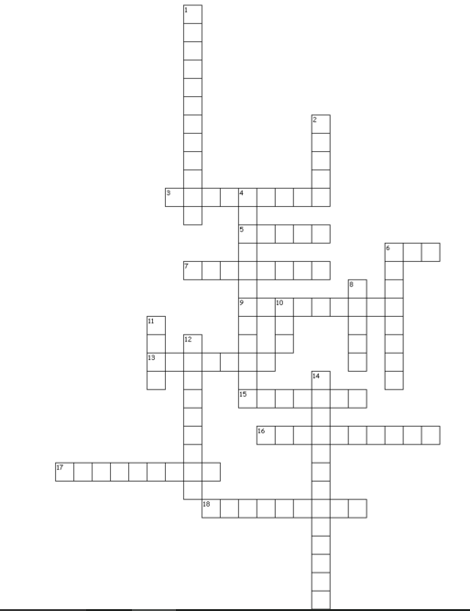

Across.

3. Event when all human rights were taken away from Jewish people.

5. Way in which some people protest

6. Initially, this man won the Noble Peace Prize

7. When people of different groups are treated fairly.

9 Buddhist leader who refuses to use violence.

13. Living in peace with others

15. This officially ended in 1833.

16. Showing loving kindness to others

17. Respecting people even if you don’t agree with their beliefs

18. Malala lost the right to this.

**Human Rights**

**& Social Justice**

Down.

1. Treating someone unfairly and misusing them in order to benefit from them.

2. China invaded this country in 1950

4. Ten rules for Christians

6. Understanding the difference between right and wrong.

8. Buddhist belief that actions have consequences.

10 System of rules enforced by the legal system.

11. Initially, a document of freedom and rights.

12. To have unfavourable views about a group of people.

14. The legal or moral duty a person has.

