- Tax Collectors
Who are they?
Jews who collected taxes from other Jews to help the Roman Empire.
Why were they disliked?
They were seen as traitors to Israel, helping the enemy oppress the people. The also used to cheat people out of money by taxing people too much and pocketing the extra money.
What was the stereotype?
Rich, dishonest, greedy, selfish traitors
How were they usually treated?
Rejected by most other Jews, hated by normal people, respectable religious people would not have anything to do with them and would not be seen with them.

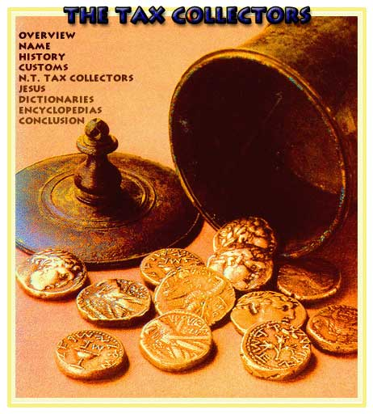
- Samaritans
Who are they?
Mixed race people from the region of Samaria which bordered on Jewish territory. They were part Israelite by ancestry but mainly Gentile (non-Jewish).
Why were they disliked?
- They had a warped version of the Jewish religion.
- Jewish travellers through Samaria were often abused, sometimes attacked and occasionally murdered by Samaritans.
What was the stereotype?
‘Dirty Gentile half-breed mongrels’ – heretics – nasty people
How were they usually treated?
Jews would have nothing to do with them; they would not speak to them or eat with them. Jews would avoid Samaria altogether even if it was inconvenient. ‘Samaritan’ was an insult word used by Jews against other Jews they didn’t like (including against Jesus).
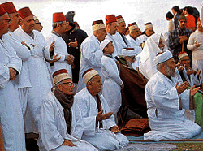

- Women
Who are they?
Female human beings.
Why were they disliked?
They were not male. They were not always disliked. Some men may have had negative experiences of women and developed a prejudice. Men often enjoyed having power over other people.
What was the stereotype?
Seen as inferior, less intelligent and unimportant. Seen by religious people as a dangerous temptation to men.
How were they usually treated?
Women should do the menial household tasks or farming tasks like giving water to the animals. “Better to burn the Torah [the Bible] than to teach it to a woman.” Many men at the time of Jesus would divorce their wives when they got bored of them and marry someone younger instead. Women had few rights.
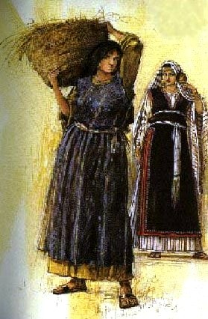
- Gentiles
Who are they?
Anyone who was not Jewish
Why were they disliked?
They were not Jewish! Gentile Romans had taken away Israel’s freedom. Gentiles worshipped pagan idols and had no respect for the one true God of Israel. They ate unclean food like pig meat.
What was the stereotype?
Uncivilised barbarian pagans who were going to hell.
How were they usually treated?
Jews would not eat with Gentiles and some would not socialise with them. Jews had to submit to the Romans or face punishment so some Jews called the ‘Sicarii’ would assassinate key Gentile leaders or Jewish collaborators.

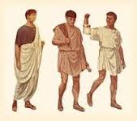
3. Lepers
Who are they?
People with skin diseases including ‘Hanson’s disease’ (proper leprosy)
Why were they disliked?
In biblical law, they were ‘unclean’ and they were a risk to others of infection. They also looked hideous because of the disease. It was often believed that they were punished by God because of their sins.
What was the stereotype?
Hideous, dirty and scary
How were they usually treated?
Not allowed to live with normal people. They had to cover their mouths, tear their clothes and shout ‘unclean’ to warn non-infected people. They could not go to a place of worship. Anyone who touched them was made unclean and had to wash. People might run from them.
