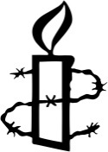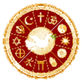bd06662_

Religions teach that their followers should obey the laws of the country in which they live. However, they also have laws, rules and guidelines of their own. Sometimes following

religious rules is difficult when a country’s laws are in opposition to those teachings.

**Religion & Human Rights**

Buddhism.

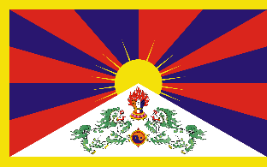

In 1950 China invaded the neighbouring country of Tibet; it is still under Chinese occupation now. Tibet is a Buddhist country, therefore the leader of the country the Dalai Lama, (the religious leader who used to rule the country), will not allow the use of violence to regain Tibetan land. The Dalai Lama lives in exile in India.

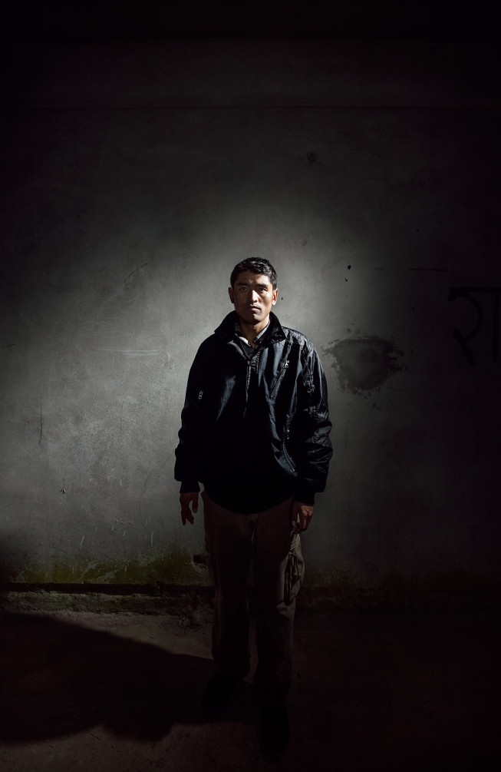Tibetans living in occupied Tibet often protest peacefully (although not always) against the Chinese occupation. This may include peaceful marches holding the banned image of the Dalai Lama, performing poems and songs celebrating Tibet's culture and throwing Chinese flags in the river. Some Tibetans have taken far more drastic action, setting themselves on fire in protest against Chinese rule.

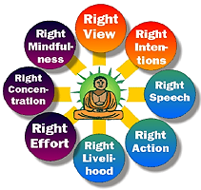In response to the protests, the Chinese government have included life imprisonment for singing Tibetan songs, writing political blogs or any form of protest. Torture is common and prisoners are denied access to families, lawyers and medical treatment. China’s response to self-immolations (setting themselves on fire) has been to punish protester’s families and blame the Dalai Lama.

Buddhists follow the Eightfold Path which includes Right Action. They also believe in wisdom and compassion. Therefore if someone is treated in an unjust way, they should take peaceful action to put things right. The Law of Karma discourages a Buddhist from carrying out actions that will cause suffering, this encourages them to support the law and human rights. Compassion for others encourages Buddhists to help people who are denied their human rights.

Things to do:

1. Explain how some Tibetans have had their Human Rights denied.
2. Give examples of how Tibetans have protested against the Chinese occupation.
3. Explain why Buddhists think it is important to support the Law and Human Rights.
4. Why do Buddhists think it is important to help people who are not getting their human rights?

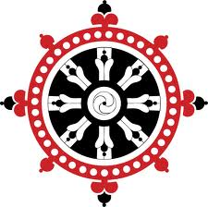

bd06662_

**Religion & Human Rights**

Christianity.

*‘Everyone who makes a practice of sinning also practices lawlessness; sin is lawlessness’.* 1 John 3:4 (from the New Testament)

The above quotation teaches Christians that they should not sin and not break the law. Christians also believe that because ‘God created everyone in his own image’ humans have ‘rights’ and that all humans should be treated fairly. However, if a law is unjust, Christians are likely to act to try to get the law changed.

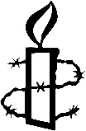Martin Luther King was a Christian Baptist Minister who led the Civil Rights Movement in the USA in the 1950s and 1960s. At this time Black people were often treated unfairly in some states America. He used peaceful protest to campaign for equal rights for blacks and whites. His most famous speech – ‘I have a dream…’ inspired millions. In it he said, ‘I have a dream that my four little children … will not be judged by the colour of their skin, but by the content of their character’. MLK and his followers protested by marching to campaign for equal voting rights, they held meetings in churches and took part in ‘sit-ins’ to make restaurants and shops serve blacks and whites equally. His work campaigning to end segregation won him the Nobel Peace Prize, but just four years later he was assassinated.

Things to do:

1. Explain, using the quotation above, Christian attitudes to the law.
2. On the sheet you will be given, note down Human Rights that link to the Ten Commandments.
3. Explain why Christians believe that all humans should have rights.



Exam Questions:

1. Give two examples of what religious believers would see as a violation of human rights. (2 marks)
2. Describe the work of a religious believer who has worked to gain human rights. (4 marks)
3. Explain different attitudes in contemporary British society to human rights. You must refer to religious views in your answer. You may also refer to non-religious views. (5 marks) Note: ‘contemporary British society’ = ‘people in Britain today’

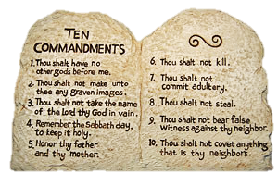

Illustration Commandment Responsibility Human Right

**The Ten Commandments**

