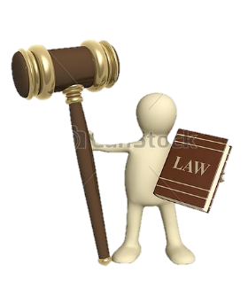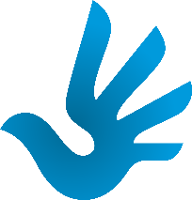bd06662_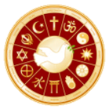

Responsibilities

With rights come responsibilities. If it is right for a person to have free speech, then with this right comes a moral responsibility not to cause upset, hatred or violence by what they say.

For example, in a class discussion where a controversial subject is being discussed

people often have strong and opposing opinions. There is a responsibility to allow

people to express their views but at the same time the views of others should be

respected and not ridiculed, even if you do not agree with them.

The responsibilities of being a citizen include respecting the rights of others and obeying the law. In 1991 the United Nations set out the rights of children in the Convention of the Rights of the Child. In it children have the right to be protected from cruelty, exploitation and neglect, therefore they have the responsibility not to bully or harm each other. Children are entitled to live in a clean environment therefore they have a responsibility to look after their environment. The same principle applies to all human rights, including the duty to respect other people’s religious beliefs.

Development of Rights

Some people are not allowed a voice to fight for their rights so other people try to do so on their behalf. Over the centuries we have gradually realised that everyone should have rights and be protected from abuse.

The first real attempt to protect Human Rights in Britain came with the signing of the Magna Carta in 1215. This is also seen as the start of modern democracy in this country as it gave people the right to speak freely in parliament and prevented the monarch from interfering with the law.

In 1833 Parliament passed the Abolition of Slavery act which gave all slaves in the British Empire their freedom. Also in the 19th century various acts of Parliament improved the lot for child workers restricting the age and hours they could work until in 1878, only children above 10 years old could work a maximum of half a day. Other acts of Parliament gave children the right to an education and the Human Rights Act became Law in 2000.

*In your exercise books…*

Note down some of the laws that improved peoples’ lives.

Rights and Responsibilities

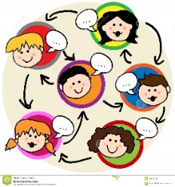

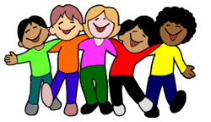

Key Terms;

* Rights – entitlements all people should have.
* Responsibility – the legal or moral duty a person has.
* The Law – a system of rules enforced by a country’s legal system with consequences for those who break them.
* Human Rights – the basic rights and freedoms to which all human beings should be entitled.

Exam question.

*Give two examples of what religious believers would see as violation of the Human Rights.*

*In your exercise books…*

*Complete the table linking the rights we have to the responsibilities of having these rights.*