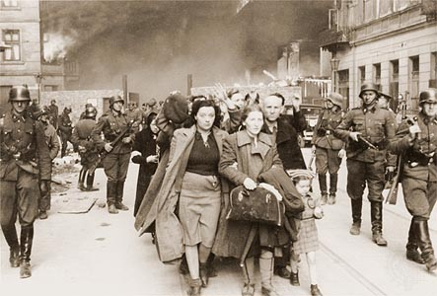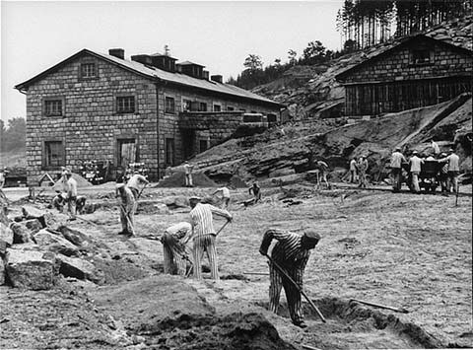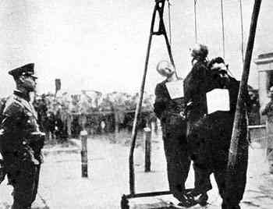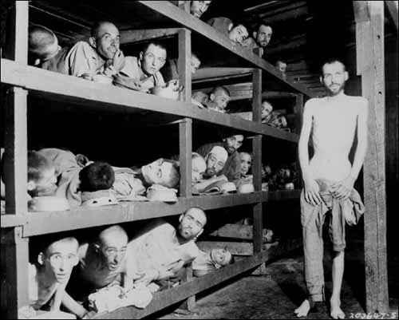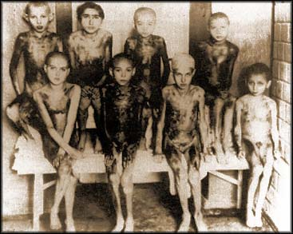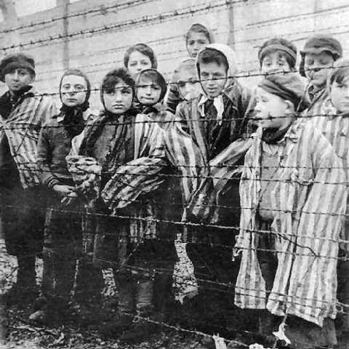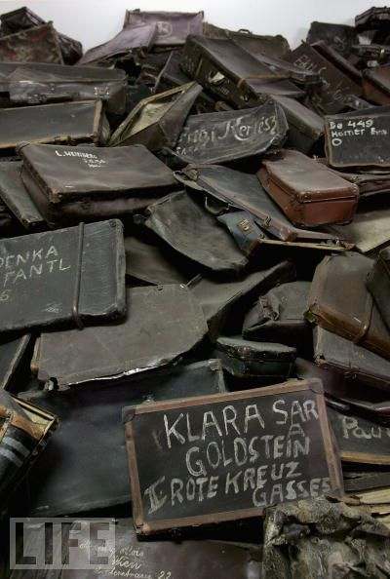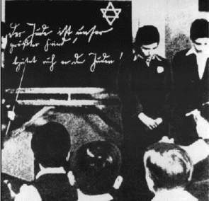

‘The wagon doors were sealed and the train set off. We had no idea were we were going. We were so cramped in the wagon that we had to take it in turns to sit with our legs stretched out. All that was provided was a metal drum for us to relieve ourselves in front of each other’

*Victoria Ancona-Vincent*

‘We were not even allowed to go to the latrines and since we suffered from persistent diarrhoea, we could not help but relieve ourselves on the spot. For this we were brutally beaten and punished’

*Victoria Ancona-Vincent*

The stars, triangles, and markings in this picture are symbols used by the [Nazis](http://www.jewishvirtuallibrary.org/jsource/Holocaust/nazitoc.html) to isolate and identify their victims. Almost everywhere under Nazi rule Jews were forced to purchase and wear a six-pointed Star of David. [Concentration camp](http://www.jewishvirtuallibrary.org/jsource/Holocaust/cc.html) prisoners wore triangular badges that identified them by their arrest category. Many badges also identified the person's race or nationality. Yellow triangles were for Jews, red triangles for political prisoners, purple for Jehovah's Witnesses, pink for [homosexuals](http://www.jewishvirtuallibrary.org/jsource/Holocaust/gay.html), green for criminals, black for [Gypsies](http://www.jewishvirtuallibrary.org/jsource/Holocaust/gypsies.html) and blue for emigrants.