**Buddhist Festivals**

Some festivals are specific to ___________ and ___________

Most major festivals celebrate _____________ __________

**Festivals – Wesak & Parinirvana Day**

An opportunity to remember ____________ life and ______________.

Some are concerned with _________ _____________ figures e.g ________________

Festivals are an opportunity to ___________ and ____________ together.

[](https://www.google.com/url?sa=i&rct=j&q=&esrc=s&source=images&cd=&cad=rja&uact=8&ved=2ahUKEwjW78HqwtThAhVixoUKHRHCD8UQjRx6BAgBEAU&url=https%3A%2F%2Fwww.kisspng.com%2Fpng-dharmachakra-buddhism-buddhist-symbolism-clip-art-785789%2F&psig=AOvVaw2CxvAWfxobW7K9SFQY6tol&ust=1555500949526255)

[](https://www.google.com/url?sa=i&rct=j&q=&esrc=s&source=images&cd=&cad=rja&uact=8&ved=2ahUKEwjZi8TPwNnhAhWrAGMBHQEyBdUQjRx6BAgBEAU&url=https%3A%2F%2Fgallery.yopriceville.com%2FFree-Clipart-Pictures%2FFlowers-PNG%2FLotus_Flower_PNG_Clip_Art_Image-1994989468&psig=AOvVaw2Hat0WfvuhzcQlJ4sPLRyC&ust=1555672155691058)

[Image result for lotus flower clipartImage result for lotus flower clipartImage result for lotus flower clipartImage result for lotus flower clipart](https://www.google.com/url?sa=i&rct=j&q=&esrc=s&source=images&cd=&cad=rja&uact=8&ved=2ahUKEwjZi8TPwNnhAhWrAGMBHQEyBdUQjRx6BAgBEAU&url=https%3A%2F%2Fgallery.yopriceville.com%2FFree-Clipart-Pictures%2FFlowers-PNG%2FLotus_Flower_PNG_Clip_Art_Image-1994989468&psig=AOvVaw2Hat0WfvuhzcQlJ4sPLRyC&ust=1555672155691058)

Vassa - an ____________ retreat when ________________ monks spend more time ____________ and ______________________.

A period of time ____________ _________ from regular ______ to focus on ________________ __________________.

**Buddhist Retreats**

Held in __________ & ________ __________

May involve ________________, __________, study ___________ and _______________.

Aim to help people ___________ their _______________ of Buddhist ______________.

*Wesak.*

1. Commemorates Buddha’s ___________, _____________________ and _____________ ___________.

2. An opportunity to ______________ and _____________________ ________________ and his _____________________.

3. Lights are used to symbolise __________, ____________________ and ___________________ _______________________.

Significance

& meaning

[](https://www.google.com/url?sa=i&rct=j&q=&esrc=s&source=images&cd=&cad=rja&uact=8&ved=2ahUKEwjvpJWMzdnhAhUFWxoKHRcgBqYQjRx6BAgBEAU&url=https%3A%2F%2Fwww.123rf.com%2Fphoto_77589982_stock-vector-happy-vesak-day-.html&psig=AOvVaw0205AImCVnS-KBUH9EkKUD&ust=1555675518129109)

*Wesak.*

1. Buddhists may light up their ___________ with _______________, _____________ or __________________.

2. They will make ____________________ to ________________ and give ___________ to the local ____________________.

3. They will take part in _______________ and __________________ or listen to _____________________ about ________________ life and ________________ at a ___________ or ___________________.

4. In ____________________ they may take part in the ___________ of caged _________________ as a symbol of ___________________.

Celebrations

[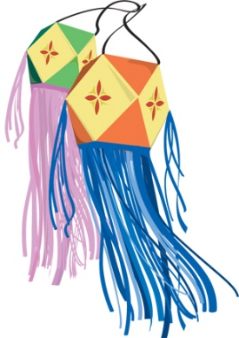](https://www.google.com/url?sa=i&rct=j&q=&esrc=s&source=images&cd=&cad=rja&uact=8&ved=2ahUKEwj4r_uAzNnhAhVRxhoKHRAID2oQjRx6BAgBEAU&url=https%3A%2F%2Fscubasanmateo.com%2Fexplore%2Flantern-clipart-vesak%2F&psig=AOvVaw3v1o6o53Mi9Uc525jfZy5u&ust=1555675230538076)

[](https://www.google.com/url?sa=i&rct=j&q=&esrc=s&source=images&cd=&cad=rja&uact=8&ved=2ahUKEwjW78HqwtThAhVixoUKHRHCD8UQjRx6BAgBEAU&url=https%3A%2F%2Fwww.kisspng.com%2Fpng-dharmachakra-buddhism-buddhist-symbolism-clip-art-785789%2F&psig=AOvVaw2CxvAWfxobW7K9SFQY6tol&ust=1555500949526255)

1. Celebrated in _________________ to remember ______________ passing into _________________ (the final state of ______________)

2. A ______________ occasion when Buddhists _______________ on their own future __________ and remember friends and __________ who have ______________ ____________.

3. The teaching of _________________ (anicca) is a focus for the day.

*Parinirvana*

*Day.*

Significance

& meaning

[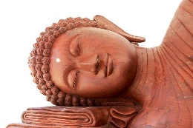](https://www.google.com/url?sa=i&rct=j&q=&esrc=s&source=images&cd=&cad=rja&uact=8&ved=2ahUKEwiRjISK4dnhAhUHQBoKHYtKBjYQjRx6BAgBEAU&url=https%3A%2F%2Fthebuddhistcentre.com%2Fportsmouth%2Fparinirvana-day&psig=AOvVaw2IhYZ0f54sqmN7SaXYfTxc&ust=1555680858591987)

*Parinivana*

*Day.*

1. Buddhists read and ____________ scriptures that _____________ Buddha’s __________ _________.

2. They will ________________ and ______________ at __________ or with others in a _______________ or _____________________.

3. They may go on a ______________ to ________________ and ___________________ or go on a _______________________ e.g. to visit ___________________ in India, where Buddha ______________ ____________.

Celebrations

[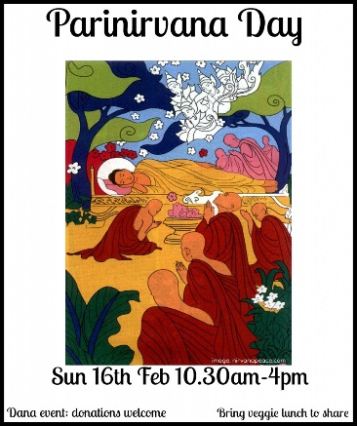](https://www.google.com/url?sa=i&rct=j&q=&esrc=s&source=images&cd=&cad=rja&uact=8&ved=2ahUKEwjw4rqz4tnhAhUKx4UKHWdRC6gQjRx6BAgBEAU&url=https%3A%2F%2Fthebuddhistcentre.com%2Ftags%2Fparinirvana&psig=AOvVaw1XeSFoOGYo-4dKVpKZ81VU&ust=1555681134708205)

[](https://www.google.com/url?sa=i&rct=j&q=&esrc=s&source=images&cd=&cad=rja&uact=8&ved=2ahUKEwjZi8TPwNnhAhWrAGMBHQEyBdUQjRx6BAgBEAU&url=https%3A%2F%2Fgallery.yopriceville.com%2FFree-Clipart-Pictures%2FFlowers-PNG%2FLotus_Flower_PNG_Clip_Art_Image-1994989468&psig=AOvVaw2Hat0WfvuhzcQlJ4sPLRyC&ust=1555672155691058)

**Karma & Rebirth**

*The basics;*

Karma is an _____________ principle. It teaches that it is not just the ____________ that is important but also the _____________________ behind it. Karma explains how the __________________ behind a person’s _______________ lead to ____________________ or ____________________.

|  |  |  |
| --- | --- | --- |
|  | **Actions** | **Results** |
| Type of Action | Skilful (good, ____________ actions  or _____________________. | Unskilful (_______ unethical  actions or _______________ |
| Motivated by | Generosity, ___________________,  _____________________. | _________________ hatred,  ______________________. |
| Results in | ______________________ | ___________________ |

Buddhists believe that a person’s _________________ in this life affect their __________________ and ____________________ now and in the _____________. Depending on their _______________, they will be ______________ into one of the ________ realms of the wheel of _________. By developing ___________________ mental _____________ and ______________ Buddhists can life a _______________ life and lay the ground for a _____________________ rebirth. The hope is to be _____________ into the ______________ realm which is the ____________ realm for reaching ____________________.

Karma & Rebirth

_______________ realm

[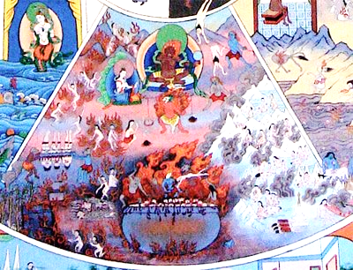](https://www.google.com/url?sa=i&rct=j&q=&esrc=s&source=images&cd=&ved=2ahUKEwi0jp_G9t7hAhXOxYUKHfI2CtQQjRx6BAgBEAU&url=https%3A%2F%2Fwww.tibetanbuddhistaltar.org%2Fhells%2F&psig=AOvVaw0HhRFJpAijREwnRDE3CtJQ&ust=1555858342121697)

**Buddhist Ethics**

[](https://www.google.com/url?sa=i&rct=j&q=&esrc=s&source=images&cd=&cad=rja&uact=8&ved=2ahUKEwjT6vXEsNzhAhUExIUKHeASCq4QjRx6BAgBEAU&url=http%3A%2F%2Fkmxt.org%2Fgraphic-happy-kids-people-helping-others-clipart-1-from-worldartsme-com%2F&psig=AOvVaw1dpUWvKkSg1OZ5a6k98hNl&ust=1555770909891853)[](https://www.google.com/url?sa=i&rct=j&q=&esrc=s&source=images&cd=&cad=rja&uact=8&ved=2ahUKEwiow5Cqo9zhAhUQhRoKHRwwD1YQjRx6BAgBEAU&url=http%3A%2F%2Fworldartsme.com%2Fherd-of-animals-clipart.html&psig=AOvVaw0zyCmkp2tJ-TCFsZuCg1MB&ust=1555767382496423)

Believing that a person’s ____________ causes their ________________ or ___________________ is motivation to live in a more _____________ way. Acting skilfully (_________________) reduces suffering for _______________ and ______________ and enables progress on the path to ________________

___________ beings

(hell realm)

____________ realm

Realm of the

________

__________

gods

[](https://www.google.com/url?sa=i&rct=j&q=&esrc=s&source=images&cd=&cad=rja&uact=8&ved=2ahUKEwid7fOf8t7hAhXLz4UKHR1kBNsQjRx6BAgBEAU&url=https%3A%2F%2Fwww.arrowriver.ca%2Fwheel%2Fheaven.html&psig=AOvVaw1fnDRbAsyf74wyfKxMNNct&ust=1555857292497320)[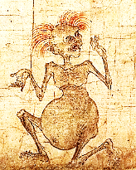](https://www.google.com/url?sa=i&rct=j&q=&esrc=s&source=images&cd=&cad=rja&uact=8&ved=2ahUKEwiKmOPCrdzhAhXEzIUKHTj1CTYQjRx6BAgBEAU&url=https%3A%2F%2Ftwitter.com%2Frichmond_lee%2Fstatus%2F806888408953958401&psig=AOvVaw2f52CnNCgHEBF3f4WmN0pq&ust=1555770008960362)

[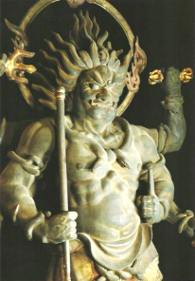](https://vignette.wikia.nocookie.net/fictional-battle-omniverse/images/5/51/Asura_Hinduism.png/revision/latest?cb=20170130070324)

[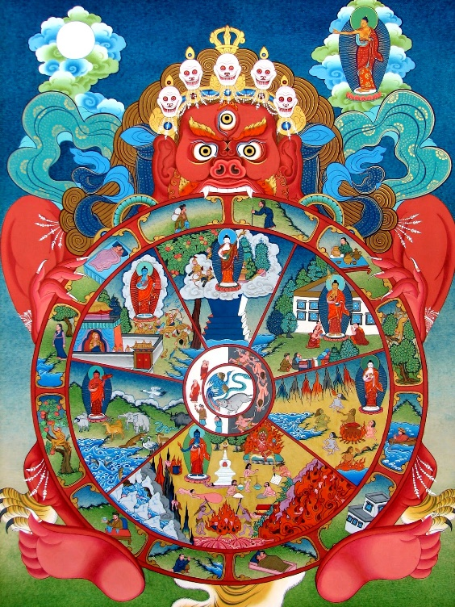](https://www.google.com/url?sa=i&rct=j&q=&esrc=s&source=images&cd=&cad=rja&uact=8&ved=2ahUKEwiEosXC_97hAhUPUhoKHauaAgAQjRx6BAgBEAU&url=http%3A%2F%2Fcpdaush.org%2Fwp-content%2Fgallery%2Fdiplo%2Fpdf.php%3Fq%3Dla-cosm%25C3%25A9tique-bio-2008.html&psig=AOvVaw0fiOOJkrykjOOUl5dkRxqa&ust=1555860837628077)

Skilful behaviour includes following the five _______________, helping the _____________ acting ____________________ and not __________________ life.

____________ ghosts (pretas)

[](https://www.google.com/url?sa=i&rct=j&q=&esrc=s&source=images&cd=&cad=rja&uact=8&ved=2ahUKEwiukcWTgN_hAhXC34UKHZIFBWoQjRx6BAgBEAU&url=https%3A%2F%2Fspirylife.com%2Fproducts%2Fwatercolor-buddha-art&psig=AOvVaw2xH-a6NMJrCyX27LVch5Ud&ust=1555860956150789)

[](https://www.google.com/url?sa=i&rct=j&q=&esrc=s&source=images&cd=&cad=rja&uact=8&ved=2ahUKEwjQlcfZgN_hAhVJURoKHY5JD5YQjRx6BAgBEAU&url=https%3A%2F%2Fwww.dhgate.com%2Fproduct%2Fbuddha-lotus-poster-canvas-painting-modern%2F419753937.html&psig=AOvVaw2xH-a6NMJrCyX27LVch5Ud&ust=1555860956150789)