*The basics;*

Buddhist funeral practices __________ between different Buddhist traditions.

Death is not seen as an _______, but a ________________ from one life to the next. Buddhists believe that, at death, ______________ energy leaves the body and is _____________ into a new one.

**Death & Mourning Rituals**

[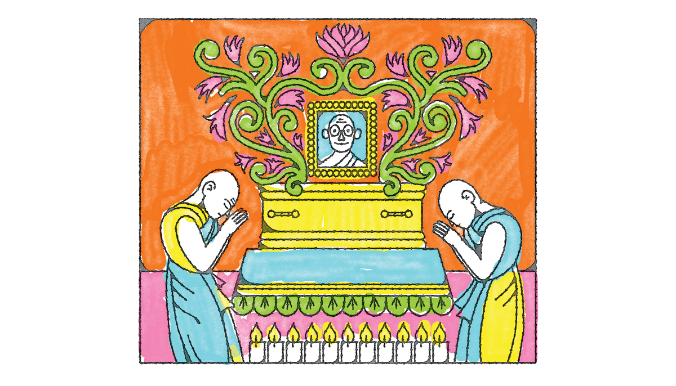](https://www.google.com/url?sa=i&rct=j&q=&esrc=s&source=images&cd=&ved=2ahUKEwj9ssnBtNfhAhVBXhoKHWWnCj8QjRx6BAgBEAU&url=https%3A%2F%2Fwww.lionsroar.com%2Fwhat-happens-at-a-buddhist-funeral%2F&psig=AOvVaw0g36QXMGwx9UMEfvPQ6jaQ&ust=1555600150521353)

[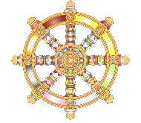](https://www.google.com/url?sa=i&rct=j&q=&esrc=s&source=images&cd=&cad=rja&uact=8&ved=2ahUKEwjW78HqwtThAhVixoUKHRHCD8UQjRx6BAgBEAU&url=https%3A%2F%2Fwww.kisspng.com%2Fpng-dharmachakra-buddhism-buddhist-symbolism-clip-art-785789%2F&psig=AOvVaw2CxvAWfxobW7K9SFQY6tol&ust=1555500949526255)

*Theravada funerals.*

1. Little ____________ is spent on funerals, instead money may be ______________ to a ______________ cause and ______________ the merit to the _____________ person to help them have a _____________________ rebirth.

2. Other rituals to transfer ____________ to the __________________ may include offering _____________ to make new ____________ to a ____________________.

3. At the funeral a ____________ may display the ___________________ portrait as well as an image of ____________. Monks often attend funerals and perform _____________ or give a _______________. ____________________ of the deceased is more common than ________________. Mourners send good _______________ to the family and contemplate ____________________ (anicca).

*Tibetan funerals.*

1. Sky _____________ is a traditional funeral practice in ______________. The body is left in a __________ place as a _________ to the _______________. The practice arose due to ___________ of wood for ________________, however it is now more common to __________ the __________.

2. Important teachers are always _________________ and their remains placed in a _______________ to became a site of ________________.

3. Ceremonies involving _______________ and offerings of butter ___________ may be made every ___________ days for _______________ days after the death.

[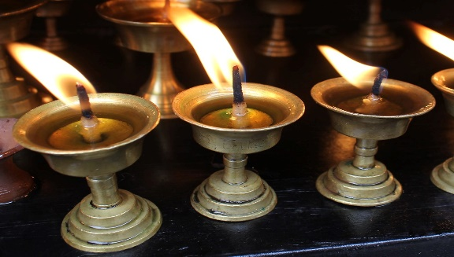](https://www.google.com/url?sa=i&rct=j&q=&esrc=s&source=images&cd=&cad=rja&uact=8&ved=2ahUKEwivxJ-OtdfhAhVOxoUKHdjADWsQjRx6BAgBEAU&url=https%3A%2F%2Fhiveminer.com%2FTags%2Flamp%252Ctibetan&psig=AOvVaw23C7xQacjYUW2ibEQ13e56&ust=1555600355897698)

*Japanese Pure Land Buddhist funerals.*

The coffin is placed pointing _________, towards the direction of _____________ the people assembled will chant ________________ as the process around the ___________. After the body is ___________________ bones are picked out of the _________ with _________________. The remains may be kept for _______________ days and prayers offered every ______________ day.

[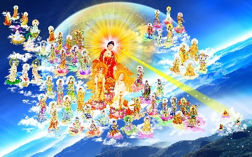](https://www.google.com/url?sa=i&rct=j&q=&esrc=s&source=images&cd=&cad=rja&uact=8&ved=2ahUKEwjCx6i1t9fhAhUS1BoKHdJrBK4QjRx6BAgBEAU&url=http%3A%2F%2Fwww.voluongthophat.com%2FHINH_PHAT_DEP%2F12%2F&psig=AOvVaw0ZxxPlSS7lIXX44SW-8Mtd&ust=1555600952372168)