*What is visualisation?*

1. The meditator __________________ (imagines) an _____________in their mind.

2. They may first use an ____________ for ________________ and then visualise it.

3. They then try to ______________ the object in ___________ ______________, examining all the ____________________ of it.

4. The object is a focus of ____________________, the meditator will hold a ________________ _______________ of the object in their ___________ for as long as ________________.

**The visualisation of Buddhas and Bodhisattvas**

[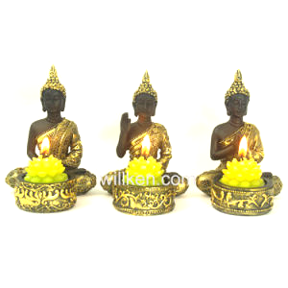](https://www.google.com/url?sa=i&rct=j&q=&esrc=s&source=images&cd=&cad=rja&uact=8&ved=2ahUKEwig9579jNfhAhWyx4UKHSJnCicQjRx6BAgBEAU&url=https%3A%2F%2Fwillken.en.made-in-china.com%2Fproduct%2FmNsnEieCaUVJ%2FChina-New-Resin-Gold-Color-Small-Buddha-Statue-Candle-Holder.html&psig=AOvVaw2irkns9zB0drcm6zG1WmHQ&ust=1555589575840113)[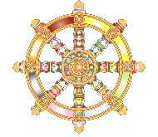](https://www.google.com/url?sa=i&rct=j&q=&esrc=s&source=images&cd=&cad=rja&uact=8&ved=2ahUKEwjW78HqwtThAhVixoUKHRHCD8UQjRx6BAgBEAU&url=https%3A%2F%2Fwww.kisspng.com%2Fpng-dharmachakra-buddhism-buddhist-symbolism-clip-art-785789%2F&psig=AOvVaw2CxvAWfxobW7K9SFQY6tol&ust=1555500949526255)

*Deity visualisation.*

Tibetan Buddhists often visualise a ____________, an ______________________ being such as _____________ or a _____________________ (not gods). The meditator focuses on its ____________ and _________________ qualities. They may _____________ themselves as that __________ in order to _____________ its _____________ qualities. Visualising themselves as a ______________ may help Buddhists to awaken their _______________-nature.

Examples of Buddhas or Bodhisattvas meditators might visualise.

Medicine Buddha

[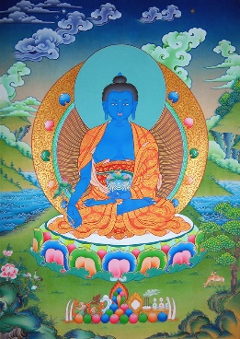](https://www.google.com/url?sa=i&rct=j&q=&esrc=s&source=images&cd=&cad=rja&uact=8&ved=2ahUKEwiKx9Ghh9fhAhXuThUIHU0OA2AQjRx6BAgBEAU&url=https%3A%2F%2Fwww.beatrex.com%2Fbuddha%2F&psig=AOvVaw0eKOmVqB7Se92KJKAv_G1B&ust=1555586705325121)

Buddha Amitabha

Avalokitesharva

Visualisation of the Buddha of ___________ may reduce _________________ and promote _______________.

[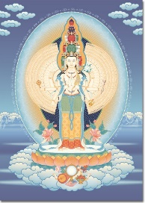](https://www.google.com/url?sa=i&rct=j&q=&esrc=s&source=images&cd=&ved=2ahUKEwj2zOqrhtfhAhX7ShUIHY_dCoEQjRx6BAgBEAU&url=https%3A%2F%2Ftharpa.com%2Fuk%2Favalokiteshvara-1000-armed-2.html&psig=AOvVaw0KS0dBJVg-UasIivVKW1jx&ust=1555586931185103)

Visualisation of the Bodhisattva of ____________________ helps Buddhists develop a sense of __________________.

[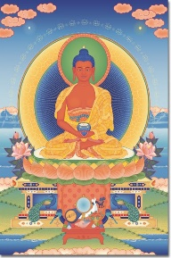](https://www.google.com/url?sa=i&rct=j&q=&esrc=s&source=images&cd=&cad=rja&uact=8&ved=2ahUKEwiE8KrHhNfhAhXBrHEKHdehBUQQjRx6BAgBEAU&url=https%3A%2F%2Ftharpa.com%2Fus%2Famitabha-2.html&psig=AOvVaw05PPWiJbsGooFW_dtqjdNW&ust=1555587316442842)

Pure _________ Buddhists believe that visualisation of Buddha _____________ will help them to be _____________ in the _________ land.

*Visualisation using Thangkas and Mandalas.*

Thangkas are paintings of ______________ or _____________________.

Mandalas are _________________ colourful patterns made of sand. They represent Buddhist _______________ such as compassion or a ____________. They can take ____________ to create and once finished they are ______________ away. They symbolise ____________________ (anicca).

[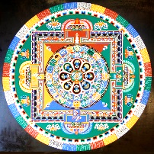](https://www.google.com/url?sa=i&rct=j&q=&esrc=s&source=images&cd=&cad=rja&uact=8&ved=2ahUKEwi20ZqTi9fhAhUQNhoKHQEuA9gQjRx6BAgBEAU&url=https%3A%2F%2Fwww.hancockcollege.edu%2Fpublic_affairs%2Fannouncements%2F2017Aug9TibetanMonks.php&psig=AOvVaw0l6AhlD2aQ9-0G-NhGV3cK&ust=1555588989720419)