Buddhist Meditation

Four types of Buddhist meditation;

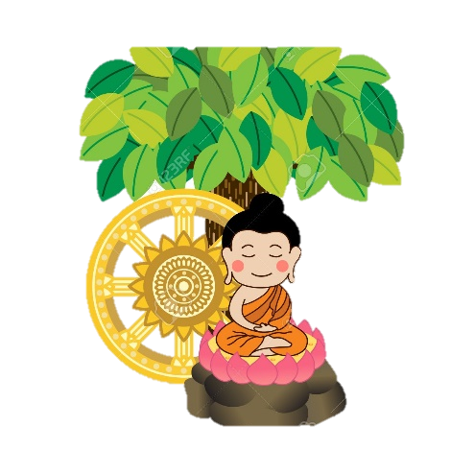

Why do Buddhists meditate?

1. It _________ the mind and ________ and helps the development of ___________ into the nature of __________________.

2. A range of meditation techniques help Buddhists develop ________________ (calmness) and ___________________ (insight).

3. Meditation often starts with ____________________ of the _______ and breath.

4. Buddhists may use things as a focus for __________________ such as certain ________________ traits or _______________, breathing an _____________ or a statue of _____________ (Buddharupa).

Samatha meditation.

1. The breath is used as a focus for ________________ and how the __________ responds to each ____________ with the aim of becoming _____________ of the details of _________________ and all the __________ movements it creates in the __________.

2. If the mind ______________ as they meditate, they bring their attention back to their ________________.

3. Gradually they become more able to ________________ and focus on their ____________ leading them to feel more ________________ and _____________.

4. Sometimes _______________ are used instead of _________________ to focus. There are ______ kasinas including elements such as ___________, _________ and ____________ and colours such as _________, _______ and ______________. For example, the meditator could focus on a _________ of ____________ or a _______ circle.

5. Aims of samatha meditation include; creating a _________ and ______________ mind; developing _________________ and ____________; as preparation for __________________ meditation; to feel _________________.

Vipassana meditation.

Often called ‘___________ _______________’ the aim is to _________ insight into the true _______________ of ____________, usually reflecting on the ___________ marks of ________________. Other aims of vipassana __________________ include developing _____________ and awareness of the ____________ and to ultimately achieve ___________________.

Buddhist Meditation

Similarities & differences between samatha and vipassana meditation.

Samatha Meditation  Both use the same ____________________ of ______________________ and focus on ________________ things in a __________ and ___________________ manner. | Vipassana
The meditator focuses on one _________ object or __________ e.g. a _________ triangle or a ____________ __________. | The meditator may ____________ their focus between ______________ objects, _____________ and ________________ e.g. a feeling of ______________ or the sound of _________ ______________.
The aim of focusing on the object is to develop _________________ and ________ e.g. the meditator focuses on their ____________ to become _____________ and more ___________ | The aim of focusing on the object is to _________________ its _________ ____________ and the three _________ of ________________ e.g. the meditator thinks about how their ____________ shows the _________________ of the ___________ marks of ______________.

Walking meditation.

Buddhists sometimes meditate while _____________. This consists of walking ____________ and ______________ the movement of the _________ with the in and ________ of the ______________.

Zazen meditation.

Zazen means ____________ meditation. It is practiced in _______ Buddhism, which is popular in ___________.
It begins with _____________ relaxing and a period of _________________ of _________________. The meditator sits with __________________ of the __________________. Thoughts come and go but the _______________ always returns to the _______________

