[](https://www.google.com/url?sa=i&rct=j&q=&esrc=s&source=images&cd=&ved=2ahUKEwi-mvnlrtLhAhUGtRoKHV_TDxwQjRx6BAgBEAU&url=https%3A%2F%2Fwww.vectorstock.com%2Froyalty-free-vector%2Flotus-flower-border-vector-1734899&psig=AOvVaw1MgCICEUInYQdbQGZBgSc6&ust=1555426549710035)

*Types of Buddhist worship*

**Buddhist Worship**

*Types of Buddhist worship (puja);*

____________ is usually the focus of worship. Worship helps Buddhists to…

1. Express ___________________________________________________________

2. Deepen their _______________________________________________________

3. Move closer to _____________________________________________________

Types of

Buddhist Worship

[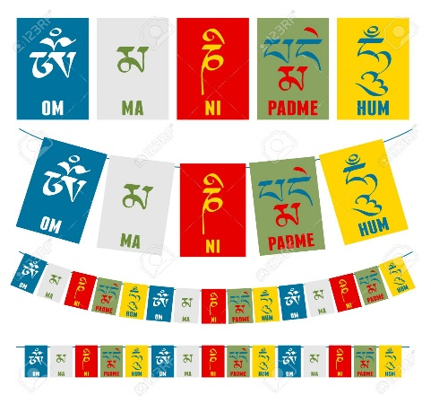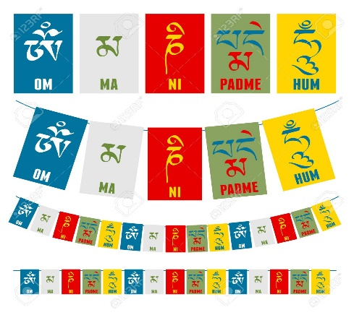](https://www.google.com/url?sa=i&rct=j&q=&esrc=s&source=images&cd=&cad=rja&uact=8&ved=2ahUKEwiTkZDxwdLhAhUPzoUKHQY6BYMQjRx6BAgBEAU&url=https%3A%2F%2Fwww.123rf.com%2Fphoto_60914273_stock-vector-sanskrit-calligraphy-of-buddhist-mantra-om-mani-padme-hum-on-multicolored-flags-.html&psig=AOvVaw2ibMxGKMw29uuIqJDNnKBy&ust=1555431970135203)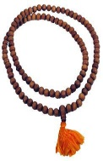

*Mantras…* … are sequences of _____________ _________________ that are ______________ out loud or _____________ in the _________.

1. Mantras help to ____________________________________________________

2. Mantras are often associated with _____________________________________ ___________________________________________________________________

3. A common mantra is _______________________________________________ it helps Buddhists connect with ___________________________________________.

*Chanting;* In the early days, Buddhist ____________ texts were remembered and ____________ orally, they were not ______________ down. Chanting was used to _______________ and pass on _________________.

*Now chanting …*

1. … is a ____________________________________________________________

2. …helps to _________________________________________________________

3. …might include _____________________________________________________