[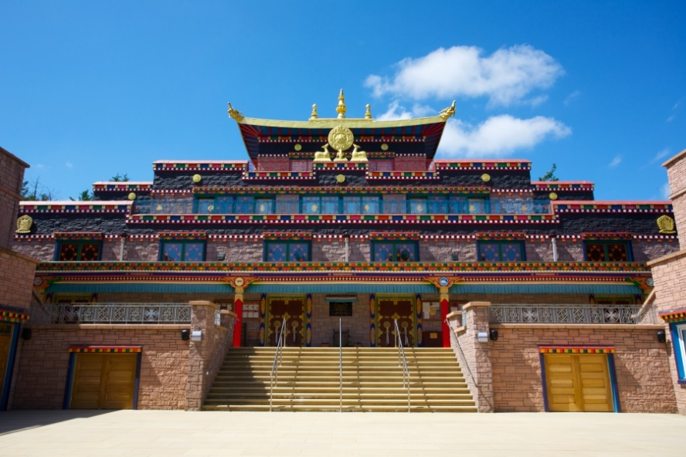](https://www.google.com/url?sa=i&rct=j&q=&esrc=s&source=images&cd=&cad=rja&uact=8&ved=2ahUKEwjhs9DF-crhAhVCPBoKHcoPC5MQjRx6BAgBEAU&url=https%3A%2F%2Fwww.weatherforecast.co.uk%2Funited-kingdom%2Fscotland%2Fdumfries-and-galloway%2Flangholm%2Fkagyu-samye-ling-monastery-and-tibetan-centre-19987.html&psig=AOvVaw10XnagraN0h1_1Zvdg9T7w&ust=1555171890646035)

*There are three main types of place of worship for Buddhists;*

Temples: Where Buddhists can _________,

_____________ and ______________

together. The main ________ contains a

_____________________ (statue of Buddha).

This may also be the ___________________

hall, a quiet space where Buddhists can

________________. The shrine room also

has statues of _____________ and shrines

where offerings can be placed. A stupa is a ____________ tower that contains remains or _____________ of an important _____________. These are often in the gardens of a temple.

**Places of Worship**

[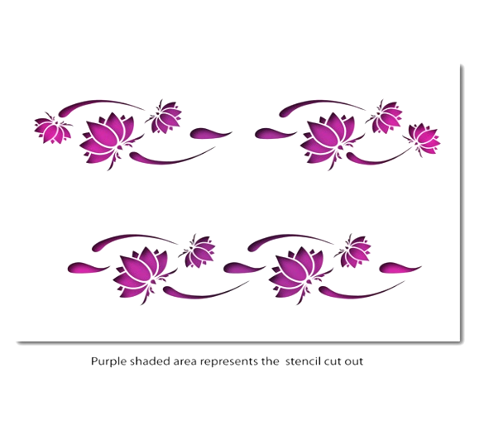](https://www.google.com/url?sa=i&rct=j&q=&esrc=s&source=images&cd=&cad=rja&uact=8&ved=2ahUKEwiLifnA5s_fAhXDzIUKHUHqAvEQjRx6BAgBEAU&url=https://www.ebay.co.uk/itm/Lotus-Flower-Border-Stencil-CraftStar-Laser-Cut-Border-Stencil-/262841266351&psig=AOvVaw2DtDj2nP2DauqJ-cM9HIQS&ust=1546542627994322)

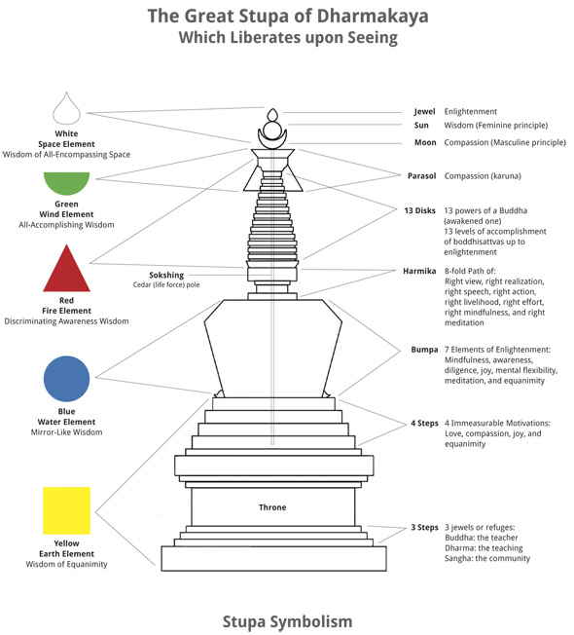

Label the diagram with the symbolism of the stupa.



*Monasteries…* … are places where __________ or ________ live a ___________, __________________ life of _____________, __________________ and companionship. A ____________ is often an important part of a __________________.

*Shrines…* …are found in _____________, ________________ and in peoples’ homes. They provide a ____________ ____________ for Buddhists to _______________ and express _____________. They make _______________ at shrines to show thanks for ___________ teachings.

***On a shrine you will find…***

**Light/Candles** – Symbolise _____________ and _______________ driving away ______________.

**Flowers** – as they ________ and _______ they remind Buddhists of anicca (__________________)

**Incense** – symbolise ___________ and reminds Buddhists to practice _________ ______________, ______________ and _______________________.