**Becoming an Arhat.**

For ____________________ Buddhists an Arhat is a ‘_______________ _____________’ who has overcome the main causes of ____________________ (dukkha), - the three ______________ of ______________, ______________ and _____________________ to achieve ______________________. When someone becomes an ______________they are no longer ___________________ when they die. This means they are ______________ from ____________________ and the ________________ of birth, _____________ and rebirth (________________). They attain ________________. This goal is achieved by following the ______________________ Path.

The Arhat & Bodhisattva

Mahayana Buddhists sometimes use the term ______________ to refer to someone who is far along the path to _______________________ but has not yet become _____________________. The ideal, however, for a ___________________ Buddhist, is to become a _____________________ rather than an Arhat.

**The Six Perfections.**

A person becomes a __________________ by perfecting certain attributes know as the Six _____________________:

1. ____________________ to be

_________________ and generous.

2. ________________ to live with good

______________ and ethical behaviour.

3. ________________ to be patient and

calm in all things.

4. ____________ to cultivate __________

and _______________________ .

5. _________________ to develop

_______________ and _______________.

6. ____________ to obtain ____________

and _____________________.

**Becoming a Bodhisattva.**

A Bodhisattva is an ___________________ being who, out of ____________________ remains in the cycle of ________________ in order to help others achieve ____________________ as well.

Bodhisattvas combine being _______________________ with being wise. Bodhisattvas

aim to follow Buddha’s teaching to his disciples to ‘________________________ __________________________________’

[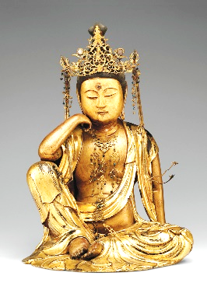](https://www.google.co.uk/url?sa=i&rct=j&q=&esrc=s&source=images&cd=&ved=2ahUKEwj8ju2knqzhAhVRWxoKHdlNC0wQjRx6BAgBEAU&url=https://www.lionsroar.com/who-is-avalokiteshvara/&psig=AOvVaw077wDu9cYUw13xl_B5CF50&ust=1554116711017357)

**Bodhisattva Vows.**

However innumerable

beings are, I vow to meet

them with kindness and

interest.

However inexhaustible the states of suffering are, I vow to touch them

with patience and love.

However immeasurable the Dharmas are, I vow to explore them deeply.

However incomparable the mystery of interbeing, I vow to surrender to it freely. *Thich Nhat Hanh*

[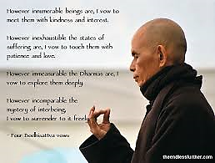](https://www.google.co.uk/url?sa=i&rct=j&q=&esrc=s&source=images&cd=&ved=2ahUKEwjV0Lf2n6zhAhVHrxoKHc98BdAQjRx6BAgBEAU&url=http://theendlessfurther.com/tag/bodhisattva-path/&psig=AOvVaw1Al6p24fRMp2Jkd7-JMHl4&ust=1554117204682645)