**What is Mahayana Buddhism?**

Mahayana ____________________ is a term used to describe a number of different ____________________ that share some _______________________. Some of the main Mahayana traditions include ____________ ____________, _________, and ____________________. Whilst Theravada Buddhists believe Buddha to be simply a _________________ figure and cannot _________________ with the world. In _________________, Mahayana Buddhists believe that _______________ remains active and can _____________________ the world. He can be encountered through _______________ and ______________________ . He can ______________________ himself in different _____________, ________________ and ___________________.

One of the differences between Theravada and ______________________ Buddhism is how _______________________ can be achieved.

**Mahayana Buddhism**

[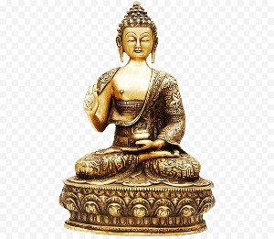](https://www.google.co.uk/url?sa=i&rct=j&q=&esrc=s&source=images&cd=&cad=rja&uact=8&ved=2ahUKEwjQ1uCCjKzhAhUGA2MBHdjQBo0QjRx6BAgBEAU&url=https://www.kisspng.com/png-india-gautama-buddha-statue-buddha-472375/&psig=AOvVaw2lVVBC2m5lxyEKQJlHxtYS&ust=1554110514743119)

[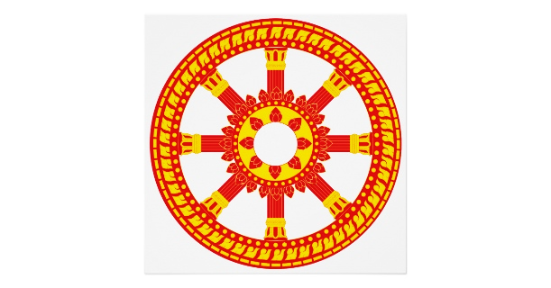](https://www.google.co.uk/url?sa=i&rct=j&q=&esrc=s&source=images&cd=&cad=rja&uact=8&ved=2ahUKEwiNx7npjazhAhVozoUKHSPZAzIQjRx6BAgBEAU&url=https://www.zazzle.com/ashtamangala_symbol_dharmachakra_wheel_of_dharma_poster-228993647058347871&psig=AOvVaw05K4isLWI3nrNYu1f5OmP9&ust=1554112333228391)

**Buddha-nature and attaining Buddhahood**

____________-nature is an important concept in Mahayana _______________. It refers to the idea that everyone has the essence of a _____________ inside them. However, achieving the ______________ to become a Buddha is hidden by ______________, ___________________, ____________________ and ______________________ thoughts.

Only when people come to fully _____________________ Buddha’s _____________ (teachings) and the _________ of themselves and _________ can they experience the _____________- nature that was ____________ there.

_________________ Buddhists aim to achieve ____________________: to become a ____________, an ___________________ being.

**Sunyata.**

Sunyata means _____________________. For ___________________ Buddhists understanding sunyata is essential for achieving _____________________. Sunyata could be understood as a similar idea to _______________. It emphasises that not only do _________________ not have a ______________ independent, _______________________ nature, but ______ things are like that. Nothing exists _______________________, but in _________________ to other things.

For Buddhists realising that everything ____________ on and ________________ with everything can lead to ___________, ________________ and _______________. Realising everything is _________________ is important for reducing _______________ resulting from ______________________.

[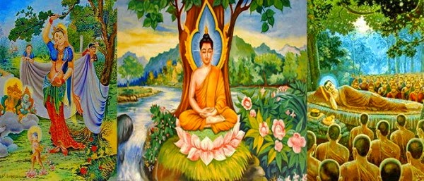](https://www.google.co.uk/url?sa=i&rct=j&q=&esrc=s&source=images&cd=&cad=rja&uact=8&ved=2ahUKEwizr5zshazhAhUN4YUKHVdDDEIQjRx6BAgBEAU&url=http://wisdomquarterly.blogspot.com/2014/12/seven-weeks-after-enlightenment.html&psig=AOvVaw0Z8G3V8KXzivT-jAdmyYJN&ust=1554110074483460)