**What is Theravada Buddhism?**

The ‘school of the ______________’ – Theravada Buddhism is one of the _____________ schools of ____________________. It is practised mainly in South East ___________ in countries such as ______ _______________ and ___________________.

Theravada Buddhism is often regarded as _____________________ Buddhism. It is practised in very ____________________ ways wherever it is found across the world. The school emphasises ________________________ in the _______________________ community.

The Buddha and his _______________ (teachings) are seen as the main foci of commitment. Theravada monks devote their ____________ to following the _________ of ________________________. They promise to follow a number of ____________, including having very few _____________________, not having ________________

relationships and to never be _______________________ to anyone. Buddha is seen as purely a ________, a ____________, never a _________.

In particular, Theravada Buddhists focus on

______________________. They believe

____________________ to the ________________

and the ______________________ Path will bring

good ___________ (merit). Their goal is to achieve

__________________________ and reach

____________________.

**Theravada Buddhism**

[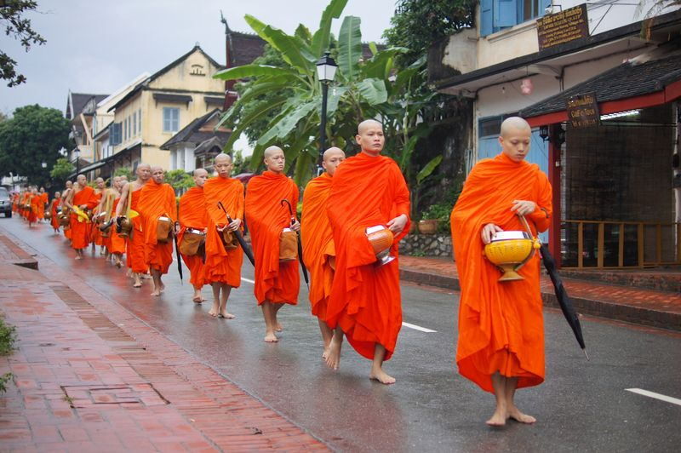](https://www.google.co.uk/url?sa=i&rct=j&q=&esrc=s&source=images&cd=&cad=rja&uact=8&ved=2ahUKEwj-9feD3KnhAhUFrxoKHYO0Du4QjRx6BAgBEAU&url=https://www.nalanda.org.my/lecture-on-theravada-buddhism/theravada-monks/&psig=AOvVaw0B1fwF2ly8Q9pEAHSp0hxp&ust=1554030251113163)



**The human personality...**

Buddha taught people are made up of ____________ parts or __________________ (skandhas). Theravada Buddhists in particular believe that these five ___________ _________________ with each other to make up a person’s identity and _______________

**Transferring merit.**

Some _____________________ Buddhists believe it is possible to _______________ their good ___________________ with other people by _______________________ the _____________ they have ______________ to someone else. This is particularly important when someone has ___________. The ________________ gather round the deceased and _________________ their merit in the ___________ that this will help the dead person have a ______________________ rebirth.

[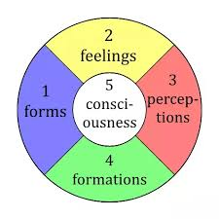](https://www.google.co.uk/url?sa=i&rct=j&q=&esrc=s&source=images&cd=&cad=rja&uact=8&ved=2ahUKEwj7k9fo8KnhAhXxyYUKHVU0BN8QjRx6BAgBEAU&url=https://www.quora.com/How-does-Buddhism-explain-anxiety&psig=AOvVaw1EZk7XUF8XjT0CaSpwvK5S&ust=1554035772761771)