The fourth noble truth is also known as _____________ (the ‘way’), the _____________ way and the Eightfold __________.

The Eightfold Path consists of ____________ aspects that Buddhists ________________ in order to achieve ________________________. The eight aspects are grouped into _______________ sections which are ________________, ________________________ and ____________________.

**The Eightfold Path – The cure for suffering**

[](https://www.google.co.uk/url?sa=i&rct=j&q=&esrc=s&source=images&cd=&cad=rja&uact=8&ved=2ahUKEwiD4ID15KThAhXqAmMBHSJGAYkQjRx6BAgBEAU&url=https://www.vectorstock.com/royalty-free-vector/lotus-bamboo-vector-2154381&psig=AOvVaw3QVUf0agBL68EDd6ngT3mj&ust=1553860834550848)

Label the diagram above. Include each of the eight sections (English and Pali) in the spokes, and in outer circle, the threefold way. In the eight sections give examples.

**Ethics (Sila)**

This section of the threefold __________ is concerned with having _______________ _______________ and _______________________. It essentially requires Buddhists to act in ways that ____________ rather than ______________ others.

**Meditation (Samadhi)**

This section is concerned with how to _________________________ effectively, which is important for developing _________________ and achieving ______________________

**Wisdom (Panna)**

This section emphasises the importance of overcoming ___________________________ and achieving ___________________.

**The Eightfold Path – The cure for suffering**

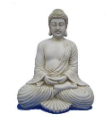

**The symbol of Buddhism – the eight spoked wheel – Dharmachakra.**

The Eightfold Path is represented as a _______________ to emphasise the fact that the steps do not need to be ________________ in a ______________ sequence. They can be practiced at the ___________ ___________. Each step ________________________ the others. For example, acting more ____________________ takes __________________, meditation helps understand __________________ ______________________ which in turn increases ___________________.

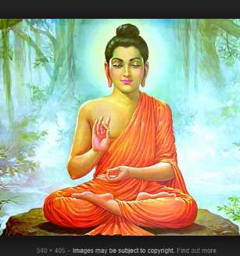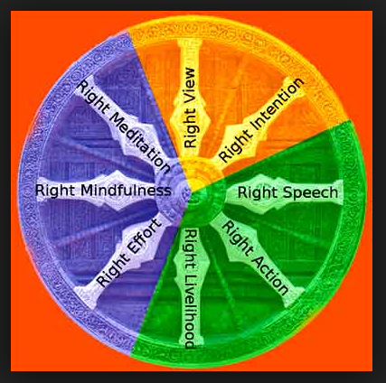

Exam Questions;

1. Give two reasons why Buddha rejected his life of wealth. [2 marks]
2. Explain two ways in which learning about the life of the Buddha influences Buddhists today. [4 marks]
3. Explain two ways in which the Buddha’s ascetic life influenced his later teaching. [4 marks]
4. Explain two Buddhist teachings about the causes of suffering.

Refer to sacred writings or another source of Buddhist belief and teaching in your

answer. [5 marks]

1. For Buddhists, ‘impermanence (anicca) is the most important of the Three Marks of Existence.’ Evaluate this statement.

*In your answer you should:*

• refer to Buddhist teaching

• give reasoned arguments to support this statement

• give reasoned arguments to support a different point of view

• reach a justified conclusion. [12 marks] [+ 3 SPaG marks]