**The Four Noble Truths**

*The Four Noble Truths are…*



2. Suffering (______________) is ________________ by something.

The truth of origin is like the ___________ of the _________________,

1. ___________________ exists.

The truth of __________________ is like a ________________, (the illness)



3. Suffering (___________) can ______.

.

The truth of ___________________ is like the ___________ of the _________________,

4. There is a _______ to end

______________. It is the Noble ________________ ___________.

The truth of the __________ is like the __________________.



*The First Noble Truth – Dukkha (suffering).*

The four unavoidable types of physical suffering are: ________________; _________ ________; ____________________ and ________________.

The three main forms of mental suffering; ______________________ from someone or ______________________ you _____________.; contact with _____________________ or _____________________ you __________________; not being able to ____________ or fulfil __________ ________________.

*Suffering and the Three Poisons*

The three poisons are ________ _________ and _____________

They are at the centre of the wheel of life because they cause ___________ (suffering) and keep the __________ of ______ and the cycle of _____________ turning. Buddhists need to defeat the three ___________ in order to achieve __________ (enlightenment).

*The Second Noble Truth – The cause of dukkha.*

One of the main causes of dukkha is _______­­­­­­______

which means thirst or ______________________.

The three main types of tanha are;

1. Craving things that _______________ the _________________ such as ___________________ __________________________________________.

2. Craving to__________________ something you are _________, e.g. __________________________.

3. Craving _______ to be or ______-_____________ This refers to when you want to ________ ________ of ______________________ or stop something ______________________ for example __________ ___________________________________________.

[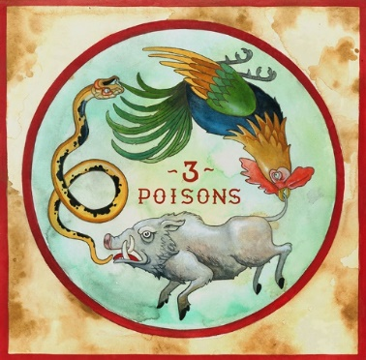](https://www.google.com/url?sa=i&rct=j&q=&esrc=s&source=images&cd=&cad=rja&uact=8&ved=2ahUKEwipkf3DoKPhAhUkx4UKHQxjDVoQjRx6BAgBEAU&url=https://gumroad.com/l/MWnJ&psig=AOvVaw0Xd8Qvc45g7sLJIdQ6SVzc&ust=1553808133774793)

