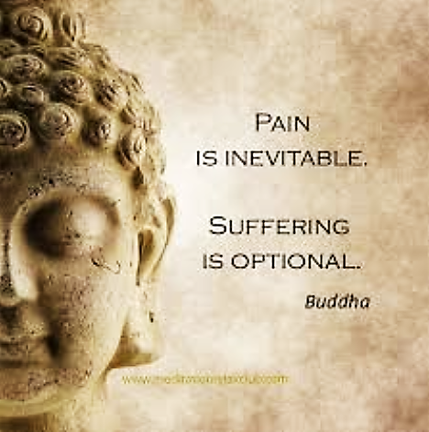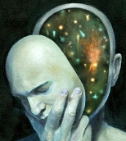

In Buddhism suffering – dukkha – is much more than just physical or emotional pain. It also means _________________ or ______________________. Buddhists try to ____________ dukkha for _____________________ and ________________ through ___________ ___________ and ________________. The main reason why Buddha left his life of ______________ was to search for ____________________________________ ___________________________________________________.

*The three marks of existence are…*

**The Three Marks of Existence**

Buddha talked about seven states of suffering:

Three Types of Dukkha

*Ordinary Suffering:*

Describes ______________ and ______________ pain.

*Suffering due to change:*

Linked to the idea that nothing is _____________

*Suffering due to attachment:*

When people __________ and _______ on to things they are ______________ to they ______________.

The Seven States of Suffering

Three Types of Dukkha - Examples

*Ordinary Suffering:*

________________________________________________________________________________________________________________________________________

*Suffering due to change:*

____________________________________________________________________________________________________________________________________________________________________________________________________________

*Suffering due to attachment:*

____________________________________________________________________________________________________________________________________________________________________________________________________________



*The Story of Kisa Gotami;*

Kisa Gotami had a child but when it was still very young the boy ____________. She went from house to house looking for _________________ because she could not accept that her child had ___________. She went to Buddha for help. He told her to, ‘Go to a house where no one in the family had died and ask for _____________ __________.

She went to many ____________ sharing her sorrow, but every

household had suffered a ____________. This made her realise

that _______________ and __________ are a part of life. This

helped to accept her child’s ___________.

*Links between anicca and dukkha;*

____________ taught that when people expect things to remain ___________________, they become _________________ to them. Therefore when they do _________ (anicca) people experience suffering (____________).

Anicca means ____________________. Anicca affects the world in three ways:

1. It affects all _____________ ____________. For example: ___________________ ________________________________________________________________________ 2. It affects _____-_______________ _______________. For example:_______________ ________________________________________________________________________3. It affects our __________. For example: _____________________________________ ________________________________________________________________________

**Anicca**

**The Three Marks of Existence – Anicca & Anatta**

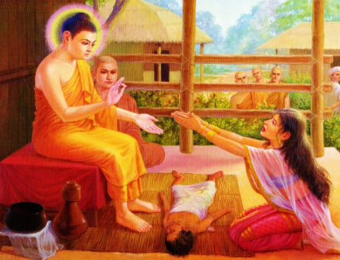

**Anatta**



*Nagasena and the chariot;*

A story used to illustrate this idea is found in a text called, ‘The questions of __________ _____________. Nagasena was a monk who explained Buddhism to the king. He described anatta using a chariot; Nagasena said a chariot is not the ____________ or _________ or _______, so the term ‘chariot’ is merely a ________ used to refer to a collection of __________. People are made up of various _________ _________ but only when these are put together to we recognise the ‘_____________’. There is not a ________________ ‘self’ that is ___________________ from the parts.

Anatta is often translated as ______ ___________ or no __________. This

M means that the ‘self’ is not _____________ or __________________.

