Revision activities
Data response
Oreos in China
Oreos are America's number one biscuit brand and have grown increasingly popular in the UK. In 1996, Oreos' owner, Kraft Foods, launched the brand in China. It had assumed that what made the product popular in the US would work in China just as well, amongst a growing middle class hungry for western brands. After nearly a decade, during which time Oreos never became the hit that Kraft had hoped for in China, the company was considering pulling out of the Chinese market altogether. Before taking this drastic step, Kraft carried out market research in China, aimed at finding out why the product had not been successful. The key findings were as follows:

• Biscuits as a whole are not as popular in China as elsewhere in the world.
• Chinese consumers found the biscuit element a little too bitter and the cream inside a little too sweet for their tastes.
• Prices had been set too high for value-conscious Chinese consumers.

By 2006, Kraft had made significant changes to cater for the Chinese market. Smaller packs had been introduced at far lower prices. The biscuit itself had been radically redesigned, now to be made of four layers of crispy wafer filled with vanilla and chocolate cream, coated in chocolate. In addition, recipes had been adjusted to reduce the sweetness of the vanilla cream and the bitterness of the chocolate. Lessons have been learned and Oreos sales have increased dramatically, prompting Kraft to continue to tinker with the product to better suit local tastes, with Oreo green-tea ice cream now being sold in China. Kraft's willingness to adapt to local tastes helped Oreo become the first biscuit brand ever to have sales of more than $3 billion (2014) with more than $1 billion coming from developing countries, including China.
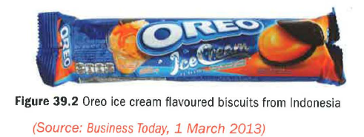
Questions (50 marks; 60 minutes)
1 Use the example of Oreos to assess the importance of local market research being conducted before launching into a foreign market. 10)

2 Assess two possible reasons why Kraft management failed to carry out effective (research before launching its brand in China. (8)

3 Assess the issues Kraft may have considered before deciding whether to pull out of China in 2004. (12)

4 Evaluate the extent to which adapting a product like Oreos to local tastes may be the most important part of a successful product launch in a new foreign market. (20)

