**Revision questions**30 marks; 30 minutes)

1 Explain two factors a British manufacturer might consider in deciding which developing country should be the base for its first overseas factory. (6)

2 In 1979, the African country of Benin had the world's highest rate of illiteracy (83.5 per cent of all adults). In 2015, Benin's annual GOP per capita of $835 was among the lowest in the world. Explain the possible connection between these figures. (5)

3 Explain why it may be useful to see GOP per capita figures shown 'at PPP'. (4)

4 Should wealthy countries increase the rates of tax on their own populations in order to finance greater help to people living on less than $1.25 a day? Explain your answer. (5)

5 Outline three possible reasons that may explain why China's growth rate is so much higher than that of Nigeria or India. (6)

6 Explain why governments might find it useful to see HOI measured, rather than simply GOP per capita. (4)



**Revision activities**

**Data response**

Global business strategy isn't easy In 1980, it wasn't obvious whether India or Pakistan had the better economic prospects. Yes, India's population was hugely bigger (685 million compared with 85 million for Pakistan) but Pakistan had a higher GOP per capita. Whatever the reasons, Honda opted for Pakistan. By 2005, even though India was the growth story, Honda's 50 per cent share of Pakistan's car market was a big consolation. Honda Pakistan's position was very profitable, and its place was secured by owning Pakistan's only large car factory. For those growing up locally, the Honda Civic and Accord models epitomised luxury driving.

To keep its position strong, Honda embarked in 2005 on heavy investments in capacity expansion. The goal was to be able to produce 50,000 cars a year. Then it all went wrong. From 2006, the market for passenger cars started to slide. Worse, competition from Toyota and Suzuki (in partnership with the Pakistan government) chipped away at Honda's market share. In 2007, Honda sales were just 18,709 cars from a factory capable of producing 50,000. Worse was to come, as sales slid further in the face of world recession and a collapse in security and consumer confidence. Healthy operating profits turned into severe losses.

Naturally enough, Honda's strategy had been to focus on 'the market' - largely companies or government departments buying prestigious cars for managerial staff. Yet from about 2005, the market moved more towards individuals buying cars for themselves. A Honda Civic was priced at about £11,000; a Suzuki Swift cost half that. Honda's marketing strategy was facing the wrong way - looking backwards instead of forwards. In2010, Honda's market share fell to 23 per cent and by 2014 it was 18 per cent. Toyota with 27 per cent and Suzuki with 55 per cent made up the rest of the market. Meanwhile the difference in 2014 car production between Pakistan and India emphasised the poor choice Honda made back in 1980 (see Figure 25.5).

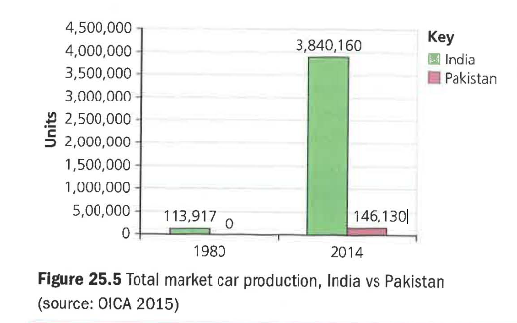

**Questions** (40 marks: 45 minutes)

1 Assess why a business might make a mistake when choosing which country to focus on. (10)

2 Honda's international strategy has been hugely successful; but not in this case. Assess why a successful international company such as Honda might fail within one country. (10)

3 Evaluate two alternative strategies Honda might choose in the face of its current problems in Pakistan. Explain which you would recommend, and why. (10)

