What is 'the economy'?

Each of us goes about our business in our own way. A teacher receives a monthly salary paid directly into the bank, and draws out the cash needed to buy the shopping, buy petrol and give the children some pocket money. The children may spend this on chocolate, Coca-Cola and packets of crisps.

Although, as individuals, we 'do our own thing', the actions and decisions taken by millions of people and businesses make up 'the economy'. Collectively, chocolate purchases in Britain add up to £3,500 million per year. This, in turn, provides the income for chocolate producers and shopkeepers, who employ tens of thousands of staff.

If the value of all spending on all products bought in the UK is added together, it comes to an annual figure of over £1.5 trillion (a thousand billion). This spending provides the vast revenues that companies need in order to pay for Britain's 30 million workers, and enough profit left over to pay for business growth.

The key thing to remember is that the economy is intertwined. Cadbury is successful only if families have enough cash to be able to buy chocolate bars. Therefore, if there were a big cutback in consumer spending, perhaps in the wake of government spending cutbacks, many firms would struggle, including Cadbury.

When times are bad, almost every business suffers; this, in turn, can lead to job losses. When the economy is recovering, things get better for almost all firms.

Current economic climate
Business thrives on confidence. Confident consumers are willing to dip into their savings for a holiday, or to borrow to buy a new carpet or car. Confident investors are willing to put more money into businesses in return for shares. And the companies themselves will spend to invest in their future: new factory buildings, new machinery and new computer systems. All this spending can create an upsurge in economic activity.

The reverse also applies: gloom can spread doom. Therefore, the economic climate is important. The sections that follow give an idea of the factors that help to create an economic climate, either of optimism or of pessimism. These factors include:

• the business cycle
• changes in inflation
• changes in interest rates
• changes in exchange rates
• changes in taxation and government spending.

The business cycle

The business cycle is the pattern of boom then slowdown that has been a feature of the UK economy for more than 150 years. When the economy is growing rapidly (around 3 per cent a year), consumers and companies have the confidence to spend and invest. This extra boost to output risks creating an unsustainable boom, which may lead to a bust, such as the one in 2009.

Figure 45.1 shows the tricky period for the UK economy between the start of recession in 2008 and the second quarter of2014, when the economy finally returned to its pre-recession peak. The straight black line shows the GDP trend excluding the recession and the unprecedentedly slow recovery. The graph also shows the normal progress of the UK economy. For more than 200 years, it has grown at an average of just under 2.5 per cent per annum – that is, growth is normal. Therefore, the general expectation is that the underlying market conditions will be positive, with the size of markets expanding on a regular basis.
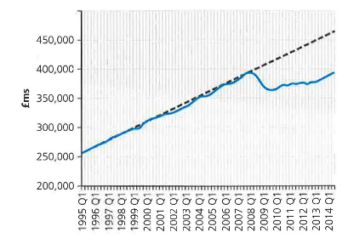

Figure 45.1 UK gross domestic product, 1995-2014; chained volume measures, quarterly figures, seasonally adjusted (source: ONS)

When market conditions are as tough, as in 200812009, there are likely to be failures as businesses run out of cash (Woolworths, La Senza and many others went under). There may also be huge pressures placed on company workforces, as people are forced to choose between redundancy and real wage cuts. In the recessions of 1980 and 1990, job losses pushed unemployment up above three million. The recent recession saw instead a huge squeeze on people's real incomes, meaning that the pain was shared more fairly across the population. Government statistics show that between July 2008 and March 2014 earnings rose 8.6 per cent while prices rose 16.9 per cent. This made people 7.1 per cent worse off (even worse if the tax to be paid on the extra earnings is included). In addition to this squeeze on incomes, Figure 45.2 shows why consumer confidence was hard hit in 2009, with people worried whether they would be next for a redundancy notice. No wonder that, at times, even products like chocolate and chewing gum saw falls in sales volume as market conditions tightened.

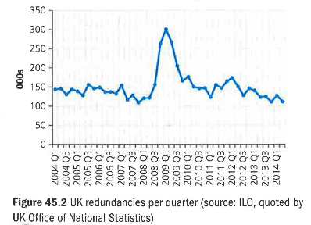

Inflation

Inflation measures the percentage annual rise in the average price level. For consumers, inflation increases the cost of living. The rate of inflation is measured monthly, but presented as a year-on-year figure. Therefore, September 2014 inflation of 1.2 per cent meant that the prices of the average household's shopping basket were 1.2 per cent higher than in September 2013.

Does this matter? Traditionally, it mattered most to those with cash savings, such as pensioners. Steady inflation erodes the spending power of money and therefore makes each £1,000 of cash savings worth less. In the period between 2009 and 2015, it mattered because the weakness of the labour market meant that earnings were hardly rising at all, year on year. Therefore, every 1 per cent of inflation meant a 1 per cent reduction in the value of employees' earnings. In turn, that meant squeezed living standards.

The most widely quoted index for measuring inflation is the Consumer Prices Index (CPI). This data series is produced by the government's statistical office each month. It selects 700 items that we buy most often, then measures changes in the price charged for this shopping basket in thousands of different stores and locations. The data is then converted into an index to make it easier to understand and use by students, journalists and others.

An index means converting a series of data into figures that all relate to a base period where the data = 100. This allows users of the data to see at a glance the percentage changes and trends. In Table 45.1, column A shows the total price of buying the shopping basket. Column B converts that data into an index. This starts by saying 'let £402 = 100', then all the other figures in column A are related to that base figure of 100. For example, the figure for 2014 is £514.15/£402 X 100 = 127.9. Column C then calculates the percentage change each year based on the data in column A (or column B - it should give the same figure).
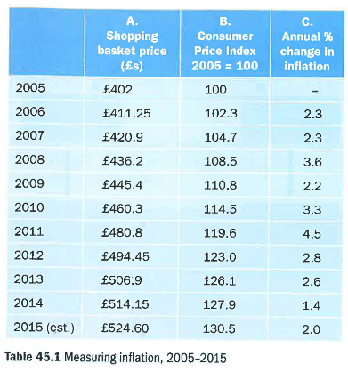

The advantage of index numbers is that you can see quickly that, for example, inflation amounted to 27.9 per cent between 2005 and 2014. Therefore, index numbers help you understand trends rather more easily. Their other huge benefit is that they enable direct comparisons to be made between different data series. In the case of inflation, the interesting recent comparison would be with earnings.
This data is shown in Table 45.2 and Figure 45.3. It shows average earnings outstripping prices in 2006 and 2007, but then being dragged back until - from 2011 – they were well behind the rise in prices.

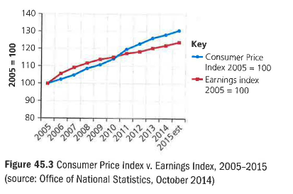
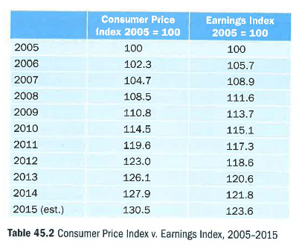

Effects of inflation on businesses

1 Firms with large loans benefit from inflation because inflation erodes the real value of the money owed. So when they have to repay the loan, it does not feel as painful because of the fall in the value of money. As an extreme example, a house in south London has just been sold for £1.2 million. When bought, 20 years ago, its price was £80,000. It was bought with a £50,000 mortgage.

Repaying a £50,000 mortgage seems a lot easier now that the sale has provided £1.2 million of cash.

2 But inflation can damage profitability, especially for firms that have fixed-price contracts that take a long time to complete. For example, a local building company might agree a £5 million price for an extension to a local private school, which is expected to take three years to finish. If inflation is higher than expected, profit could be wiped out by the unexpectedly high cost increases created by the unexpectedly high rates of inflation.

3 If costs in Britain are rising faster than prices elsewhere, UK companies will find that they are losing their ability to compete effectively with foreign firms. Renault has launched a new small car for India priced at £2,200. That would hardly pay the labour costs if the car was produced in Britain.

Interest rates
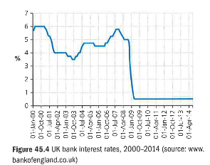
The interest rate is the price charged by a bank per year for lending money or for providing credit. Individual banks decide for themselves about the rate they will charge on their credit cards or for the overdrafts, they provide. But they are usually influenced by the interest rate that the central bank charges high street banks for borrowing money: the bank rate. In Britain, this is set each month by a committee of the Bank of England. As shown in Figure 45.4, the standard rate of interest in the UK has generally been around 4 -5 per cent. In March 2009, though, the rate was cut to its lowest point in the Bank of England's history - 0.5 per cent. And it remained there as a way of helping to revive an economy hit very hard by the 2009 recession.

The Bank of England committee is asked to set interest rates at a level that should ensure UK prices rise by around 2 per cent per year. If the committee members decide that the economy is growing so strongly that prices may rise faster than 2 per cent, it will increase interest rates.

Then people will feel worried about borrowing more (because of the higher repayment cost) and may cut their spending. This should help to discourage firms from increasing their prices.

For firms, the level of interest rates is very important because:
• it affects consumer demand, especially for goods bought on credit, such as houses and cars; the higher the rate of interest, the lower the sales that can be expected
• the interest charges affect the total operating costs (that is, the higher the interest rate, the higher the costs of running an overdraft, and therefore the lower the profit)
• the higher the rate of interest, the less attractive it is for a firm to invest money into the future of the business (because of the opportunity cost - the high interest rates available for keeping money safely in the bank); therefore, there is a risk of falling demand for items such as lorries, computers and factory machinery. If interest rates fall, the opposite effects occur, to the benefit of both companies and the economy as a whole.

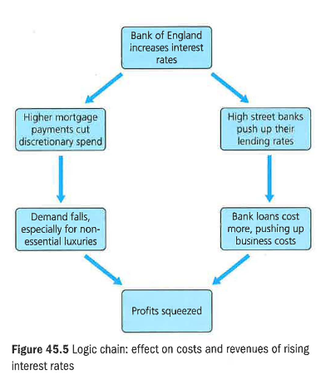

Exchange rates

The exchange rate measures the quantity of foreign currency that can be bought with one unit of domestic currency. Movements in the exchange rate can dramatically affect profitability because the exchange rate affects prices of imported and exported goods. In exams, the value of the pound (£) is usually considered only in relation to the US dollar ($) or the euro (€).
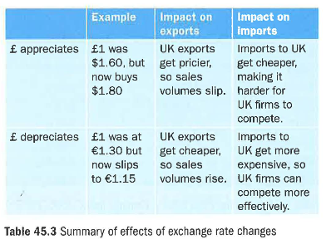
Appreciation of the pound occurs when the value of the pound rises. This means each pound can buy more dollars or euros. Depreciation means a fall in the value of the pound. It can buy fewer dollars or euros. Table 45.3 gives a numerical example of appreciation and depreciation.

The impact of a high exchange rate
On firms with large export markets

UK firms that sell a high proportion of their output overseas will prefer a low exchange rate (that is, a weak pound). Why is this so? The best way of explaining is via a numerical example.

America is an important export market for Morgan Cars. Morgan charges its UK customers £25,000 for a basic two-seater Roadster.

To achieve the same profit margin in America, Morgan has to charge a price in US dollars that will convert into £25,000. If the exchange rate against the US dollar is £1 = $1 .60, Morgan has to charge its American customers:
£25,000 x $1.60 = $40,000

If the pound appreciates to be worth $2, to generate the same £25,000 of export revenue per car, Morgan must charge its American customers:

£25,000 x $2 = $50,000

In other words, Morgan would have to increase the US price of its cars by $10,000 to maintain the current profit made on each car sold. The price increase would be off-putting to car buyers, so sales would fall.

On firms that import most of their raw materials or stock

Retailers such as Sports Direct, which import much of their stock, like a strong pound. A high exchange rate reduces the cost of buying goods from abroad. For example, Nike trainers are imported from the American producer. If the US price of a pair of trainers is $40, the price paid by Sports Direct is as follows.

If the exchange rate is £1 = $1.60, the trainers will cost Sports Direct: $40/$1.60 = £25

However, if the exchange rate goes up to £1 = $2, the same trainers cost £20 ($40/$2 = £20). A high exchange rate benefits Sports Direct because it buys imports more cheaply, allowing it to make more profit per pair of imported trainers sold to UK customers.

The impacts of a low exchange rate The impacts of a weak exchange rate are the reverse of the impacts of a strong exchange rate. A strong pound can damage exporters, especially manufacturers.

Exporters love to see the pound depreciate in value. On the other hand, companies such as Sports Direct are damaged by a low exchange rate because their imported stock costs them more. If Sports Direct reacts to the falling exchange rate by raising its prices, the company could lose customers. If the company does nothing, it will make less profit on each sale of an imported item.

Taxation and government spending

In addition to economic change, businesses can be affected by economic policy decisions taken by government. If worried about inflation, a government could decide to increase income tax. This would take spending power out of the pockets of consumers, softening the upward pressure on prices, but cutting demand for the products and services produced by businesses. What might be right for the economy as a whole could be damaging for individual businesses.

Why would any government take actions that could damage businesses and therefore threaten jobs? The answer is simple: because ministers may believe that short-term pain may be necessary for long-term gain. This might be correct, but it will be no consolation to any business squeezed out of business by an unexpected tax rise.

The other main weapon government can use to achieve its policy goals is to change the level of government (known as 'public') spending. At present, public spending generates just over 40 per cent of the British economy. Private consumers (you and me) mainly generate the rest. The government spends huge sums on the health service, defence, roads and much else. If the government was concerned about rising prices, it could consider cutting back on its own spending. This would reduce the income of businesses involved in education, road-building, and so on. They, in turn, may have to make redundancies, thereby dampening down consumer spending, which should help to keep prices from rising so sharply.

'The last thing you want to do is raise taxes in the middle of the recession.'
Barack Obama, US President

It follows, therefore, that sensible businesspeople keep an eye on government activity. Years ago, the government announced its tax and spending plans in the Spring Budget, which was always kept secret until the government announced it. Today, an 'Autumn Statement' announces, six months in advance, the government's public spending plans. This ensures that firms can anticipate the tax decisions that will be announced in the spring.

Table 45.4 shows how a government could use its power over taxation and spending to tackle different economic problems.

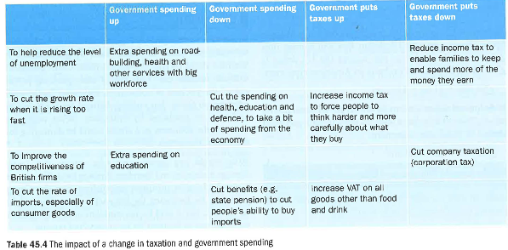

The effect of economic uncertainty on the business environment

In late 2013, investment bankers Goldman Sachs made their forecast for oil prices for the coming year. They expected a price rise to $105, with $115 a distinct possibility. In fact, by December 2014, the world oil price was below $60 a barrel. Some very highly paid bankers got it all wrong. This, in turn, would mean that airlines would have paid too much for their fuel, and that suppliers of sustainable energy such as wind power would now be under severe economic pressure.

This gives an idea of what economic uncertainty looks like. If it is extremely difficult to forecast the level of supply and demand in the oil business (and therefore the price), how much harder is it to forecast the level of demand throughout an economy? It verges on the impossible. Therefore, every business has to make its plans for the coming year with little certainty about the overall state of the economy, and even less certainty about certain economic variables that are especially prone to big ups and downs. These include:

• the value of the pound; in the ten years from 2005 to 2014, the value of the pound against the euro fluctuated between £1 = €1.02 and £1 = €1.52; that variation of 50 per cent adds huge uncertainty to the plans of UK exporters • the rate of economic growth; in that same ten-year period, UK annual growth varied between +3.2 per cent and -5.0 per cent

• the value of oil; between 2005 and 2014, the world oil price varied between $41 and $133 once again, making planning extremely difficult.

The lesson businesses need to take from the uncertain economic environment is to always be prepared for changing times around the corner. In good times, make sure your cash balances are being built up sufficiently to cope with a sudden worsening of your position. And in bad times, keep alert to the opportunities that may soon be about to open up.

Five whys and a how
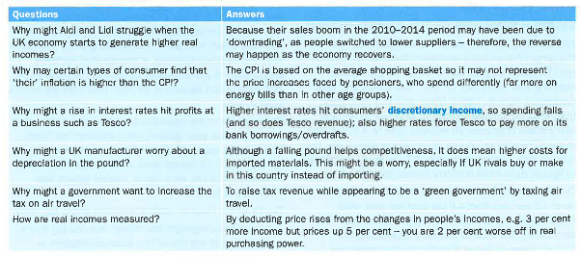

45.9 Economic influences - evaluation
When companies publish their annual results, commentators groan if the boss blames disappointing results on external factors such as the weather or the weakness of the economy. Business journalists admire chief executives who achieve their targets no matter what. Yet that may not be realistic. If you are running Coca-Cola, you have huge control over your pricing and therefore can probably find a way to boost profits to meet analysts' expectations. Not long ago, people assumed that Tesco was in a similar position. The squeeze on household spending, the rise of Aldi and Lidl and a series of strategy mistakes by Tesco make it look very different now.

In truth, it is always the case that firms are vulnerable to external factors. Even monopolies (when a single firm dominates a market) are subject to changing consumer habits, as Microsoft and even Apple have found in recent years. If things seem to be going wonderfully well - and every commentator thinks your business is bulletproof – it is probably time to worry. The one-time boss of monopolist microchip supplier Intel, Andy Grove, once said that 'only the paranoid survive'. That remains grimly true.

Key terms
Consumer demand: the levels of spending by consumers in general (not just the demand from one consumer).

GDP: gross domestic product is the value of all the goods and services produced in a country in a year.

Discretionary income: a person's income after deducting taxes and fixed payments such as rent and utility bills.

Economic climate: the atmosphere surrounding the economy (for example, gloom and doom or optimism and boom).

Real: changes in money (for example, wages) excluding the distorting effect of changes in prices. So a fall in real wages might be that wages are unchanged, but prices have risen.

Recession: two or more quarters of negative economic growth.

45.10 Workbook
Revision questions

- Explain why a fall in spending in London could have a knock-on effect on the economy in Bradford, Plymouth, Norwich or anywhere else in the country. (3)

- Explain whether the Bank of England should raise or cut interest rates in the following circumstances:

- A sharp recession has hit the UK economy. (3)
- House prices have risen by 16 per cent in each of the last two years. (3)
- Household incomes and spending have been rising rapidly. (3)

- Outline how an economic downturn could affect the level of unemployment. (5)

- Outline a change in government spending or taxation that could boost sales at Mothercare. (3)
- Explain the possible impact on a supermarket chain of an increase in inflation. (4)

- What is meant by 'an appreciation' in an exchange rate? (1)

- A British detective agency has been hired by a French woman to tail a man. The fee is €500 per week. After four weeks, the sum of €2,000 is due to be paid, but the rate for the pound against the euro has fallen from 1.30 to 1.15.

- What sum will the detective agency receive in pounds for this four weeks' work? (3)
- What may stop the agency from simply putting the euro price up? (3)

- Outline two possible reasons why a UK manufacturer of chemicals might be concerned if the value of the pound depreciated. (4)

Data response
External pressures on the grocery market
The booming discount supermarket chain Aldi is on the verge of overtaking upmarket Waitrose to become the UK's sixth biggest supermarket as the German owned grocer continues to open new stores and steal customers from its bigger rivals. Industry data show that, while Tesco and Morrisons continue to decline, Aldi's share of grocery till receipts rose to 4.8 per cent in the 12 weeks to 20 July 2014. A year previously, the discounter's market share was 3.7 per cent, according to figures from retail analysts Kantar Worldpanel.

Over the same period, Waitrose's market share edged up to 4.9 per cent from 4.8 per cent last year, while Tesco dropped to 28.9 per cent from 30.3 per cent. The data confirm the trend of shoppers abandoning midmarket players in favour of more upmarket rivals and the discounters, with increasing numbers of shoppers cherry-picking from both ends of the market. 'Waitrose has continued to resist pressure from the competition, testament to its policy of maximum differentiation, and has grown sales by 3.4 per cent. This figure is well above the market average and thereby has lifted its market share.'

Despite this positivity, The Grocer magazine has questioned whether Waitrose is now starting to suffer. Its profit margins at 5.4 per cent are well above industry averages, and perhaps shoppers are starting to query its value for money. Partly because of its high prices, Waitrose offers free delivery to online grocery shoppers. With online sales booming, it may be that Waitrose profits start to get squeezed by the free delivery, given that picking and delivery is far from free from the shop's point of view. The numbers come against a backdrop of a challenging market. Kantar says grocery price inflation has fallen for the tenth successive period and now stands at just0.4 per cent - its lowest level since prices were first measured in 2006. As a result, market growth has fallen to 0.9 per cent.

Tim Vallance, head of retail at property group JLL, said:

'The figures highlight the impact that the big four's response to the rise of the discount retailers is having on the grocery sector, with vicious price cutting leading to shrinking market growth. As shoppers continue to demand a more convenient offer in an increasingly digital world, supermarkets need to think about how and where their customers shop and need to focus on choice, provenance, quality, service and convenience to differentiate from the discounter offering.'

Questions (40 marks; 45 minutes)

- Assess the possible implications for Waitrose of a fall in 'grocery price inflation' to 0.4 per cent a year. (10)

- At this time in mid-2014, the rate of interest had been 0.5 per cent for five years. Assess how the position of Waitrose might have been affected by an increase in interest rates. (10)

- Evaluate whether Waitrose would have been wise, at this time, to have differentiated itself further by switching entirely to Fairtrade supplies. (20)

Extended writing

- Jaguar Land Rover exports 80 per cent of all the 500,000+ cars it produces in Britain.
Evaluate the most probable response from the company if the pound appreciated sharply against other currencies. (20)

- In the last recession, Tata Steel closed one of its Scunthorpe steelworks, making hundreds redundant. Evaluate the strategies Tata could have adopted to prepare for recession. (20)

