Revision activities

Data response
In early 2007, Tesco confirmed rumours that it was to launch into the US grocery market: the world's biggest and most competitive. This would bring it face-to-face with Wal-Mart in a market worth $500 billion. Huge though Tesco had become, with 500,000 employees worldwide, it remained a shrimp compared with Wal-Mart. Despite scepticism by some analysts, most assumed that the magic touch of Tesco's long-time boss Terry Leahy would ensure success. Leahy had switched his best executives from China to America and allowed them to carry out a year's research and investigation into the US grocery market. Leahy never quite said it, but analysts were starting to wonder whether his real mission was to make Tesco the world's number 1 retailer.

In its 2007 annual report, Tesco confirmed its plan to invest £250 million a year for five years to develop a new grocery concept called Fresh & Easy. Its stores would be one-third of the size of a typical US supermarket, but double the size of the average convenience store. Tesco believed it had found a market gap. By Spring 2008, Tesco had 60 Fresh & Easy stores in operation, and was trumpeting that sales were 'ahead of budget'. It said 150 more would be opened in the 2008/2009 financial year. Break-even would be achieved, it said, within two years. By 2009, it was clear that the original launch plan had been a flop. Not enough cash was coming through the tills to generate a profit. Tesco claimed that all it needed was 'scale', i.e. enough stores to deliver sufficient economies of scale to push the business beyond its break-even point.

It announced a series of changes that would be made to store design and layout, and to the range of goods on offer. Effectively it was admitting 'we got it wrong' – but without acknowledging that if the concept was wrong it was time to cut the losses and withdraw.

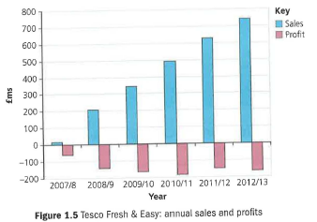
Only after the retirement of Terry Leahy in 2011 did serious questions start to be asked within Tesco about the future of its US loss maker. In February 2013, the new CEO Phillip Clarke made it clear that Fresh & Easy had to go. Embarrassingly, Tesco could not even give the stores away - it had to pay an American company to take some of the stores - and the rest of the business was liquidated. In 2013, Tesco said it would have to write down its balance sheet by more than £1 billion to account for the failure of Fresh & Easy, but as nearly £900 million of operating losses had been made (see the Table 1.1), the total loss for Tesco was probably around £2 billion.

Important though £2 billion is, the long-term consequences of the Fresh & Easy fiasco may be much greater. In 2007/2008, Tesco was making a serious commitment to Asia, especially China. This commitment seemed to slip away as the American disaster required ever more management time. In 2013, Tesco effectively sold out of its long-term operational commitment to China. Worse still, perhaps, has been the impact on Tesco's UK performance, with sales, market share, profits and credibility being eroded away in 2013 and 2014. Not long ago Tesco was Britain's most admired company; no longer.

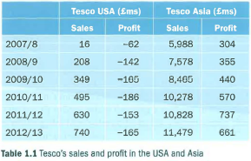

1. Assess the mission and objectives Terry Leahy seemed to be pursuing through his Fresh & Easy strategy. (12)

2. Tesco decided to prioritise a developed economy over developing ones. Assess why it might have decided to do that (12)

3. Such was Terry Leahy's status within Tesco that he was able to push ahead with quite a personal ambition to succeed in the US market. Evaluate how important the leader's views should be in setting the objectives and strategies of a business. (16)

