Data response 2
Apple's cash machine
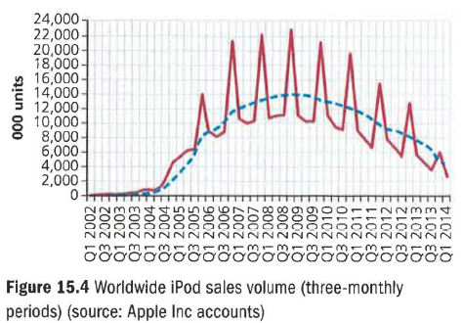
The Apple iPod was launched in 2001, into a market dominated by Sony. For a company based on computers, the move into personal music appeared risky. As the graph in Figure 15.4 shows, sales grew slowly; iTunes was launched in 2002 but only in late 2004 did iPod sales move ahead dramatically. This was partly due to the launch of the iPod Mini, but also coincided with the start of the brilliant 'silhouette' advertising campaign. In fact, Apple has handled iPod's marketing strategy very cleverly.

IPod marketing mix

• Product: quick product development, from iPod 2001 to iPod Mini 2003, iPod Photo 2004 to iPod Shuffle 2005, and the iPod Touch in late 2007 and iPod Touch 4g in late 2010. As with all its competitors, the iPod is made (very cheaply) in China, so the key to its success is the stylish design, not high-quality manufacture.

• Price: always startlingly high; at launch, the iPod was over £200; even in 2014 prices for the iPod Touch were as high as £329, whereas other MP3 players cost as little as £20. Apple has managed the business dream of achieving market penetration at prices that skim the market.

• Place: nothing new here; Apple has distributed the iPod through the normal mixture of department stores, electrical shops and online retailers .

• Promotion: brilliant and lavish use of posters and TV, featuring one of the all-time great images, the 'silhouette'.

The key to the strategy has always been to achieve high credibility through brilliant design and a non-corporate image. Consumers have tended not to notice that the iPod is an amazing cash machine. In the year to March 2014, the revenues generated by iPod and iTunes came to $19,960 million.

1 a) What is meant by the term 'product life cycle'? (2)
b) Assess what Figure 15.4 shows about iPod's product life cycle. (8)

2 Assess which of the elements of iPod's marketing mix have been the most important in its sales success. (10)

3 Given the business's success with the iPod, iPhone and iPad, evaluate whether Apple should now make a move towards the games console business, competing with Nintendo, Sony and Microsoft. (20)

