Pricing Strategies

Revision questions

(35 marks; 35 minutes)

1 Explain why price is fundamental to a firm's revenues. (3)

2 Look at Figure 12.1. Outline two factors that would affect the 'psychologically right price range' for a new Samsung phone. (4)

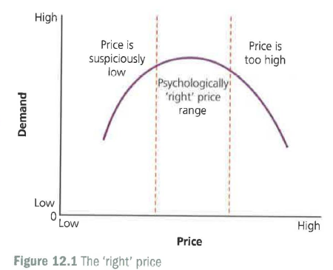
3 Explain how the actions of Nike could affect the footwear prices set by Adidas. (3)

4 Look at Table 12.1, on the price sensitivity of products, brands and services. Think of two more examples of highly price-sensitive and two examples of not-very-price-sensitive products, services or brands. (4)

5 Explain the difference between pricing strategy and pricing tactics. (2)

6 For each of the following, decide whether the pricing strategy should be skimming or penetration. Briefly explain your reasoning.

a) Richard Branson's Virgin group launches the world's first space tourism service (you are launched in a rocket, spend time weightless in space, watch the world go round, then come back to earth). (4)

b) Kellogg's launches a new range of sliced breads for families who are in a hurry. (4)

c) The first robotic washing machine is launched. It washes, dries and irons the clothes - and places them in neat piles. (4)

7 Is a price-elastic product likely to be priced competitively or on a cost-plus basis? Explain your reasoning. (3)

8 Outline two circumstances in which a business may decide to use predatory pricing. (4)

