Revision questions
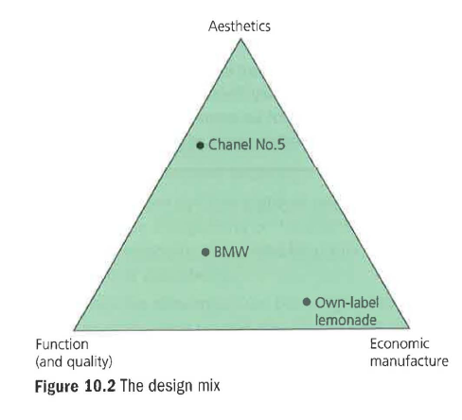
Product and service design
(30 marks; 30 minutes)

1 Explain how resource depletion might affect the future design of motor cars. (4)

2 Explain where you would plot the following on Figure 10.2. Give your reasoning: (9)

a) the latest Phone
b) the packaging of a Cadbury £5 Easter egg
c) a new double-decker bus for London.

3 Explain two marketing advantages that good design could bring to a business of your choice. (8)

4 How are the concepts of short-termism and design linked? (3)

5 Briefly state and explain whether ethical sourcing would be important to customers in the following circumstances:

a) the sourcing of a meat pie at Charlton FC's snack bar
b) the sourcing of a meat pie at Dundonald Primary School
c) the sourcing of a silk scarf sold at a department store. (6)

