Revision questions
(35 marks; 35 minutes)

1 Choose one of the following terms, and explain what it means:
a) stock market
b) labour market
c) foreign exchange market. (4)

2 State the probable impact on price of:
a) falling demand, while supply remains unchanged
b) rising supply at a time when demand is unchanged
c) rising demand at a time of falling supply. (3)

3 When a shortage of Ed Sheeran tickets allows touts to charge £400, only wealthy people can get to the concerts. Most people would not worry about this. But why might people be concerned about a high 'market price' if there was a shortage of water at a time of drought? (4)

4 Explain why the price of a hotel room might be high on a Wednesday night. (4)

5 Consider the following.
a) Draw supply and demand curves for oranges, based on the data shown in Table 7.4. (5)
b) Why may orange growers be unwilling to supply any oranges at lOp each? (2)
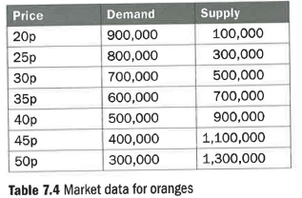
6 Explain how market movements might ensure that a sharp rise in the price of apples proves temporary. (4)

7 Examine Figure 7.2 (supply and demand for J.K. Rowling in Manchester) below and answer the following:

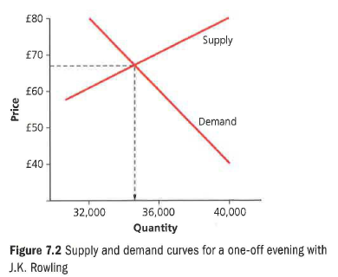
a) Why is £68 the right price to charge for the tickets? (4)
b) What would the effect be of setting a price of £80 for the tickets? (5)

