Data response

Each year, more than £1,500 million is spent on pet food in the UK. All the growth within the market has been for luxury pet foods and for healthier products. Seeing these trends, in early 2014 Town & Country Petfoods launched 'HiLife Just Desserts', a range of pudding treats for dogs. They contain Omega-3 but no added sugar and therefore have no more than 100 calories per tin.

Sales began well, especially of the apple and cranberry version. Now sales have flattened out at around £1 million a year and the company thinks it is time to launch some new flavours. They commissioned some primary research that was carried out using an online survey linked to pet care websites. The sample size was 150.

The main findings of the online survey are shown below.

- Have you ever bought your dog a pet food pudding?
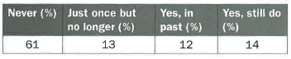
- Which of these flavours might you buy for your dog?
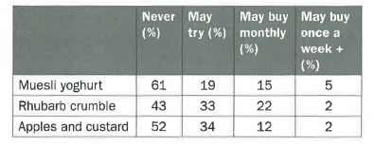
The marketing director is slightly disappointed that none of the new product ideas has done brilliantly, but happy that there is one clear winner. She plans a short qualitative research exercise among existing HiLife customers and hopes to launch two new flavours in time for the annual Crufts Dog Show in three months' time.

Questions (30 marks; 35 minutes)
1 Explain whether the sample size of 150 was appropriate in this case. (4)

2 Explain one possible drawback of using an online survey. (4)

3 Assess the marketing director's conclusion that 'none of the new product ideas has done brilliantly', but that she is 'happy that there's one clear winner'. (10)
4. a) Explain one method of qualitative research that could be used in this case. (4)

b) Assess two ways in which qualitative research may help the marketing director. (8)

