The market
Definition

The market is where buyers meet sellers, either face-to-face or online.

2.1 Mass marketing
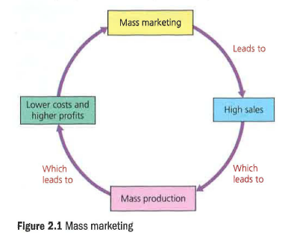
Mass marketing is the attempt to create products or services that have universal appeal. Rather than targeting a specific type of customer, mass marketing aims the product at the whole market. The intention is that everyone should be a consumer of the product. Coca-Cola is a good example of a firm that uses mass marketing techniques. The company aims its product at young and old alike. Its goal has always been to be the market leader and remains the same today.

The ultimate prize of mass marketing is the creation of generic brands. These brands are so totally associated with the product that customers treat the brand name as if it was a product category. Examples include 'Coke' (cola) and 'Bacardi' (white rum).

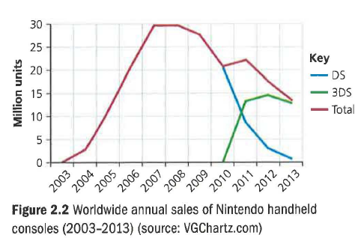
As shown in Figure 2.1, when mass marketing is carried out successfully, it can be highly profitable. Firms such as Ryanair set out to be high-volume, mass market operators and achieve handsome profits. However, it is important to note that mass marketing does not have to go hand in hand with low prices. For example, Nintendo, when it launched the DS, decided to become the handheld games console. Superb launch advertising and excellent games software development meant that it achieved mass-market sales while keeping its prices high. Even now, with its sales entering the decline phase of its product life cycle (see Figure 2.2), it remains the dominant brand in its market. Mass marketing does not have to aim at the lowest common denominator.

2.2 Niche marketing
A niche market is a very small segment of a much larger market. Niche marketing involves identifying the needs of the consumers that make up the niche. A specialised product or service is then designed to meet the distinctive needs of these consumers. A niche market product sells their prices are in relatively low volumes. As a result, their prices are usually higher than the mass-market alternative. Niche market operators often distribute their products through specialist retailers, or directly to the consumer via the internet. Finally, the niche must be large enough to support a profitable business.

Small niche operators lack the economies of scale required to compete on price with larger, established operators. Instead, the small firm could try to find a small, profitable niche. Small, niche market businesses survive on the basis that they occupy a relatively unimportant market niche. Larger firms operating in the mass market are happy to ignore the niche businesses because they represent too small an opportunity to be worth their while.

Mass v. niche

Let no-one doubt it. Every business would love to have the central, mass market positioning of Wrigley (92 percent share of UK chewing gum market) or Pampers (63 per cent of UK market for disposable nappies).

The conclusion is clear: if someone else has already 'captured' the mass market, you would be wiser to find your own, profitable niche.

'Most large markets evolve from niche markets.'
R. McKenna, businessman

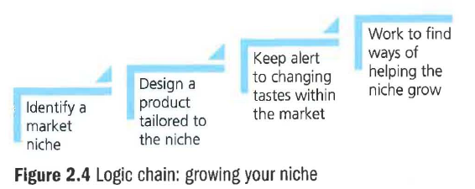

'Increasingly, the mass market is turning into a mass of niches.'
Chris Anderson, author of The Long Tail

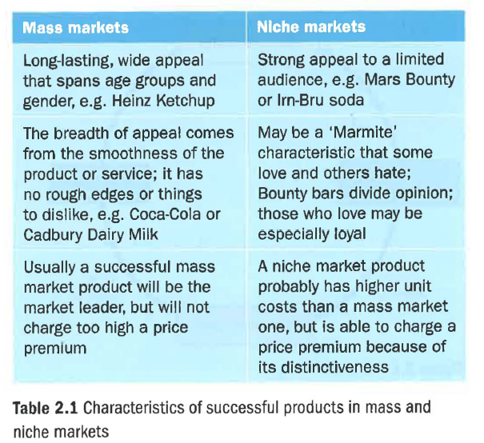

2.3 Market size

If a business has a large share of a market, it may worry that boosting sales further may bring investigations from the Competition and Markets Authority. Therefore, its best way to achieve further growth is by encouraging growth in the market sector as a whole. In the UK, Wrigley has a 90 per cent share of chewing gum sales. So anything it could do to boost the size of the market would help boost its own sales.

In these circumstances, businesses might sponsor research by academics into the health-giving properties of the product. Ocean Spray has a 66 per cent share of the UK market for cranberry juice. So research into the supposed benefits of 'cranberries - the super fruit' could boost sales in the market as a whole, from which Ocean Spray would get 66 per cent of the benefit.

2.4 Market share
Nothing is more important to a marketing department than the market share of its key brands. External factors largely control market size - for example, the weather or the state of the economy. Market share, by contrast, is largely the product of the marketing department's successes or failures.

2.5 Brands
Faces can just merge into a crowd and disappear. Products would be the same without branding. A brand can be given a 'personality', which helps it to be recognised and remembered. Think of the different personalities of brands such as Peperami, BMW, Ryanair and Nespresso.

Effective branding is a key aspect to establishing a successful niche market brand. It is also at the heart of achieving product differentiation.

2.6 Dynamic markets

Companies such as Cadbury and Heinz are lucky enough to operate in very long-lived, stable markets. Many others have to operate in a situation of competitive or market turmoil in which yesterday's grower is today's loser.

There are four key factors to consider in dynamic markets:

- Online retailing. This distribution channel is dynamic and quite unpredictable.
- How markets change. Even physical (as opposed to digital online) markets change significantly over time. A key factor is changing affluence levels.
- Innovation and market growth. Innovation means bringing a new idea to life, such as launching a new product or service onto the market. Innovation can help a business gain market share, but can also spur market growth.
- Adapting to change. The case of Coca-Cola Life is a classic of adapting to change. With clear, evidence that consumers were buying fewer cans of full-sugar fizzy drinks, Coca-Cola brought out a product with 89 calories instead of the 139 in the red can, in the hope of winning customers back.

2.7 How competition affects the market

In most markets, competition is a key factor, and potential competition is equally important. Wrigley, in 2006, had a 94 per cent share of the UK market for chewing gum. Then Cadbury launched Trident gum in a blaze of TV advertising. Trident quickly achieved sales of £25 million, taking sales from Wrigley. By 2014, Wrigley had seen Trident off (sales had slumped to under £4 million) and Wrigley's share had recovered to 92 per cent. But managers at Wrigley will not have forgotten the huge shock caused by Cadbury. Potential competition can keep companies on their toes as much as actual competition.

Competition is the pressure that keeps businesses from getting careless and complacent.

For most companies, competition, not monopoly, is the norm. This makes it hard to charge high prices unless customers perceive the business as offering an outstanding product or service.

2.8 The difference between risk and uncertainty

The difference is that risk can be quantified whereas uncertainty cannot.

So what exactly is risk? This is best answered with statistics. Data from America shows that only 40 per cent of new, independent restaurants survive until the end of year three. So their failure rate is 60 per cent and therefore the risk of failure can be quantified at 60 per cent.

- No-one should risk their life savings opening a new, independent restaurant
- It may be worth considering a lower-risk proposition, such as buying a franchise to operate a successful restaurant brand such as TGI Fridays.
- It can only be worth opening a high-risk independent restaurant if there are big profit margins.

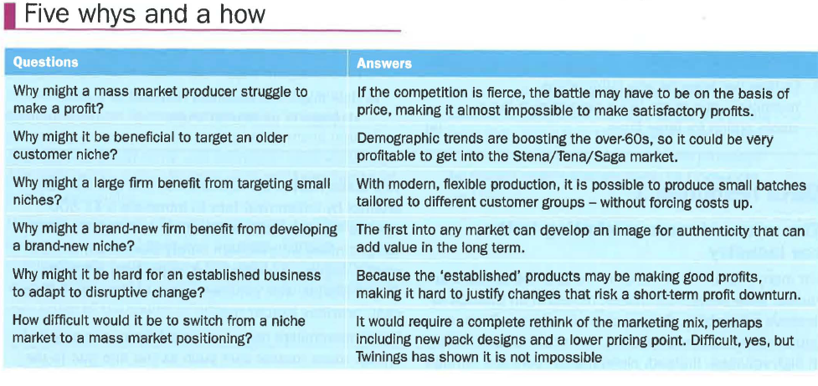
2.9 The market – evaluation

Which is better? Is it mass or niche marketing? The answer is that it depends. In the bulk ice cream market, large packs of vanilla ice cream have become so cheap that little profit can be made. It is better by far, then, to be in a separate niche, whether regional, such as Mackie's Scottish ice cream, or upmarket, such as Rocombe Farm or Haagen-Dazs. The latter can charge ten times as much per litre as the mass-market own-label bulk packs.

Yet would a film company prefer to sell a critic's favourite or a blockbuster smash hit? The answer is the latter, of course. In other words, the mass market is great, if you can succeed there. Businesses such as Heinz, Kellogg's and even Chanel show that mass marketing can be successful and profitable in the long term.

Key terms

Economies of scale: factors that cause costs per unit to fall when a firm operates at a higher level of production.
Franchise: a business that sells the rights to the use of its name and trading methods to local businesses.
Generic brands: brands that are so well known that customers say the brand when they mean the product (for example, 'I'll hoover the floor').
Product differentiation: the extent to which consumers perceive your brand as being different from others.

