Introduction to marketing
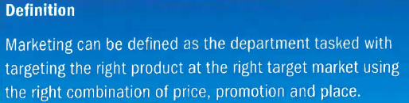
Peter Drucker, a famous business academic, says that, 'The aim of marketing is to know and understand the customer so well; the product or service fits him and sells itself.' In other words, marketing is about gaining an understanding of what product or service is needed to match customer requirements.

To turn this understanding into a profitable business requires the ability to communicate the customer benefits clearly and consistently. L'Oreal has been transformed from an also-ran into the world's biggest cosmetics business on the back of the brilliant claim of quality and superiority: 'Because I'm worth it'. Tesco went from number two in the grocery business to unrivalled number one with 'Every Little Helps'.

1.2 Marketing objectives
A marketing objective is a marketing target or goal that an organisation hopes to achieve, such as to boost market share from 9 to 12 per cent within two years. Marketing objectives steer the direction of the business. Operating a business without knowing your objectives, is like driving a car without knowing where you want to go.

Charities such as Oxfam and Christian Aid need marketing to keep their brands alive and donations coming in. Typical marketing objectives that a charity may set could include the following.
- Raise brand awareness. Brand awareness is the percentage of the market that knows of your brand.
- Brand loyalty. Brand loyalty exists when consumers return to your brand rather than swapping and switching between brands.
- Corporate image. A scandal-hit charity could set a marketing objective of trying to improve its reputation, in order to protect its income stream from donors.

1.3 Marketing strategy
Marketing strategy is the medium- to long-term plan for how to achieve your marketing objectives. The process of thinking it through requires rather more, though, than simply writing down a plan.

Hugh Davidson says that effective marketing strategy requires POISE

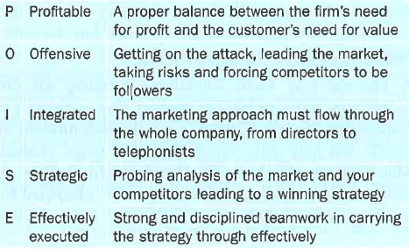
1.4 Making sure your marketing is effective
Effective marketing starts with identifying an opportunity. In many small businesses, the owner will come into regular contact with customers. This allows the owner to hear first-hand about the needs and wants of the target market.

In large businesses, formal market research is undertaken because head office managers cannot feel sure that they know what customers think and want. Once consumer wants have been identified, products and services will need to be designed to match consumer preferences.

Finally, a launch marketing mix must be decided. This involves decisions such as setting price, choosing an appropriate distribution channel and setting a promotional strategy.
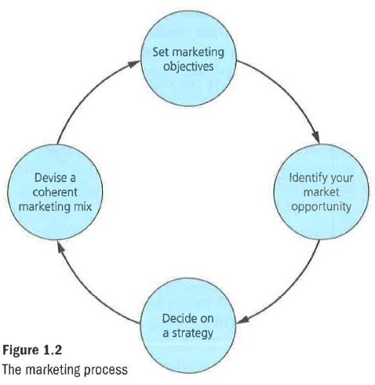
1.5 Why is effective marketing important?
Consumers tend to be quite rational. They will seek out fairly priced products that satisfy their needs. In a competitive market, firms stand or fall according to their ability to satisfy the needs of the consumer. Generally, firms that fail will lack customer loyalty and be punished automatically by the market. These firms will lose market share and profit.

Firms that fail to adapt their business model, at a time when consumer tastes are changing, are normally forced out of business. In recent years, retail chains such as HMV, Jessops and Blockbuster have collapsed.

1.6 The characteristics of effective marketing
Identifying the target market

When a business creates a new market (as Richard Branson is attempting currently with space tourism), it can aim its product at everyone who can afford the product. Some time later competitors will arrive, and usually focus on one segment of the market. In space tourism, perhaps some firms will focus on thrill-seekers, while others will target wealthy, older travellers seeking a super-safe, luxury version of the same thrill.

'Everyone is not your customer.'
Seth Godin, American entrepreneur

To succeed at marketing, you need to know and understand the customers within your target market:
what do they really want from your product? Is it the satisfaction of using/ having the product, or the satisfaction of showing it off to friends? What are their interests and lifestyle? Having a clear idea of the age, sex and personality of the target market enables the business to do the following things.

Focus your market research

A business may focus market research by interviewing only those who make up the target market. 'This should make the findings far more re liable. If the target market is clearly defined, the firm's market research budget can be spent with greater effect.

Focus your advertising spending

A business may focus advertising spending on the people most likely to buy the product. One national TV commercial can cost £500,000; it will reach millions of people, but how many are really in the target market? Men do not need to know that 'Maybe it's Maybelline'. A product targeting young women would be advertised far more cost-effectively in magazines such as Look or New!

Segment your markets

Most markets are not made up of identikit consumers who all want exactly the same product. In practice, consumer preferences can vary greatly. Firms that market their products effectively in this situation produce a range of products, each targeted at specific market segments.

A coherent brand image through a coherent marketing mix

Firms that market their products successfully use the marketing mix in an integrated manner to create a coherent and attractive brand image that appeals to the target market. Marketing success depends upon getting all four marketing mix decisions right. A good product that is properly priced and promoted will still fail if distribution is poor. Firms use the marketing mix to create an attractive and coherent brand image for each of the products that they sell. Creating the right brand image is important. If the brand image created by the marketing mix appeals to the target market, there should be an increased chance that the product will succeed.

The most important thing to remember is that all four elements of the mix must be co-ordinated. If the marketing mix is not co-ordinated, mixed product messages will be sent out to the target market. This could create confusion, leading to disappointing sales.

1.7 Short-termist marketing ineffective marketing
Short-termism describes a business philosophy whereby a firm pursues strategies that could boost profit in
the short run, even if these strategies damage the firm's long-run profitability. Some examples of short-termist marketing strategies are given below.

High prices designed to exploit consumer loyalty or a dominant market position

In the short run, firms that operate in a market where there is little competition may be tempted to raise their prices to boost revenues and profits. A decision to exploit consumers by charging high prices is definitely not a good example of effective marketing. High prices can also encourage new competitors to join the industry.

Short-run sales-driven marketing
Some managers believe that their employees can only be motivated to work hard if they are set targets that are linked to bonuses and other performance-related payments. This can create a ruthless and dishonest culture that can affect a firm’s marketing. Miss selling of PPI has not worked out too well for the banks!

Five whys and a how
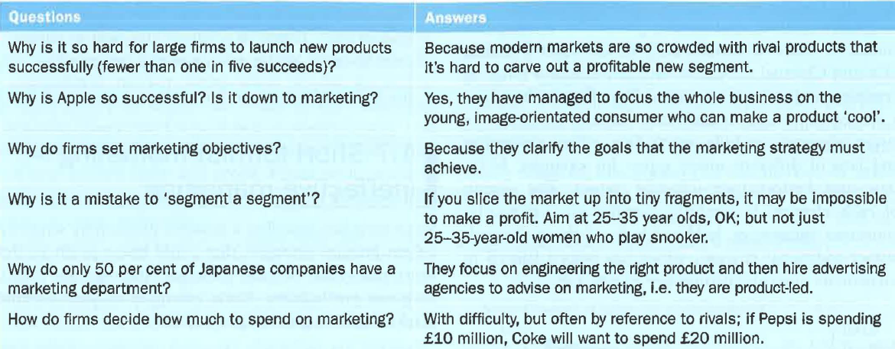

1.8 Introduction to marketing – evaluation
Marketing guru Philip Kotler says that 'marketing only takes a day to learn, but a lifetime to master'. It seems easy to learn what customers want - and sell it to them.

In fact, new product launches by big UK companies such as Mars and Heinz have a success rate of less than 20 per cent. So marketing is harder than it looks – largely because it is easy to ask questions, but harder to interpret the results.

All that is certain about marketing is that there is a wrong way to do it. A short-termist approach based on cynicism will backfire. There may be lots of money to be made before it backfires, but backfire it will.

Abraham Lincoln:
'You can fool all the people some of the time, and some of the people all of the time, but you cannot fool all the people all the time.'

