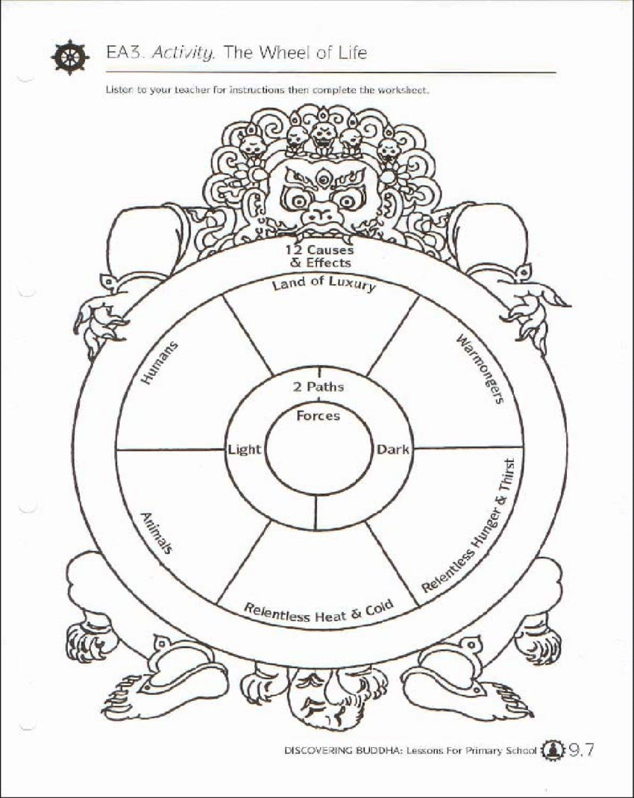

Dependent arising is the idea that everything that happens is dependent on __________________. The ____________ of ________ illustrates this idea. For example, the ___________ _______________ such as the potter shows how our lives are _____________ by our _____________, positive actions leads to _______________ results, this is the idea of ___________.

**Dependent**

**Arising**

**The Tibetan**

**Wheel of Life**