[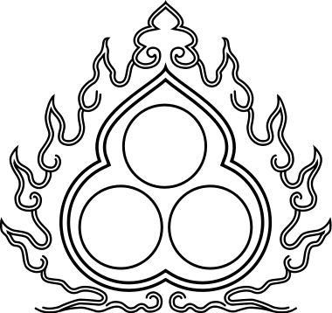](https://www.google.com/url?sa=i&rct=j&q=&esrc=s&source=images&cd=&cad=rja&uact=8&ved=2ahUKEwjwnNfa0NPcAhXPzYUKHUEqA4YQjRx6BAgBEAU&url=https://www.pinterest.com/pin/350154939747844877/&psig=AOvVaw33wKBDjQTyCeI2FABSmjUJ&ust=1533477743047971)[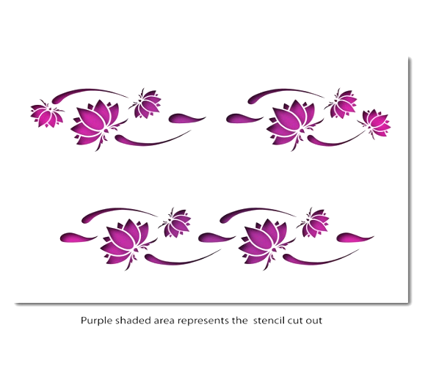](https://www.google.com/url?sa=i&rct=j&q=&esrc=s&source=images&cd=&cad=rja&uact=8&ved=2ahUKEwiLifnA5s_fAhXDzIUKHUHqAvEQjRx6BAgBEAU&url=https://www.ebay.co.uk/itm/Lotus-Flower-Border-Stencil-CraftStar-Laser-Cut-Border-Stencil-/262841266351&psig=AOvVaw2DtDj2nP2DauqJ-cM9HIQS&ust=1546542627994322)[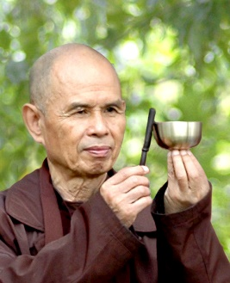](https://www.google.com/url?sa=i&rct=j&q=&esrc=s&source=images&cd=&cad=rja&uact=8&ved=2ahUKEwiO18fn5c_fAhWHxYUKHRB6CTIQjRx6BAgBEAU&url=https://blogs.psychcentral.com/mindfulness/2014/11/a-mindful-gift-from-thich-nhat-hanh-thay-to-all-of-us/&psig=AOvVaw1j6UZkxX9lTb6yaV2r9E5f&ust=1546541996156034)

1. In the outline above, note down the three elements of the triple refuge.

2. Going for refuge for a Buddhist means to seek __________________ from

_______________________. For example Buddha’s teachings in the

_______________ we take refuge (try to find happiness) in things that are _______________ and _____________________. For example ________________

___________________________________________________________________.

3. For Buddhists taking refuge means ______________ for the _____________

Dharma and ____________ to guide them to develop _____________________

and ______________.

4. It could be said that the Buddha is the most important of the triple refuge because ____________________________________________________________

___________________________________________________________________. However it could also be said that the Dharma is more important because ______

___________________________________________________________________. The Sangha is also very important because ________________________________

________________________________________________________________________

*Thich Nhat Hanh… on Buddha Dharma;*

My teaching is not a __________________. It is a result of ____________ ____________________. My teaching is a means of _______________, not something to __________ on to or _____________.

What this means is, that the Dharma should be _________________ and be a way of _________ rather than just ___________________ or blindly ______________.

**The Triple Refuge (Three Jewels)**