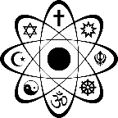
Religion & Science – Quiz

- Give 3 general causes/grounds for belief.

- Give 2 ways in which someone may justify their beliefs.

- Give 1 example of an ‘absolute truth’.

- Give 3 examples of miracles.

- Give 2 scientific theories about the creation of the earth.

- Give 1 religious belief about the creation of the earth.

- Give 3 reasons why religion and science are thought to be incompatible.

- Give 2 examples of ‘truths’ that have changed.

- Give 1 reason why religion can sometimes be necessary when new scientific discoveries are made.

