[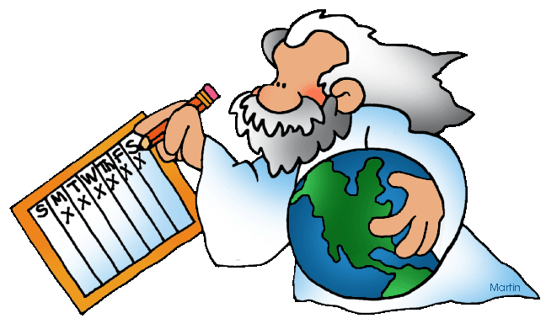](https://www.google.co.uk/url?sa=i&rct=j&q=&esrc=s&source=images&cd=&cad=rja&uact=8&ved=0ahUKEwjsg4agr6_ZAhWROsAKHc2pBtcQjRwIBw&url=http://biblestudy.pppst.com/genesis/creation.html&psig=AOvVaw34Fi5dGAvPZ9hd52G9MmIr&ust=1519040021571458)

**Religion & Science – Creation**

The Creation Theories.

The Big Bang Theory:

* Many scientists believe the universe began in a hot ‘big bang’ about 13,600 million years ago. The theory states that the universe was concentrated into a single, incredibly tiny point, this began to enlarge and resulted in the explosion, now referred to as the Big Bang.
* Evidence for the Big Bang includes the following facts; the universe continues to expand, the existence of background radiation and red-shift (stars do not stay the same, the change as they age). Scientific observations suggest that all galaxies are moving away from us – just as matter moves away from the origins of an explosion.

[](https://www.google.co.uk/url?sa=i&rct=j&q=&esrc=s&source=images&cd=&cad=rja&uact=8&ved=2ahUKEwiI7_K2q6jZAhXDYlAKHWfqDIMQjRx6BAgAEAY&url=https://www.dreamstime.com/stock-photos-explosion-vector-illustration-image23214093&psig=AOvVaw0mQ-bbT-kgYDYq59ZxDt71&ust=1518798336409797)

The Steady State Theory:

* An alternative theory to the Big Bang theory, Steady State suggests that the density of matter in the expanding universe remains unchanged due to a continuous creation of matter.
* Since the mid-20th century this theory has been largely rejected as the observational evidence points more to the hot Big Bang cosmology with a finite age of the universe, which the steady state does not.

[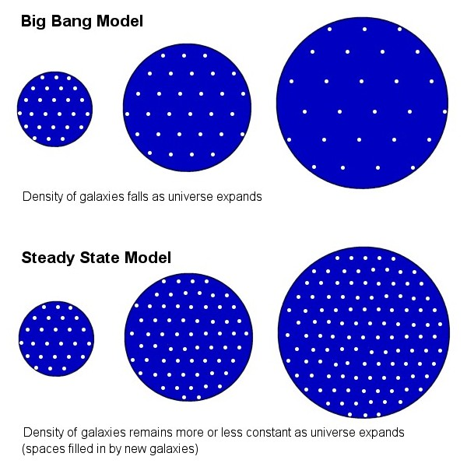](https://www.google.co.uk/url?sa=i&rct=j&q=&esrc=s&source=images&cd=&cad=rja&uact=8&ved=2ahUKEwi97p75rqjZAhURL1AKHfVGB1QQjRx6BAgAEAY&url=https://thespaceplaceforspace.weebly.com/steady-state-theory.html&psig=AOvVaw3DavfoSojW0FbMaqCyGlsO&ust=1518799346859055)

[](https://www.google.co.uk/url?sa=i&rct=j&q=&esrc=s&source=images&cd=&cad=rja&uact=8&ved=2ahUKEwi97p75rqjZAhURL1AKHfVGB1QQjRx6BAgAEAY&url=https://thespaceplaceforspace.weebly.com/steady-state-theory.html&psig=AOvVaw3DavfoSojW0FbMaqCyGlsO&ust=1518799346859055)

[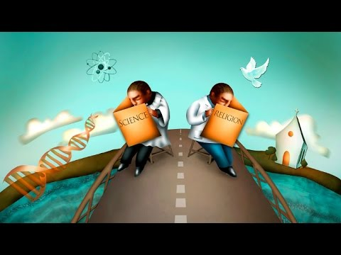](https://www.google.co.uk/url?sa=i&rct=j&q=&esrc=s&source=images&cd=&cad=rja&uact=8&ved=2ahUKEwj0r5SXu6jZAhVG46QKHV9NBUoQjRx6BAgAEAY&url=https://www.youtube.com/watch?v%3DSuslgoGJdiw&psig=AOvVaw3DavfoSojW0FbMaqCyGlsO&ust=1518799346859055)

Explain…

1. …briefly, the Big Bang theory and the evidence for it.
2. … briefly the Steady State theory.
3. … why most scientists now dismiss the steady state theory.

Intelligent design (ID) and irreducible complexity:

* ID is pseudoscientific view that ‘certain features of the universe and of living things are best explained by an intelligent cause rather than an undirected process such as natural selection. As such, philosophers and scientists agree that ID is a religious argument, a form of creationism which lacks empirical evidence and offers no testable hypotheses.
* Creationism starts with a religious text and then tries to see how the findings of science and evidence from nature can be reconciled to it. ID, unlike creationism, does not identify the intelligent cause as supernatural.
* The origins of ID are with Professor Michael Behe (1996). He says he once fully accepted the scientific theory of evolution however he came to believe that there were ‘irreducibly complex’ systems in nature that could not have evolved by natural selection.

[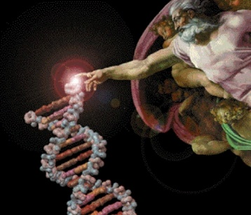](https://www.google.co.uk/url?sa=i&rct=j&q=&esrc=s&source=images&cd=&cad=rja&uact=8&ved=0ahUKEwjR3u_5parZAhXoAMAKHQMAB5IQjRwIBw&url=http://blogs.christianpost.com/science-and-faith/removing-the-darwinian-spin-to-research-dominated-by-intelligent-design-9698/&psig=AOvVaw1a9M1C3mWDCSO_ify2L1ik&ust=1518865683771036)

Intelligent design (ID) and irreducible complexity (cont/d):

* Example/analogy – Behe uses the mousetrap as an analogy for his belief that many aspects of life show design. A mousetrap has five interacting pieces, all of these must be in place for the mousetrap to work, as removal of just one piece would render it useless. Likewise, irreducible complexity of ID claims that natural selection could not create from scratch those systems for which science is currently unable to find a viable evolutionary path of successive, slight modifications because the selectable function is only present when all parts are assembled.
* Examples of irreducible complexity include; the process of blood clotting and the eye. The process of metamorphosis, as seen in insects such as butterflies, is an incredibly complex reorganization of the caterpillar. The larva disintegrates and rematerializes as a more complex flying insect. How did the caterpillar avoid extinction when it has to first become a butterfly in order to reproduce? Without metamorphosis and then

sexual reproduction, the caterpillar could not have survived to the

present day. How does metamorphosis evolve when it is a highly

complex process of taking a non-reproducing organism and turning it

into a reproducing one? The reproducing organism must first have

existed in order for its larva to exist and acquire the ability to

metamorphosize through genetic mutation according to evolution. But

how can its reproducing stage exist without metamorphosis in the first

place?

Strengths of the theory;

* ID pinpoints some of the ideas which Darwin himself recognised would falsify his theory, he also gave the example of the eye.
* Despite Behe publishing his ideas in 1996, both Plato and Cicero proposed ideas of ID, so it has a very long history.
* It doesn’t have to have a religious/theistic connection.
* It encourages evolution to be taught, so it can be questioned.

Weaknesses of the theory;

* It is an argument from ignorance – we can’t understand how the eye could evolve, therefore we attribute an intelligent designer to its design.
* Evolutionary biologists claim to have explanations for some ‘irreducibly complex’ phenomena.
* Ken Miller, returns to the mousetrap analogy – he argues that by removing parts of the mousetrap it won’t catch any mice, but it could be used as a tie clip – items may not end up the way we see them now.
* Irreducible is at its core and argument *against* evolution, rather than *for* anything else.
* However… this conclusion is based on the assumption that current evolutionary theory and intelligent design are the only two valid models to explain life which is a false dilemma.

[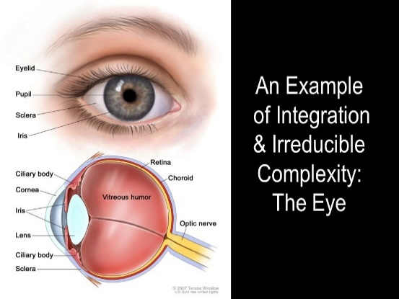](https://www.google.co.uk/url?sa=i&rct=j&q=&esrc=s&source=images&cd=&cad=rja&uact=8&ved=0ahUKEwiO_e68u6rZAhXlJcAKHaPbD0UQjRwIBw&url=http://slideplayer.com/slide/1647787/&psig=AOvVaw2_n45dHQWG-kArMDmHr6_Q&ust=1518871417166154)

[](https://www.google.co.uk/url?sa=i&rct=j&q=&esrc=s&source=images&cd=&cad=rja&uact=8&ved=0ahUKEwjD1PP1uKrZAhUTPsAKHfTRAskQjRwIBw&url=http://landentuinbouw.spinazieacademie.nl/2011/05/quiche-in-de-muizenval.html&psig=AOvVaw1BHuQNKy5N-uEpa4hH_Ymm&ust=1518870769524296)

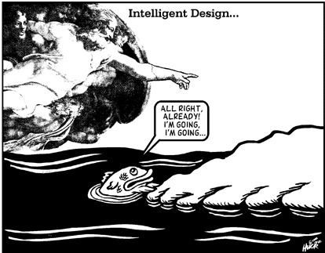

Explain…

1. … the main points of the theory of Intelligent Design. Include evidence and examples and make sure you refer to ‘irreducible complexity’ in your explanation
2. … some of the main issues with intelligent design as an explanation for the creation of the universe
3. … the strengths and weaknesses of ID.

Creationism:

* Based on the two creation stories in the Bible – Genesis 1: 1 - 27 and Genesis 2:4 – 3:24
* A largely fundamentalist belief – what it says in the Bible is what happened, if science proposes other theories, science is wrong.

Contemporary issues with the first creation story;

* Genetic engineering/cloning
* The Big Bang
* Sunday Trading
* Climate Change/environmental issues – human responsibility to look after the earth
* Design faults

Themes of the second creation story;

* The Garden represents paradise
* Man is given just one rule
* Freewill
* Naivety – man and woman were inexperienced and innocent
* Authority – man was given authority over the earth and other creatures

Contemporary issues with the second creation story;

* Differences with the first creation story (e.g. creation by command verses creation out of something)
* What is true perfection?
* Freewill – do we need rules?
* Different roles for men and women.

[](https://www.google.co.uk/url?sa=i&rct=j&q=&esrc=s&source=images&cd=&cad=rja&uact=8&ved=0ahUKEwj9r_OLkK3ZAhULJsAKHU6XDx4QjRwIBw&url=https://www.123rf.com/clipart-vector/earthquake.html&psig=AOvVaw2qMV1u654NBeiFAShPh3vH&ust=1518962933635743)

Explain…

1. …briefly, the Big Bang theory and the evidence for it.
2. … briefly the Steady State theory.
3. … why most scientists now dismiss the steady state theory.

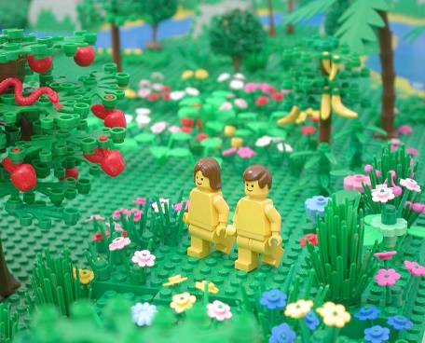

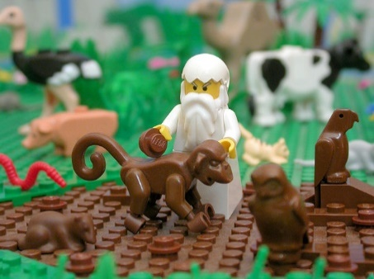

[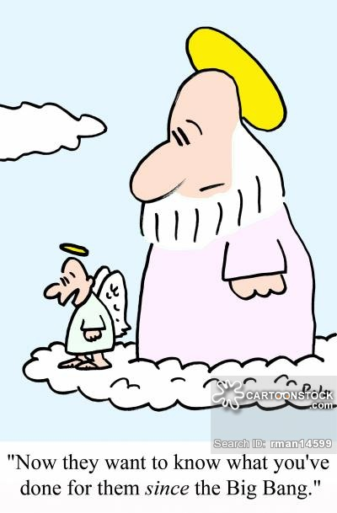](https://www.google.co.uk/url?sa=i&rct=j&q=&esrc=s&source=images&cd=&cad=rja&uact=8&ved=2ahUKEwjFu5L7qqjZAhUFZlAKHZ5vD8YQjRx6BAgAEAY&url=https://www.cartoonstock.com/directory/b/big_bangs.asp&psig=AOvVaw0mQ-bbT-kgYDYq59ZxDt71&ust=1518798336409797)

Explain…

1. … briefly, the main points of each of the two creation stories in the Bible.
2. … briefly, what creationism is.
3. … the strengths and weakness of creationism. Make sure you include examples and reference to scientific theories.
4. … some of the issues raised for Christians in the light of the belief that God created the earth and modern scientific advances. Refer to liberal Christians and fundamentalist Christians.

[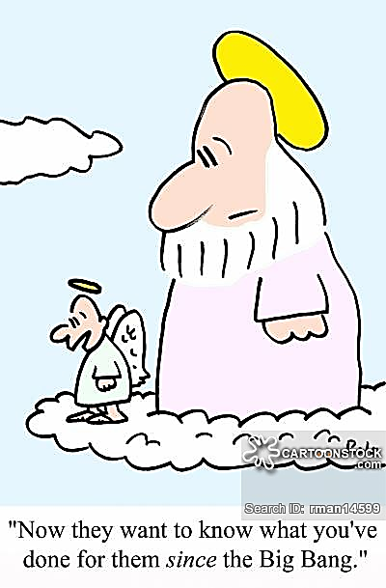](https://www.google.co.uk/url?sa=i&rct=j&q=&esrc=s&source=images&cd=&cad=rja&uact=8&ved=2ahUKEwjFu5L7qqjZAhUFZlAKHZ5vD8YQjRx6BAgAEAY&url=https://www.cartoonstock.com/directory/b/big_bangs.asp&psig=AOvVaw0mQ-bbT-kgYDYq59ZxDt71&ust=1518798336409797)

[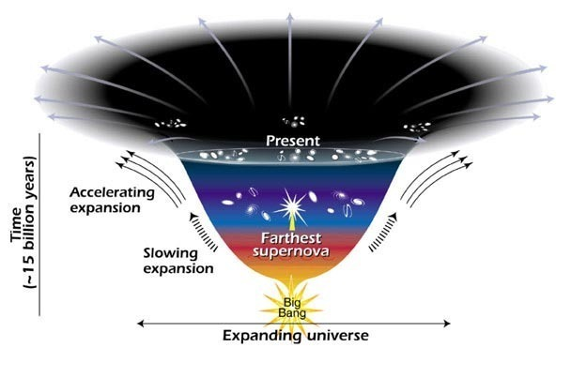](https://www.google.co.uk/url?sa=i&rct=j&q=&esrc=s&source=images&cd=&cad=rja&uact=8&ved=0ahUKEwj_8-rTm63ZAhVoLMAKHUrdBxIQjRwIBw&url=https://arstechnica.com/science/2012/02/cosmological-constant-in-a-bose-einstein-condensate/?comments%3D1&psig=AOvVaw04x30hYFgRFjfppQM56Gfu&ust=1518966043050114)

Cosmological Constant:

* In the context of cosmology the cosmological constant is an energy density that causes the expansion of the universe to accelerate. It is also known as dark energy – the unknown cause of the acceleration of the universe. Originally proposed in the development of general relativity in order to allow a static universe solution it was subsequently abandoned when the universe was found to be expanding.
* Now the cosmological constant is used to explain the observed acceleration of the expansion of the universe.

Darwin’s theory of Evolution:

* A species is a collection of organisms that interbreeds and has fertile offspring. Living organisms have descended with modifications from species that lived before them.
* Natural selection explains how this evolution happened. More organisms are produced than can survive because of limited resources, there is competition amongst organisms for the necessities of life. Some variants in species are better adapted to survive and

reproduce under local conditions than others,

these better-adapted individuals, the ‘fit

enough’, are more likely to survive and pass on

copies of their genes to the next generation,

others become extinct.

evolution, Gaia hypothesis. With reference to the ideas of C Darwin and R Dawkins.

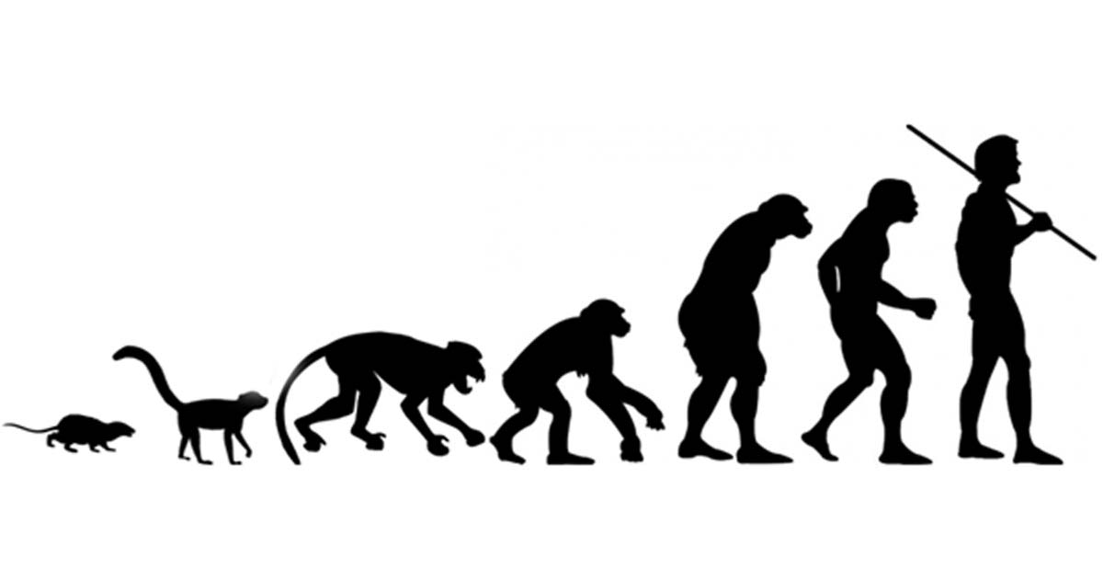

James Lovelock’s Gaia Hypothesis:

* Lovelock’s Gaia Hypothesis (Gaia – the Greek goddess of the Earth) is the most popular form of eco-holism - an idea that emphasises the interdependence of all ecosystems rather than the rights of humans. The hypothesis challenges the view that humans are the most important species.
* At one point Lovelock worked for NASA. Looking at Earth from space he saw it as a whole, self-regulating living thing, rather than a planet of diverse life forms.
* In his early work, Lovelock argued that Gaia is regulated by the living organisms within it to sustain suitable conditions for growth and development. He later rejected this and saw regulation conducted by the whole of Gaia, not just living organisms.
* Conditions seem to have favoured life – they are not random but intelligently organised, not by God, but by Gaia herself.
* This theory opposes the Darwinian theory of survival of the fittest and says that conditions on earth are actually managed by Gaia herself.

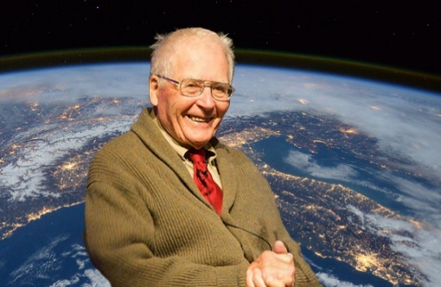

Gaia Hypothesis – strengths and weaknesses:

*Strengths*

* Lovelock’s theory suggests life cannot be destroyed. This is backed up with evidence - such as algae resistant to ultraviolent radiation, life returning after a devastating forest fire and on Bikini Atoll, where nuclear bombs were tested, life has returned.
* In Chernobyl, human life was wiped out but Gaia herself survives as humans are only a part of Gaia.
* The theory challenges humans to change their perceptions and see themselves as part of a whole. If we abuse Gaia we risk our own survival. The earth, then is a holistic living entity, humans have no particular significance, but we are part of it and all organisms are interdependent.
* Lovelock, in a later book, is more pessimistic about climate change and our reluctance to confront it. He has concerns that the planet may not be able to recover, as he once thought. He believes we have misused this planet so much that Gaia will not help us and has ultimately abandoned us. This may encourage some to work harder to protect the earth and is compatible with the idea of stewardship.
* Peter Singer agrees with Gaia and would argue that other secular responses have committed ‘speciesism’.

*Weaknesses*

* Christians would point out that God could be behind the Gaia effect. They would also say that the Bible creation stories give man domination over his creation, He created it and it is intrinsically good.
* There is no empirical evidence for the existence of Gaia.

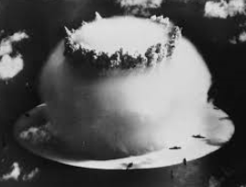

[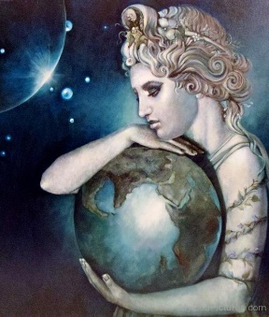](https://www.google.co.uk/url?sa=i&rct=j&q=&esrc=s&source=images&cd=&cad=rja&uact=8&ved=0ahUKEwibwa___q3ZAhUiJcAKHXj2AxkQjRwIBw&url=http://www.mygodpictures.com/gaia-earth-goddess/&psig=AOvVaw30RaZVyylShVb-m6UU8gBg&ust=1518992668963106)

Explain…

1. … briefly, the cosmic constant.
2. … the main strength of this theory.
3. … briefly, the main points of the theory of evolution.
4. … how different Christians (liberals and fundamentalists) might respond to the theory of evolution.
5. … the main points of Lovelock’s Gaia hypothesis.
6. … the main strengths and weaknesses of the Gaia hypothesis. Include examples and reference to Christian beliefs.

[](https://www.google.co.uk/url?sa=i&rct=j&q=&esrc=s&source=images&cd=&cad=rja&uact=8&ved=0ahUKEwili9CPhq7ZAhWiKcAKHYqBDuoQjRwIBw&url=https://www.unitism.com/land/en/7-earth-our-home&psig=AOvVaw2TeZhn_5BlKNQ4Lcx8pVv_&ust=1518994505551194)

Exam questions.

1. Examine the grounds for religious beliefs. (*8 marks*)
2. Evaluate the validity of miracles. (*9 marks*)
3. Evaluate the strengths and weaknesses of religious beliefs about the creation of the earth. (*30 marks*)

[](https://www.google.co.uk/url?sa=i&rct=j&q=&esrc=s&source=images&cd=&cad=rja&uact=8&ved=0ahUKEwijrcbSrq_ZAhUJI8AKHV4BBiMQjRwIBw&url=https://daniellestolt.wordpress.com/2012/12/19/what-do-we-actually-want/question-mark/&psig=AOvVaw0pBO-cbNLPdm3x6pNuFkmV&ust=1519039854334116)