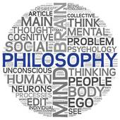
Jesus’ Miracles
Miracle | Brief description | Explanation/meaning | Quotation(s) | Reasons

