Religion & Science – Finding the ‘Truth’

‘Truth’.

What is ‘true’ for someone may not be true for someone else. Beliefs are often regarded as simply the products of the believer’s upbringing and culture. It may well be true that beliefs are affected by culture, but this does not deny their truth or falsity. Someone born into an Islamic culture is very likely to grow up a Muslim, someone whose parents are atheist may also adopt these views. The key question however is not whether the majority view or cultural influences makes something true, but whether there are adequate grounds for something to be true.

Methodologies for investigating ‘truth’.
When thinking about beliefs it is important to distinguish between the causes for belief, and the grounds or evidence for the belief.

Question: What causes people to hold religious beliefs?

Method: Investigate the factors which encourage or discourage people to hold religious beliefs.

Focus: Causes of belief.

Question: What beliefs do people hold?

Method: Conduct surveys and study world religions.

Focus: Content of belief.

Question: Are the beliefs true?

Method: Investigate claims that God exists and has spoken to us.

Focus: Grounds for belief.

Causes of belief.

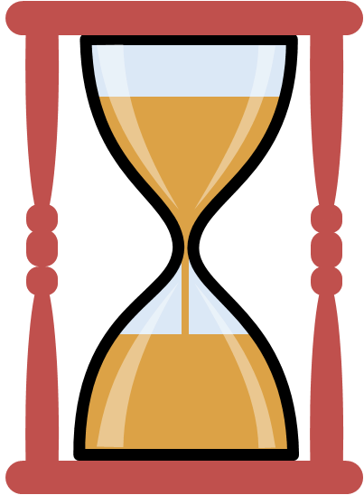
There are many causes of belief, it might be fear, wishful thinking, the need for security or hope, upbringing etc. The motives for accepting or rejecting a belief neither validates or invalidates a belief. If the cause of our belief, however is not adequate and we do not examine our beliefs they are less likely to stand the test of time. For example believing in something, just because your family do may not end up being a life-long belief because we grow up, experience different things to our parents and develop our own minds and ideas. If we investigate why our families have help these beliefs and we accept the original and ongoing causes of the beliefs then our inherited beliefs may last the test of time.
Explain...

- Explain, with examples how our perceptions of ‘truth’ can be affected.
- Explain, with examples how one’s background and upbringing can affect what a person believes to be true.
- Explain, with examples, the following causes of belief; (a) fear; (b) wishful thinking; and (c) the need for security.
- Explain, with examples why our inherited beliefs may change or develop.
- Explain, with examples why, if investigated, inherited beliefs my be solidified.

Grounds of belief.

These are objective factors which exist independently of whether anyone believes them or not.
2. Susan believed she had won a prize draw because someone said they had seen her name on a list of winners

An example;

3. Susan believed she had won a prize draw because she had seen her name on the official list of winners.

1. Susan believed she had won a prize draw because her ticket had her lucky number on it.

Suppose the person who had told Susan that they had seen her name on the list of winners was lying and hadn’t even seen the list, but it was still true that Susan was on the list had won. Susan would be believeing the right thing but for the wrong reason. However, she would not have been justified in believing it even though it was true. Only in the last instance (3) would there be grounds for Susan to believe she had won. But in that case we would say Susan knew she had won, rather than Susan believed she had won. The word ‘know’ is kept for things that are true and have been proven.
Some philosophers define knowledge as, ‘justified, true belief’. Whether a belief is justified or not depends on the evidence for it.
Proof/evidence;

- Justified, true belief depends on external, objective evidence – the grounds for belief. For example, we see something happen, we believe it.

- Sometimes we rely on indirect evidence, for example someone else tells us something has happened and if we trust that person, we tend to believe them.

- Cumulative evidence, is perhaps the most reliable form of evidence. For example, if we see something highly unusual, later we may question ourselves, but if there are additional bits of evidence such as other sightings, other reasons to accept our own experience, this collection of evidence may convince us.

There are very few ‘absolute truths’. Disproving can be quite easily proved, but proving something is true ‘beyond doubt’ is very difficult. Even in science, where experimentation is repeated many times to gain the same result, how can we be 100% sure that the equipment used is calibrated correctly, the test group is big enough, or that in the future, a different experiment would gain a different result?
Things to do;

- Give an example of a ‘truth’ – scientific or historical. Explain why we have this ‘truth’ (referring to direct, indirect and cumulative evidence.

- Explain why this example may not be considered an ‘absolute truth’.

So what has all this got to do with religious belief?

In every area of life, we like to be satisfied with the grounds for our beliefs, even if that does fall short of absolute certainty. This is why there is a demand for proof of God. However, this demand is unrealistic if it means, ‘prove it in a way no one could possibly question’. We don’t do this in science, so why do we expect it of religion?
In religion there are important differences from the use of evidence in science. For example evidence for God is not the same as evidence for electrons although the evidence for both is ‘indirect’. Indirect evidence in science is for invisible physical ‘objects’, but God, though invisible is not a physical object.

Einstein’s Static Universe.

A static universe, also called a “stationary” or “Einstein” universe, was a model proposed by Albert Einstein in 1917. Edwin Hubble obliterated it by demonstrating the relationship between red shift—the way the colour of stars/ planets change as they move away from us, which showed that the universe was indeed expanding.

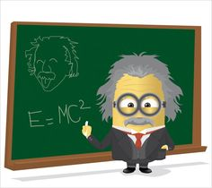

The Flat Earth.

Up to the late middle ages we would certainly not have been ridiculed for saying that the earth was flat – after all it is what we see. However despite all observers looking at a horizon and coming to the same conclusion – one man saw it differently. Columbus saw how ships gradually disappeared over the horizon, suggesting to him that the earth was indeed spherical.

Claims about the truth of religious beliefs may make appeals to the evidence from religious experience and the results of those experiences; from sacred texts; history and from looking at the complexities of the natural world; from reason or from revelation.

Some tests for religious truth apply to other disciplines too. For example, we can ask, ‘is the belief system consistent? Free from contradictions? Is it coherent – does it make sense? Is it comprehensive – covering a whole range of human experience?

Comments such as, ‘it’s all a matter of interpretation’, might suggest religious belief is just a matter of personal preference. But not all interpretations are equally valid. Some interpretations fit the data better than others, whether we like it or not. It would be misleading to imagine that everyone looking at the same evidence comes to the same conclusion.

Sometimes the search for ‘truth’ is prized more highly than the finding of answers. As finding answers could demand an unwelcome change of lifestyle!

‘There comes a moment when the children who have been playing at burglars
hush suddenly: was that a real footstep in the hall? There comes a moment
when people have been dabbling in religion (‘Man’s search for God’!) suddenly
draw back. Supposing we really found him? We never meant it to come to
that! Worse still, supposing he found us?’ C.S. Lewis

Explain…

- Explain, with an example how evidence can be used to find religious truths.
- Explain, with examples why looking for religious truths is different, but also in some ways similar, to looking for scientific truths.
- Explain with examples how religious truth can be proven and why this can be similar to how scientific or historical truths can be proven.

