Mind, Body, Dualism & Monism

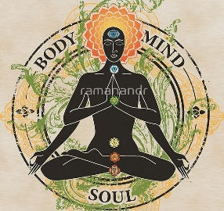
Mind Body Debate

The mind is about mental processes, thought and consciousness. The body is about the physical aspects of the brain-neurons and how the brain is structured. The mind-body problem is about how these two interact.

One of the central questions in psychology and philosophy concerns the mind/body problem: is the mind part of the body, or the body part of the mind? If they are distinct, then how do they interact? And which of the two is in charge?

Many theories have been put forward to explain the relationship between what we call the mind (defined as the conscious thinking 'you' which experiences your thoughts) and the brain (i.e. part of your body).

However, the most common explanation concerns the question of whether the mind and body are separate or the same thing.

Dualism
Human beings are material objects. We have weight, solidity and consist of a variety of solids, liquids and gases. However, unlike other material objects (e.g. rocks) humans also have the ability to form judgments and reason their existence. In short we have 'minds'.

Typically humans are characterized as having both a mind (nonphysical) and body/brain (physical). This is known as dualism. Dualism is the view that the mind and body both exist as separate entities.

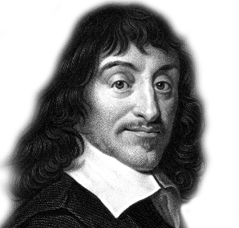
Descartes / Cartesian dualism argues that there is a two-way interaction between mental and physical substances.

Descartes argued that the mind interacts with the body at the pineal gland. This form of dualism or duality proposes that the mind controls the body, but that the body can also influence the otherwise rational mind, such as when people act out of passion.

Monism

There are two basic types of monism:

o Materialism is the belief that nothing exists apart from the material world (i.e. physical matter like the brain); materialists generally agree that consciousness (the mind) is the function of the brain. Mental processes can be identified with purely physical processes in the central nervous system, and that human beings are just complicated physiological organisms, no more than that.

o Phenomenalism (also called Subjective Idealism) believes that physical objects and events are reducible to mental objects, properties, events. Ultimately, only mental objects (i.e. the mind) exist. Bishop Berkeley claimed that what we think of as our body is merely the perception of mind. Before you reject this too rapidly consider the results of a recent study.

Explain…

- Explain Cartesian dualism.
- Explain the two types of monism.
- Explain, phenomenalism with an example.
- How might these ideas affect beliefs about life after death?

Scientists asked three hemiplegic (i.e. loss of movement from one side of the body) stroke victims with damage to the right hemispheres of their brains about their abilities to move their arms. All three claimed, despite evidence to the contrary in the mirror in front of them, that they could move their right and left hands equally well.

The Kantian Moral Argument

Immanuel Kant’s moral argument is based on the rationality of moral behaviour.
Strictly speaking, Kant’s argument is not an argument for God’s existence, but rather for justice in the afterlife. The argument’s structure is this:

- Moral behaviour is rational.
- Morality behaviour is only rational if justice will be done.
- Justice will only be done if God exists. Therefore…
- God exists.

Moral Behaviour is Rational
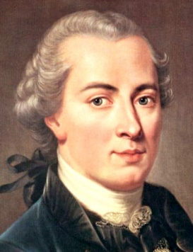
Moral behaviour, Kant says, is rational behaviour; we have good reason to be moral. This is a fundamental principle of morality: if you ought to do something then you have a reason to do it. It makes no sense to say “I see that I ought to give money to charity, but I have no reason to.” If we have a moral reason to do a thing, and another reason not to do it, then rationally speaking we ought to do it. Moral behaviour is always rational.

Moral Behaviour is Only Rational if Justice Will be Done
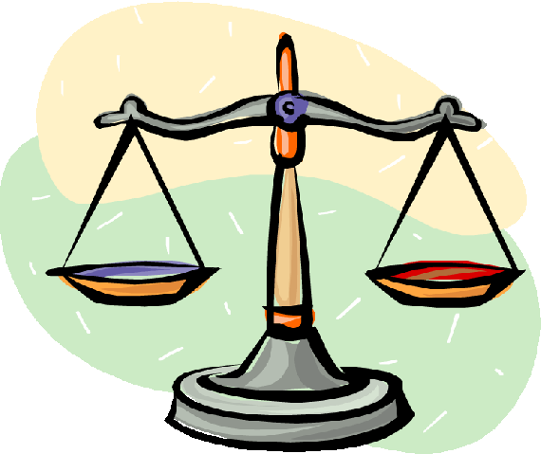
Moral behaviour, though, would not be rational if there were no guarantee that it would be rewarded. If, as seems to be the case, sin often profits more than righteousness, then surely it is sinful rather than righteous behaviour that would be rational. Faced with a choice between doing that which is right and doing that which is wrong but which benefits us most, if there are no comebacks for immorality then it is rational for us to do that which is wrong but which benefits us most. It is only if there are comebacks for immorality, if justice will ultimately be done, that we have a reason to be moral.

Justice Will Only be Done if God Exists

Clearly justice is not administered in this life: some cheats prosper; some crime pays; bad things happen to good people. People do not always, or even often, get what they deserve. Life doesn’t seem fair.
If this life is all there is, then, justice is not done, and so moral behaviour is not rational; we have no reason to be good. This life, then, cannot be all that there is. There must be something more.
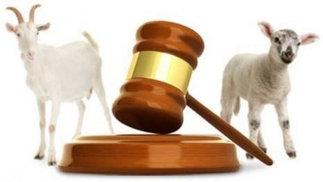
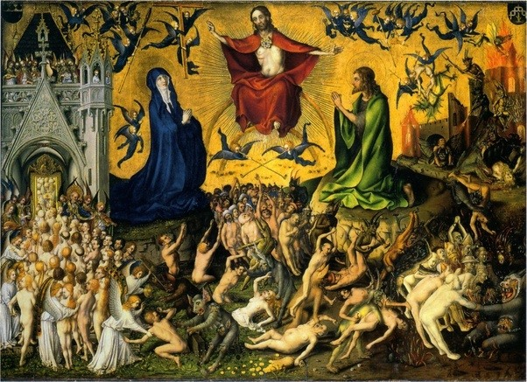
The traditional Christian view of life after death has justice being meted out to sinners, and the righteous receiving the reward that they deserve. If this view, or some other like it, is correct, then we can explain the rationality of morality. If not, then, we cannot. The rationality of morality therefore establishes that something like the Christian view of the afterlife is correct.

Explain…

- Explain why Kant believed God exists due to morality.
- Explain how, according to Kant, the idea of justice links to the existence of an afterlife.
- Look up the parable of the sheep and goats Matthew 25:31-46. Explain how this parable backs up Kant’s theory.

b) Life after death linked to moral reasoning, near death experiences, debates related to role of evidence, religious language.
With reference to the ideas of Plato and Aristotle

