A2 R. S. Plato – The Analogy of the Cave.



Plato questioned what was real. He believed that world we see around us is just an illusion created by our senses (sight, sound, touch, smell and taste). The senses are deceived by appearances and are therefore unreliable. Our senses enable us to form opinions about the world, but they can never give us true knowledge.

Plato believed that true knowledge can only be gained through the use of our minds, by the powers of rational thought. True reality lies beyond the senses. He believed that the most important task for the philosopher was to seek knowledge of this reality by searching beyond the appearances of the world.

Task one.

1. Explain, using examples, how our senses are sometimes deceived.
2. Which sense do you think you would miss the most if you were to suddenly lose it? Explain your answer.
3. Considering your answer for (b) is this, in your opinion, the most important sense and also the most easily deceived? Explain your answer.

Plato illustrates the contrast between appearances and reality as well as the philosopher’s search for knowledge in the Analogy of the Cave.



Summary of The Analogy of the Cave.

Plato describes a group of prisoners who have spent their lives chained up underground near the back of a cave. They are facing towards the rear wall and are unable to turn around. All they can see is a series of shadows, which are cast on the wall by a fire that burns some way behind them. The fire is the only light in the cave. Behind the prisoners, between them and the fire, is a low wall behind which a group of people are moving about and talking, while holding puppets above the wall. It is these puppets that form shadows on the back of the cave. To the prisoners the shadows seem real because they do not know what is happening behind them.

If one of the prisoners were set free, he would feel pain and confusion. Blinded by the fire, he would be unable to see the puppets clearly; the familiar shadows would seem much more comforting and real. If he were then dragged out of the cave into the sunlight, he would be even more dazzled. At first he would seek the shadows and reflections before slowly getting used to the clarity of real objects and animals. Finally he would see the sun for what it really is, the source of all life. For the first time he would understand truth.

The prisoner who was freed would now care nothing for the world of shadows from which he came. If he went back to tell the others what he had learned, nobody would believe him; they would think he was insane. They would also notice that his ability to predict the movement of the shadows was weakened because back in the darkness he would find it harder to see them. If he tried to convince the others to follow him, he would be put to death to stop him leading others astray.

What all great works of literature have in common is that they can be looked at on many different levels. In Plato’s Analogy we can see how he is trying to explain his *world of ideas.* We could also compare the escapee’s struggle to get others to believe him with the struggle of any pioneer of new ideas, beliefs and inventions. We could also compare this to Philip Kerr’s quote we looked at, at the beginning of this course – with the understanding that knowledge is like going into the light whereas ignorance keeps us in the dark.



The meaning of the Analogy.

The Analogy emphasises the difference between the appearance of the world (represented by the scene inside the cave) and the reality behind this appearance (represented by the outside world. Each feature within the analogy develops this contrast to convince the reader of the importance of making the effort to discover reality.

The prisoners.

They represent ordinary people who have not yet discovered true knowledge. They have been deceived into thinking that there is nothing beyond the shadow play, this is the full extent of reality. In the same way our senses can convince us that there is nothing beyond what they experience.

The shadow play.

This represents the illusion created by our senses. Just as the shadows seem real to

the prisoners, so the sights and sounds we experience seem genuine. They are,

however, equally mistaken because the senses cannot access reality. Plato emphasises the falsehood of the illusion, by depicting shadows of artificial objects cast by flickering firelight.

The cave.

This represents the visible world, where the shadows (representing appearances) seem more real than truth itself. It also represents the human body, which imprisons the soul. Just as the cave gives rise to the shadow play, the body provides us with illusions from our senses. Since these illusions seem more real than reality, the body prevents the soul seeking true knowledge.

The journey out of the cave into the outside world.

This represents the philosopher’s discovery of true knowledge. The prisoner had to loosen his chains and escape from the cave before he could see reality. In the same way the philosopher must free himself from the illusion of his senses, by using his mind to gain knowledge. Plato emphasises that this journey is painful and confusing because it involves rejecting everything that is familiar. Like the prisoner we are dazzled and frightened by reality, which is so much greater than our previous experience. Because it is so unfamiliar, reality will at first seem less believable than the illusion. It will take time to discover it’s full extent, just as the prisoner at first could not look at the sun.



The journey out of the cave into the outside world.

This represents the philosopher’s discovery of true knowledge. The prisoner had to

loosen his chains and escape from the cave before he could see reality. In the

same way the philosopher must free himself from the illusion of his senses,

by using his mind to gain knowledge. Plato emphasises that this journey is painful and confusing because it involves rejecting everything that is familiar. Like the prisoner we are dazzled and frightened by reality, which is so much greater than our previous experience. Because it is so unfamiliar, reality will at first seem less believable than the illusion. It will take time to discover its full extent, just as the prisoner at first could not look at the sun.

The sun.

This represents the most perfect of all realities, which Plato calls the *Form of the Good.* Our ultimate goal is to gain knowledge of this because this will enable us to understand everything else. All other things depend on this for their existence, just as all living things depend on the sun. Although this journey is painful, Plato emphasises that no one who discovers reality would ever want to return to his former lack of knowledge.

The return of the prisoner.

The prisoner’s return illustrates what happens when the philosopher who has discovered true knowledge tries to enlighten those who have not. Because his interests in his former way of life are so beneath him, he has lost his skills with them, being out of practice. This is represented by the escaped prisoner being unable to see the shadows properly. He will be mocked by the others who will say that his interests in philosophy have weakened his abilities. They will refuse to believe anything could be more real than their own opinions, and if he tried to force others towards the truth, he would be killed.

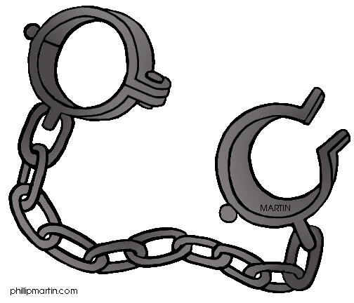

Things to do.

1. Draw and label a plan of the cave.
2. In your own words summarise the analogy and explain its meaning.
3. How might these ideas link to beliefs about body and soul?
4. How might this analogy link to ideas about life after death?