**Life After Death – Resurrection**

**‘Life on earth is only a single night we stay in a second class hotel’.**

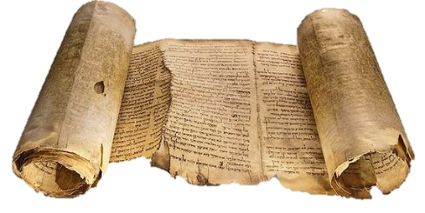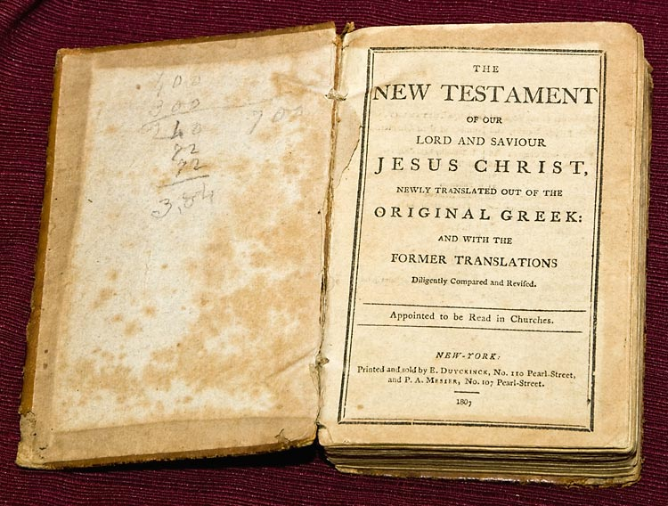

Old Testament Thinking.

The Old Testament of the Bible does not use dualistic language, it suggests body and soul are not two separable units, simply two dimensions of a single unity. The soul cannot separate from the body, therefore is there is an afterlife, it must include the body. To survive death, the body must rise again from the dead. To live after death must involve a re-embodiment - a resurrection.

The New Testament.

This way of thinking was inherited from late Judaism by the first

Christians and later by Muslims. In Jesus’ teaching there was never a

shadow of doubt about the existence of an afterlife. He spoke of coming

from God into this world and expected to go to God at death. His

parables frequently refer to the reward of heaven and punishment of

hell that lie beyond death.

In the fourth Gospel Jesus refers to himself as the Bread of Life, promising those who accept him as such will be raised from the dead on the last day. St Paul in his letters to the Corinthians frequently repeats the same theme that those who believe in Jesus will overcome death.

The basis of these claims is, of course, the claim that Jesus himself, though died a real death, was raised bodily from the dead by the power of God, leaving an empty tomb behind. He confirmed this by walking, talking and eating with his friends for weeks afterwards. The resurrection of Jesus is a central element of Christian belief.

*… St.Teresa of Avila.*

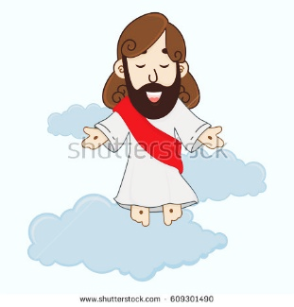

Research...

Look up and note down the following references;

* John 6:48 – 54
* John 11:25

Explain what these quotations say about the nature of resurrection.

Questions...

1. What does the Old Testament suggest about body and soul?
2. What does this mean for life after death?
3. Which religions originally had these beliefs about body and soul?
4. Why is the resurrection of Jesus important for Christians?

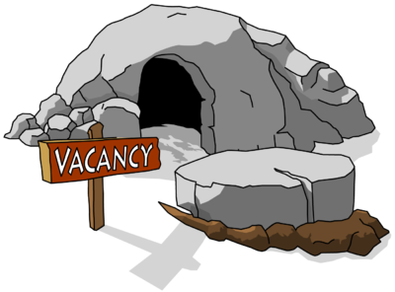

* 1 Corinthians 15:52
* 1 Corinthians 15:16

**Life After Death – Resurrection**

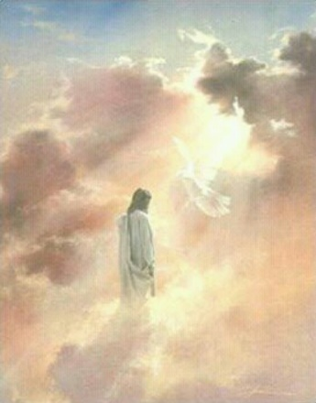

Problems of a Bodily Resurrection.

If someone has recently died (as in the story of Lazarus or crucifixion of Jesus) it is possible to think of a bodily resurrection as the miraculous reanimation of that person’s corpse. But what if the corpse has decomposed, been cremated or been eaten by animals? In such cases death can no longer be thought of in revived corpses. The resurrection body if such a thing exists will need to be a new creation out of the nothingness of death.

*More problems…*

If this is the case, where are the dead supposed to be while they wait for

this new body? What continuity is there if a newly created body is what

goes on to an afterlife? Is it the same person resurrected?

Answers to these questions are made all the more difficult if we try to

answer them literally. If talk of an afterlife cannot be anything other than

a projection from present experience, then it cannot be taken as a word

for word description as something tangible. All that Christians have to go on is their present experience of God as revealed in the life of Jesus. That experience suggests that a loving God would not abandon them in death. Even Paul doesn’t directly explain (1 Corinthians 15:35-8).

Given the great difficulty of describing the indescribable, believers turn to metaphors, symbols and parables. The Christ who lives on after death and continues to speak to his disciples is different from his previous embodiment as a dead person walking out of his tomb. To put it another way, if people asked where Christ was after his death, they would not be shown his tomb. Christians now believe he is now embodied in the community of his friends – they form the ‘Body of Christ’.

*‘Christ has no body on earth but yours… his compassion looks out on the world; yours the feet with which he goes about doing good…’ St. Teresa of Avila.*

In the light of this the first Christians spoke of resurrection and eternal life as much in *this*-worldly language as in other worldly language and as much in the present tense as in the future tense. Neither eternal life nor resurrection is an unknown quantity reserved for those who reach the other side of death.

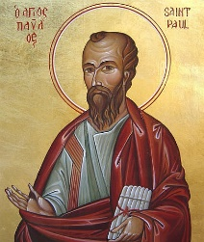

Research...

Look up and note down the following reference;

* 1 Corinthians 15:35-8

Explain what these quotations say about the nature of resurrection.

Questions...

1. Explain some of the reasons why a bodily resurrection is problematic.
2. How does Christ ‘live’ today?
3. Explain what St. Teresa of Avila says about this.





**Life After Death – Resurrection**

Christianity, Resurrection and Jesus.

Christians believe that God addressed our fears about death by allowing his son, Jesus, to die and then raising him back to life. It is this belief that is at the heart of Christianity.

*Did the resurrection really happen? What is the evidence?*

The Bible tells us that on the third day after his death and burial, Jesus rose from death. What is the evidence that this actually happened? The Romans were thorough in the treatment of their victims. They thrust a spear into Jesus’ side to make sure he was dead. The authorities were worried that his body would be stolen so a large stone was put across the entrance of his tomb and guards were put at the entrance at risk of severe punishment if they fell asleep! Stealing Jesus’ body was out of the question. However all

Gospels tell us that the tomb was empty. The same women who were

at his burial were the one to visit the tomb on the Sunday morning. After

his disappearance from the tomb Jesus appeared to his mother Mary and

Mary Magdalene, he had supper with two me he met on the road to

Emmaus, he spent time with his disciples and allowed Thomas to feel his

wounds. Jesus also appeared to 500 people at one time.



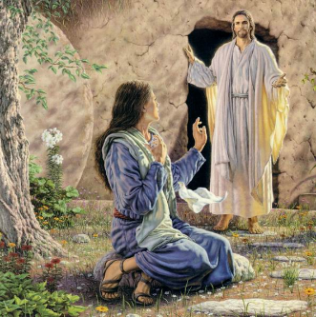

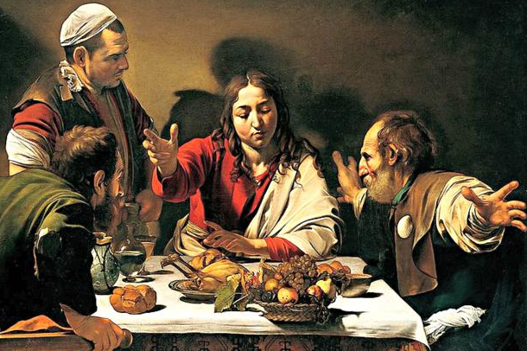

Research...

Look up and note down the following reference;

* Luke 24:30-31
* John 20:24-29

Note down a summary of these passages and highlight a quotation that could be used as evidence of Jesus’ resurrection.

…more evidence?

The disciples were not expecting to see Jesus, Mary thought Jesus was a gardener when she first saw him outside of his tomb. After his death the disciples were scared and hiding, but only a view weeks after his death they were confidently telling the crowds, including people who had arranged his death, that he was alive. They had nothing to gain and a lot to lose by doing this. The resurrection of Jesus had a profound effect on them, in their own words, ‘*we cannot stop speaking of what we ourselves have seen and heard’*, (Acts 4:20). Paul also said, ‘*If Christ has not been raised from the dead, then we have nothing to preach and you have nothing to believe’*. 1 Corinthians 15:14.

God did it…

The New Testament says that ‘God raised Jesus from the dead’. The resurrection was Jesus’ ultimate miracle – God restored life to someone that had actually died. Considering beliefs about the God if classical theism, these ideas should not be out of the question for theists.

Explain...

1. Note down the quotations on the previous page. How might these be further ‘proof’ of Jesus’ resurrection?
2. Write an explanation linking these quotations with religious experiences and proof of God’s existence.
3. Why do beliefs about the nature of God suggest theists should have no problem accepting the idea of resurrection?

Note

What does the resurrection of Jesus mean for Christians today?

The Bible sees the resurrection of Jesus as a victory over evil, the devil,

sin and death. Just as Jesus seemed to have been defeated and

humiliated, he was raised from death. Jesus returns to the world to show

he had destroyed these enemies. Jesus’ resurrection gives Christians

hope of an afterlife without pain and suffering. The resurrection shows

Christians that God will raise them from death too. By raising Jesus, it

suggests that God put the stamp of approval on Jesus’ life and teaching.

For the disciples the resurrection made sense of everything Jesus had taught and that Jesus was the son of God, as it does for Christians today. They believe Jesus is alive now, they worship him and feel they have a personal relationship with him.

Spiritual or Bodily Resurrection?

Christians believe that a person is more than just a body and a mind, human beings have souls. This soul is eternal – it lives on after the body has died. St Paul claimed that the body and soul want different things – the soul wants to be with God and to do what is right, the body wants food and other earthly pleasures. Many Christians believe that when they die, the body is not needed anymore and the soul will live on in heaven, therefore cremation of the body is acceptable. However in the Apostles’ creed (Christian statement of belief) it says; *‘I believe in … the forgiveness of sins, the resurrection of the body and the life everlasting’*. As we have seen St Paul said resurrection would be with a body, the same but different or ‘glorified’, so the soul lives on but in a new way. Some Christians believe that one day, the world will come to an end and then, people will be raised from the dead in the Last Days and will be judged when it will be decided whether they go to heaven or hell, for this reason, burial of the body is important. Other Christians have problems with this belief because if heaven is perfect, then people ought to be able to live with new, perfect bodies, therefore, they no longer need their old ones.

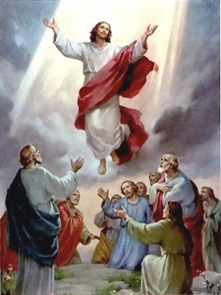

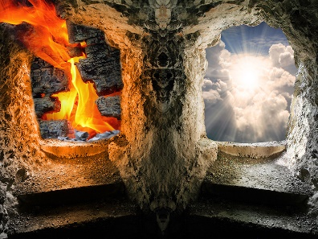

Explain...

1. Explain what the resurrections means for Christians today and why it is important for Christians.
2. Use quotations and examples to explain different beliefs about the nature of resurrection in Christianity.

Exam question…

Assess beliefs about a bodily resurrection. (12)







