**Life After Death – Rebirth**

*Reincarnation is a term avoided by writers on Buddhism since it implies the existence of an immortal soul (atman) that is periodically incarnated in a fleshly host, a notion more associated to Hinduism. By contrast, Buddhism denies the existence of an immortal soul and does not accept the dualistic opposition between spirit and matter it presupposes. Accordingly, the English term preferred by Buddhist writers to designate the dynamic and constantly changing continuity of the individual from one life to the next is ‘rebirth’. Neither this term nor ‘reincarnation’ has a direct Sanskrit equivalent, and Indian sources speak instead of ‘rebecoming’.* Damien Keown in the Oxford Dictionary of Buddhism.

In the Buddhist approach, life and death are seen as one whole, where death is the beginning of another chapter of life. Death is a mirror in which the entire meaning of life is reflected. Sogyal Rinpoche – Tibetan Book of Living and Dying.

The Buddhist understanding of rebirth.

During his meditation when he was enlightened, Buddha witnessed his previous lives. This was the basis for his teaching on rebirth, the idea that all beings are caught in a cycle of life and death.

All the main Indian religions (Buddhism, Hinduism, Sikhism and Jainism) believe that we have a series of lives. Death marks the end of one life and the beginning of a new life. This continuous cycle of life and death is called samsara, it is marked by suffering. All these religions link together the principles of karma and rebirth, the idea that every moral and immoral action will produce appropriate affects in this or future lives. Equally many of the experiences of the present lifetime are the consequences of past actions performed either in our present life or in previous lives.

The ultimate goal for Buddhists is not, however, to be reborn as this simply means more suffering. The goal is enlightenment – freedom from the cycle of rebirth, so karma and rebirth are profoundly connected in the sense that if one is free from the law of karma, one will also be free from rebirth.

Explain & Think…

* Explain the Buddhist belief of rebirth. Use a quotation from Sogyal Rinpoche in your answer.
* Explain the main differences between rebirth and reincarnation. Use a quotation from Damien Keown in your answer.
* What are the strengths and weaknesses in the ide of rebirth? Draw up a table and note down your ideas.

Definitions.

**Rebirth** – the endless cycle of birth, death, and rebirth (samsara), affected by our actions. This cycle is considered to be dukkha. The cycle stops only on enlightenment and when desire ends.

**Reincarnation** – the transmigration of the soul from one body to another after death.

What continues? Karma and rebirth.

Buddhists do not have one single answer to this question. There are a number of answers that vary according to which Buddhist tradition one follows. However the basic principle is common to all traditions.

The belief in anatta shows us that there is no unchanging self that continues from one life to the next. However there must be some continuity from one life to the next, otherwise we would have to say that a future life involves a different person to the one that passed away.

**The Questions of King Milinda**

**The Milinda Panha Sutta was probably written around the turn of the first century B.C. It depicts a conversation between a monk, Nagasena, and a king named Menander (which becomes Milinda in Pali), who wanted to learn about Buddhism.**

The king said: 'Where there is no transmigration, Nâgasena, can there be rebirth?'

*'Yes, there can.'*

'But how can that be? Give me an illustration.'

*'Suppose a man, O king, were to light a lamp from another lamp, can it be said that the one transmigrates from, or to, the other?'*

'Certainly not.'

*'Just so, great king, is rebirth without transmigration.'*

'Give me a further illustration.'

*'Do you recollect, great king, having learnt, when you were a boy, some verse or other from your teacher?'*

'Yes, I recollect that.'

*'Well then, did that verse transmigrate from your teacher?'*

'Certainly not.'

*'Just so, great king, is rebirth without transmigration.'*

'Very good, Nâgasena!'

**Nagasena uses many analogies in his explanations to the king. When asked if whether the person who is reborn is the same as the one who has died, Nagsena replies;**

*"Milk, once the milking is done, turns after sometimes into curds; from curds it turns into fresh butter; and from fresh butter into ghee. Would it now be correct to say that the milk is the same thing as the curds, or the fresh butter, or the ghee?"*

"No, it would not. But they have been produced because of it."

Explain....

1. Use a quotation from the ‘Questions of King Milinda’ to explain how there can be rebirth without the transmigration of a soul.
2. Use a quotation and an analogy from the ‘Questions of King Milinda’ to explain whether the person who is reborn is the same as the one who died.

**Life After Death – Reincarnation**

According to Hinduism, a soul, referred to as *atman*, reincarnates again and again on earth until it becomes perfect and reunites with it Source. During this process the soul enters into many bodies, assumes many forms and passes through many births and deaths. This concept is described in the following verse of the Bhagavad Gita:

*"Just as a man discards worn out clothes and puts on new clothes, the soul discards worn out bodies and wears new ones." (2.22)*

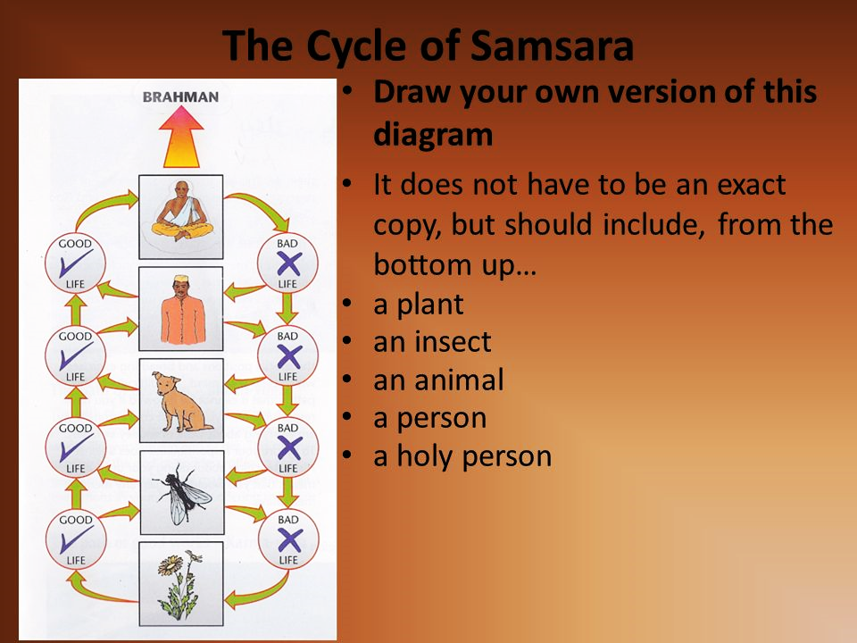

The atman in everything is the same. There is no difference between the soul in a plant or animal and a human being. Hindus believe that the soul moves through a series of ‘steps’. It begins in plants and animals, and goes on to human beings. When a man or woman dies the soul is ‘re-housed’ in another person. This continuous cycle of birth and death is called samsara.

Hindus believe, a being has to live many lives and undergo many experiences before it attains perfection and becomes one with the Divine. The Hindu theory of creation suggests that creation begins when the individual souls become separated from God. It continues as the evolution of life and consciousness progresses. The remaining souls continue their existence and return to God in the end. Thus the great cycle of creation, stretching over millions of years, comes to its logical end.

Living beings undergo innumerable births and deaths in the mortal world. They remain bound to the mortal world and the laws of nature due to desires and attachments. Death gives them temporary relief from the earthly suffering, but exposes them to the risk of falling into greater depths of sorrow and suffering since each birth bring them newer challenges and opens them to innumerable possibilities and opportunities, both good and bad. This cycle, called *samsara*, goes on until they achieve liberation and enter into the immortal world of Brahman where they remain liberated forever in a state of unity with God.

Explain....

1. Write down the quotation from the Bhagavad Gita and explain its meaning in relation to reincarnation.
2. Use a diagram to explain the Hindu beliefs about the reincarnation process. Make sure you refer to atman and samsara in your explanation.
3. What happens when an individual achieves moksha?
4. Note down definitions for the following key terms: atman; samsara; Brahman; Bhagavad Gita.

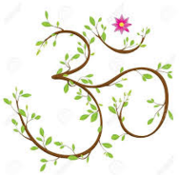

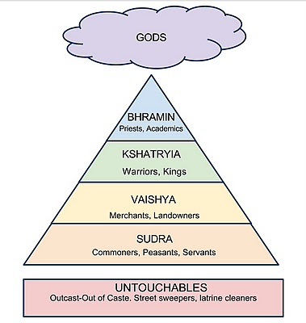

Dharma.

Hindus believe that life involves a series of duties. These duties are called dharma. Dharma is not the same for everyone, it depends on your family background in particular which caste or class you were born into. Dharma includes things like worshipping God, doing your job properly and being honest and caring. For Hindus it is their aim in life to do their dharma as well as they possibly can. Not performing these duties can affect one’s karma and therefore their reincarnation.

Karma.

The type of person your soul moves onto depends on how you have lived your life and how well you have performed your dharma. This is called the ‘law of karma’. Karma means action. Good karma in your last life will mean a good life this time. Bad karma in the last life will mean a hard life this time. There is no belief in Hinduism of being judged by God. How you live will decide whether your next life is a step up or a step down.

Moksha.

The end of samsara is called moksha. It is what every Hindu hopes to achieve. The soul breaks out of the cycle of rebirth and joins Brahman (God) where it began. This can only happen when the soul is completely pure and not affected by anything that happens on earth.

Explain....

1. Explain the meaning of dharma for Hindus.
2. Briefly explain the caste system.
3. How do (i) dharma and (ii) karma affect reincarnation.
4. What is moksha and how can it be attained?
5. Note down definitions for the following key terms: dharma; karma; moksha; caste system.

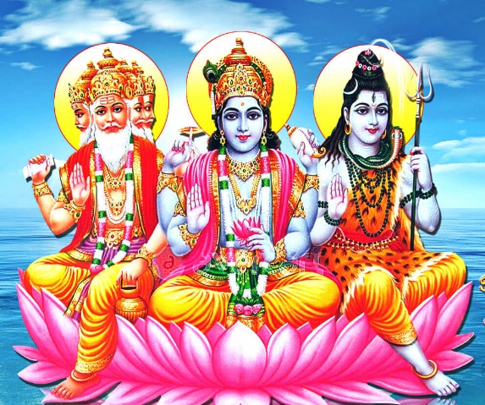

Make links....

* Who are the gods in the picture on the right?
* What are they each gods of?
* How does this link to reincarnation and the cyclical nature of life in Hinduism?

A Hindu Funeral.

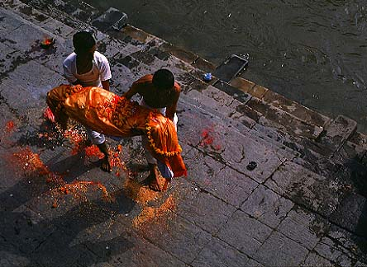Hindus believe that a single short life is nowhere near long enough to work out what life is all about. Therefore they believe that when the body dies the soul lives on and goes from body to body looking for a new home.

The body should be cremated within hours of a person dying. It is the wish of most Hindus that they should die near to the River Ganges – the sacred river of Hindus, so that their ashes can be scattered into the river. Sometimes the ashes of Hindus who have died in this country are taken to India by a relative so that they can be emptied into the holy river. Some Hindus believe that if this happens the soul will not need to enter another body but will go straight to paradise.

Flower petals leave an outline of a young girl as her body is carried to the funeral pyre.

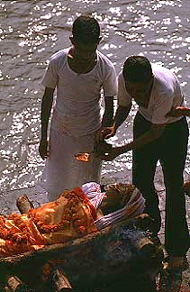 If the relatives cannot get to the Ganges they will scatter the ashes into any flowing stream because they believe that all waters mingle together in the end.

The oldest son is usually the one that lights the funeral pyre. If it is a son or daughter that has died then the father will light the pyre. It is believed that if the cremation is not done properly then the soul will return to its former haunts and become a ghost. This is why Hindus want a son because it is only he who can perform the funeral duties properly.

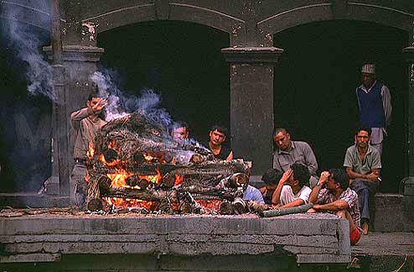After the fire has been lit ghee is added to make sure the fire burns well but also as a sign of purification. A priest then begins to chant verses. When the body has been reduced to ashes the relatives will collect the ashes and scatter them in a river.

The father of the girl starts the cremation by lighting a cloth in the mouth of his daughter.

Over the next ten days special ceremonies are carried out at the home of the dead person to help the soul find a new body. On the eleventh day another ceremony takes place to mark the time when Hindus believe the soul is now free to enter the next life.

After some hours the ashes of the girl are collected and put into the nearby river and the cycle of Hindu life continues.

Explain....

11. Explain briefly the main parts of a Hindu funeral, particularly those that link

to the release of the soul.

12. Explain why the funeral rituals are important for reincarnation.

Reincarnation in modern thinking

Once the Eastern concept of reincarnation arrived in Europe, its meaning changed. A wider acceptance of reincarnation was promoted in the Western world beginning only in the 19th century. Then came the Eastern gurus, the New Age movement, and as a result we witness a wide acceptance of reincarnation in our society today.

However, its modern version is substantially different from what Eastern religions affirmed. Instead of samsara being a torment out of which man has to escape through abolishing personhood, New Age thinking sees reincarnation as an eternal progression of the soul toward higher levels of spiritual knowledge. Thus what reincarnates is not the impersonal atman, but an entity which is currently called the soul, an entity which preserves the attributes of personhood from one life to the next. This compromise obviously emerged from the desire to adapt the reincarnation doctrine to Western thought. The concept of an impersonal atman reincarnating was too abstract to be easily accepted, so Westerners needed a milder version of this doctrine. This tendency may offer evidence for the soul’s yearning for a personal destiny, classical Eastern spirituality, however, rejects it as a perverted view.

Explain....

13. Explain how Hindu beliefs about reincarnation were developed in Buddhist belief.

14. Explain beliefs about reincarnation have developed in Western/New Age thinking.

15. Why do people believe in reincarnation? Explain and give examples of ‘evidence’ for

reincarnation.

16. How might people who do not believe in reincarnation refute the belief? Consider

people with religious faiths that have alternative life after death beliefs and non-

religious people.

Exam question....

**Explore ideas about reincarnation and in one religion.** (8marks).

You will obviously need to look at Hinduism here. Make sure you refer to key terms such as atman; samsara; dharma; Brahman and moksha. To develop your answer further you could mention the importance of funeral rituals for reincarnation.